Lesson 9 Practice Problems
- For each graph, calculate the slope of the line.
- 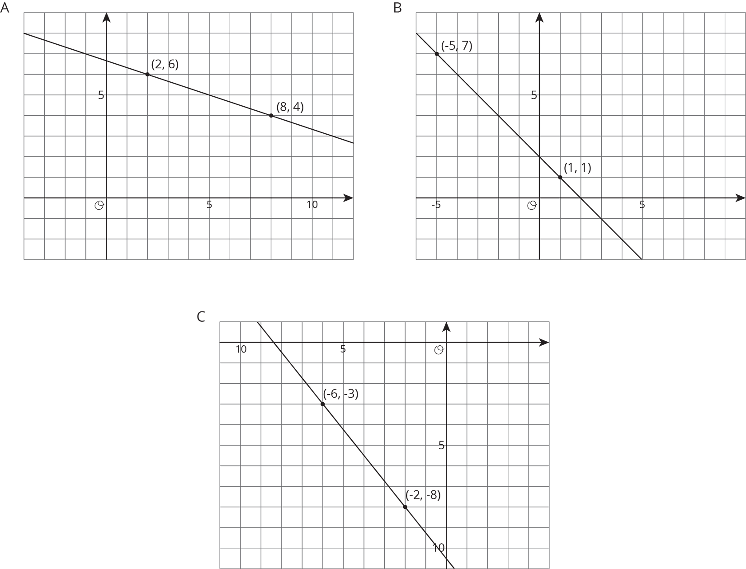
- Match each pair of points to the slope of the line that joins them.
  - $\left(9,10\right)$ and $\left(7,2\right)$
  - $\left(\text{-}8,\text{-}11\right)$ and $\left(\text{-}1,\text{-}5\right)$
  - $\left(5,\text{-}6\right)$ and $\left(2,3\right)$
  - $\left(6,3\right)$ and $\left(5,\text{-}1\right)$
  - $\left(4,7\right)$ and $\left(6,2\right)$
  - 4
  - $\text{-}3$
  - $\text{-}\frac{5}{2}$
  - $\frac{6}{7}$
- Draw a line with the given slope through the given point. What other point lies on that line?
- 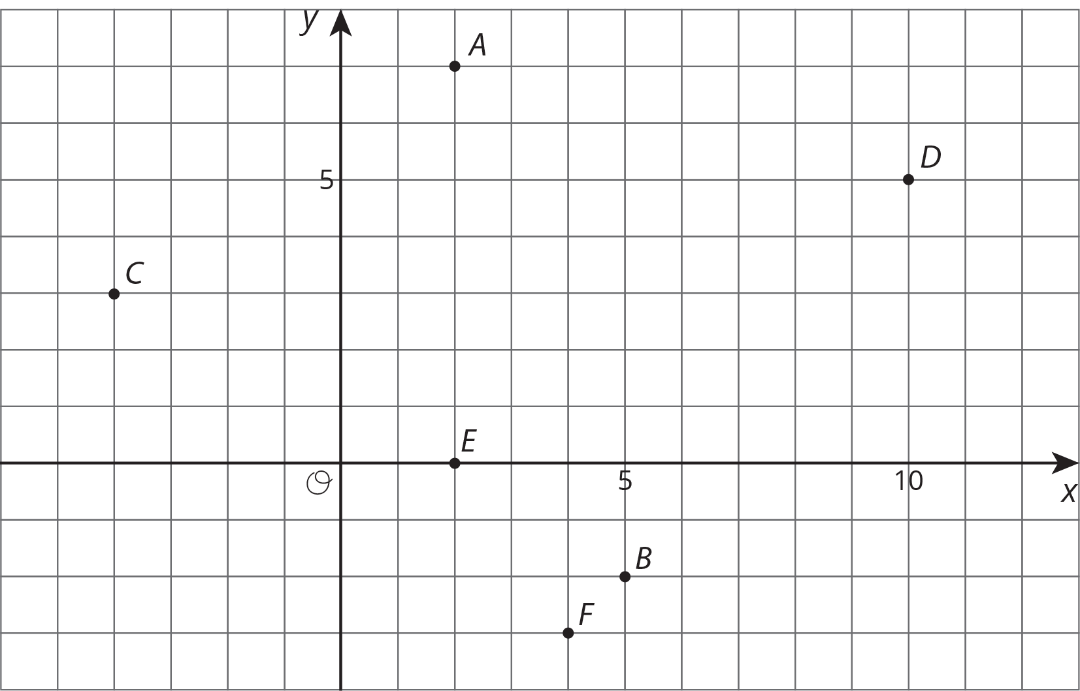
  - Point A, slope = $\text{-}3$
  - Point A, slope = $\frac{\text{-}1}{4}$
  - Point C, slope = $\frac{\text{-}1}{2}$
  - Point E, slope = $\frac{\text{-}2}{3}$
- Suppose you wanted to graph the equation $y=\text{-}4x−1$.
  - Describe the steps you would take to draw the graph.
  - How would you check that the graph you drew is correct?
- Write an equation for each line.
- 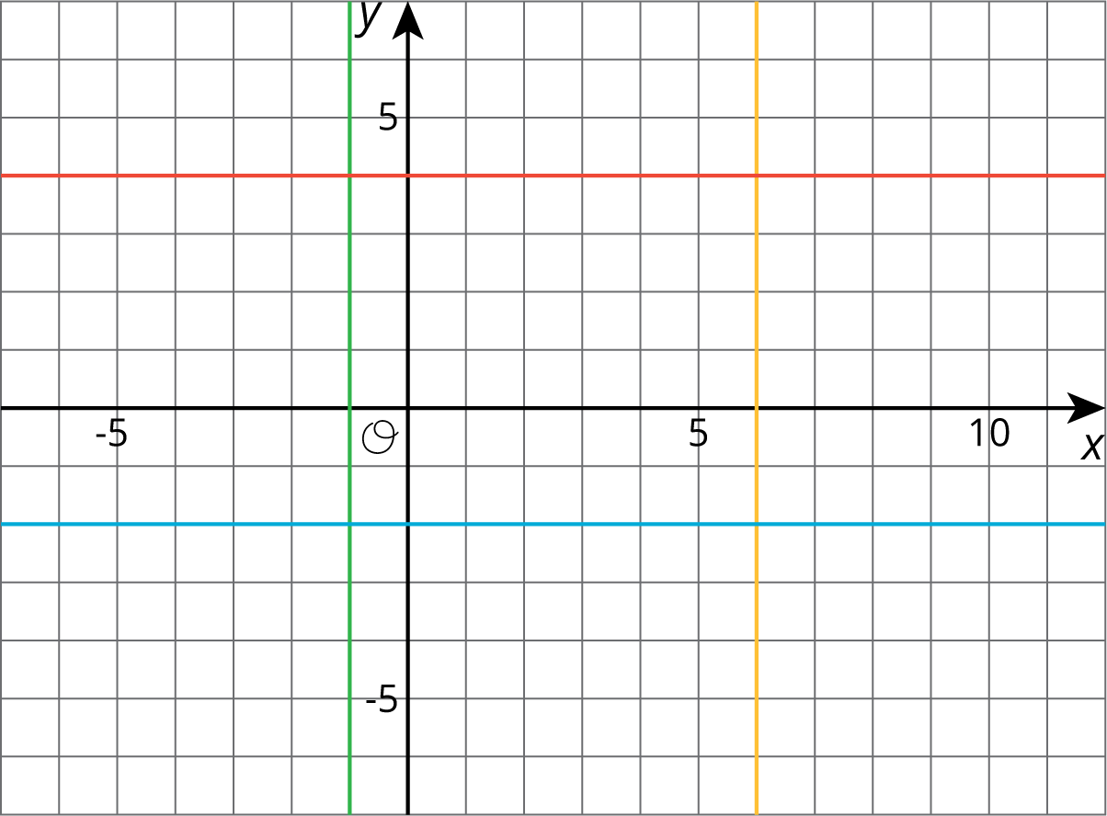

- A publisher wants to figure out how thick their new book will be. The book has a front cover and a back cover, each of which have a thickness of $\frac{1}{4}$ of an inch. They have a choice of which type of paper to print the book on.
  - Bond paper has a thickness of $\frac{1}{4}$ inch per one hundred pages. Write an equation for the width of the book, $y$, if it has $x$ hundred pages, printed on bond paper.
  - Ledger paper has a thickness of $\frac{2}{5}$ inch per one hundred pages. Write an equation for the width of the book, $y$, if it has $x$ hundred pages, printed on ledger paper.
  - If they instead chose front and back covers of thickness $\frac{1}{3}$ of an inch, how would this change the equations in the previous two parts?
- (From Unit 5, Lesson 6.)
© CC BY Open Up Resources. Adaptations CC BY IM.

