Unit 5 Lesson 4 Cumulative Practice Problems
- For each subtraction problem, circle the correct calculation.
  - $7.2−3.67$
  - $16−1.4$
- 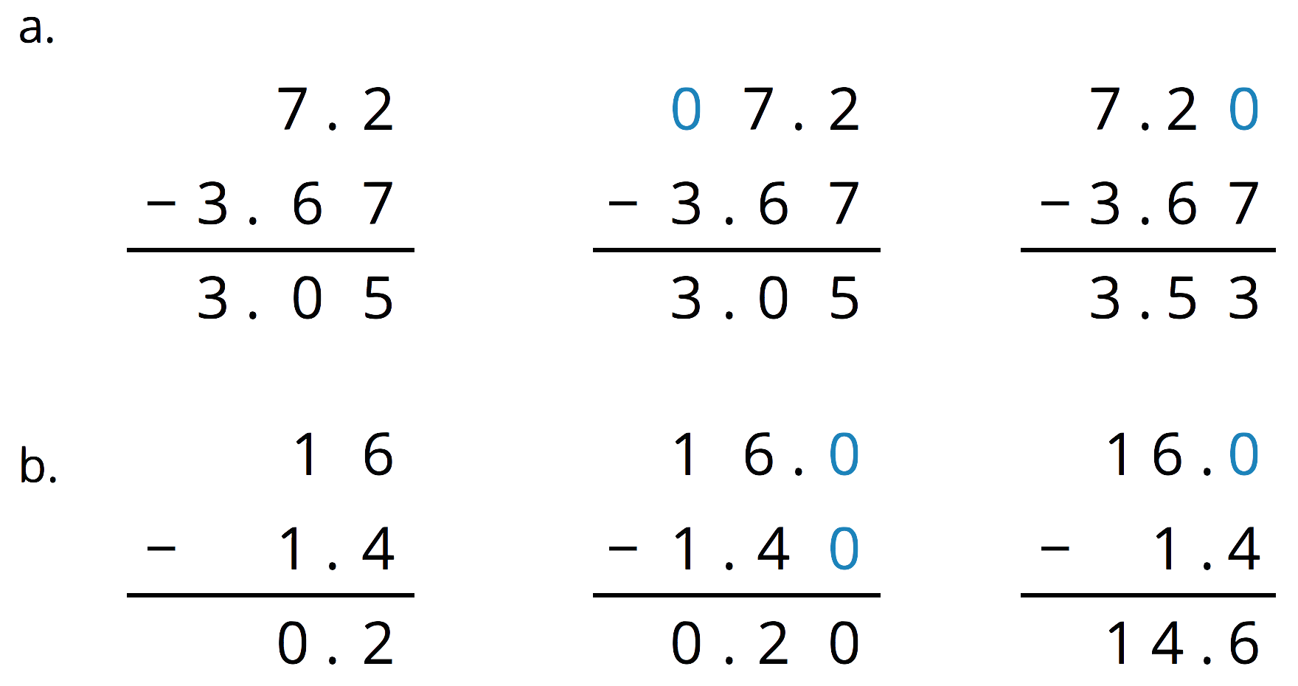
- Explain how you could find the difference of 1 and 0.1978.
- A bag of chocolates is labeled to contain 0.384 pound of chocolates. The actual weight of the chocolates is 0.3798 pound.
  - Are the chocolates heavier or lighter than the weight stated on the label? Explain how you know.
  - How much heavier or lighter are the chocolates than stated on the label? Show your reasoning.
- Complete the calculations so that each shows the correct sum.
- 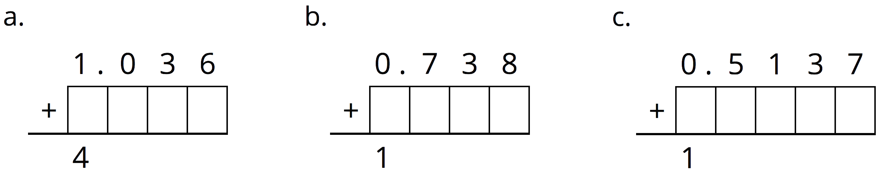
- A shipping company is loading cube-shaped crates into a larger cube-shaped container. The smaller cubes have side lengths of $2\frac{1}{2}$ feet, and the larger shipping container has side lengths of 10 feet. How many crates will fit in the large shipping container? Explain your reasoning.
- (From Unit 4, Lesson 14.)
- For every 9 customers, the chef prepares 2 loaves of bread.
  - Here is double number line showing varying numbers of customers and the loaves prepared. Complete the missing information.
  - 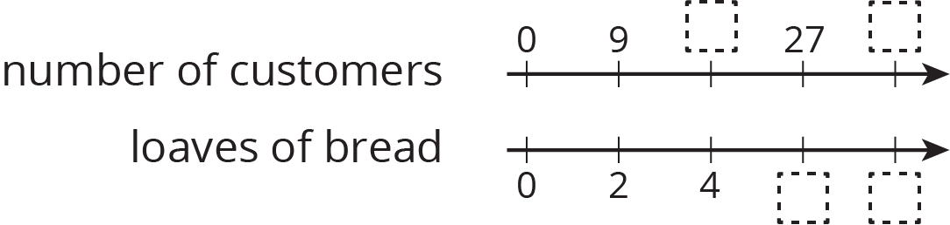
  - The same information is shown on a table. Complete the missing information.
- customers | - loaves
- 9 | - 2
 | - 4
- 27
 | - 14
- 1
- c. Use either representation to answer these questions.
  - How many loaves are needed for 63 customers?
  - How many customers are there if the chef prepares 20 loaves?
  - How much of a loaf is prepared for each customer?
- (From Unit 2, Lesson 13.)
© CC BY Open Up Resources. Adaptations CC BY IM.

