Lesson 4: Describe, Compare, and Sort Shapes
- Let’s describe and sort shapes.

4.1: Classroom Shape Hunt
Shape A
Shape B

4.2: Shape Sort

4.3: Centers: Choice Time
Choose a center.
Which One
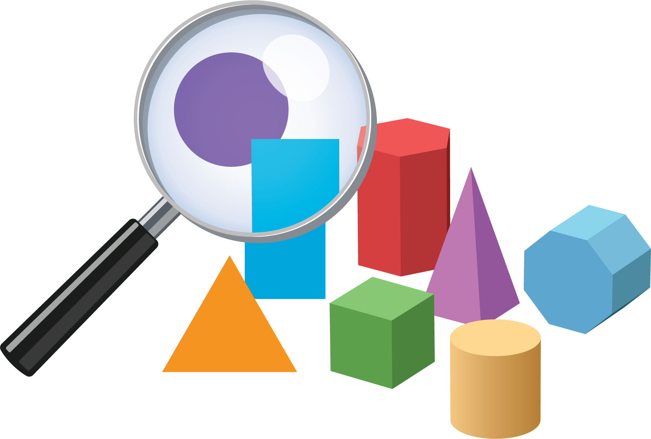
Picture Books
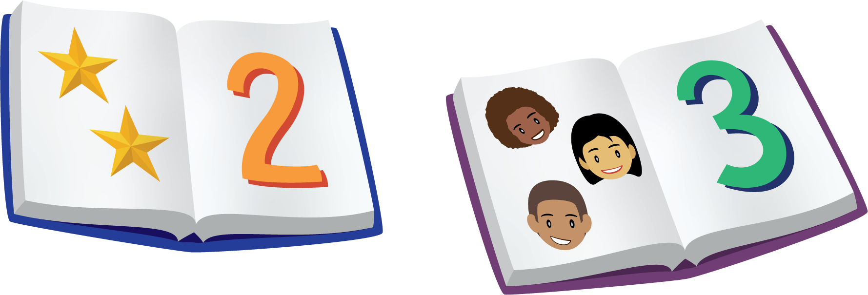
Bingo
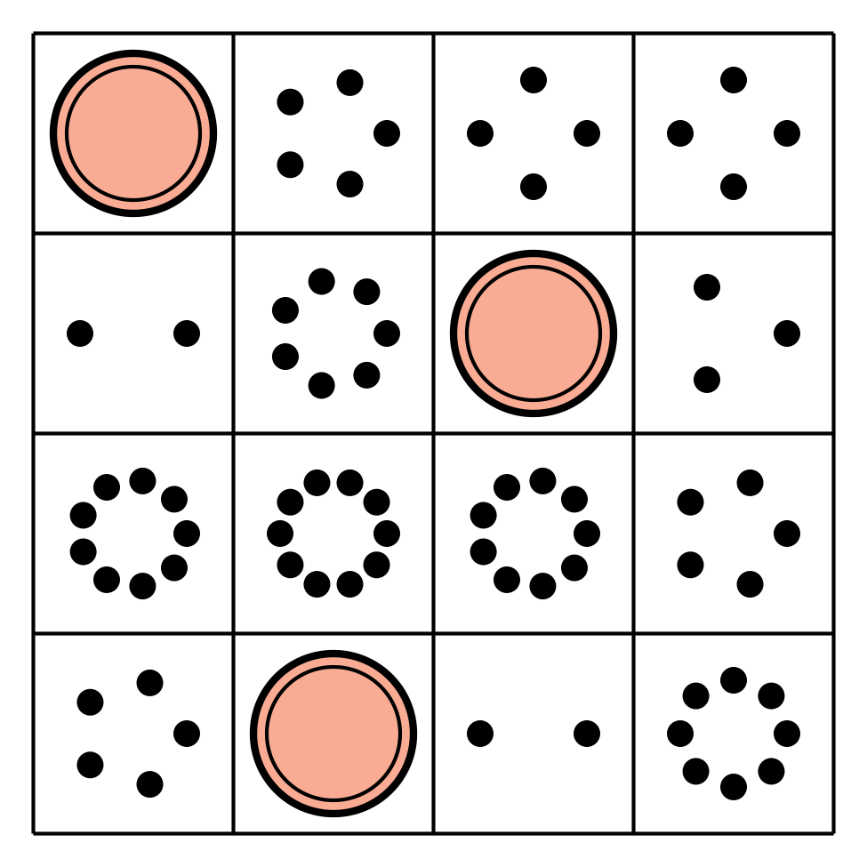
Shake and Spill
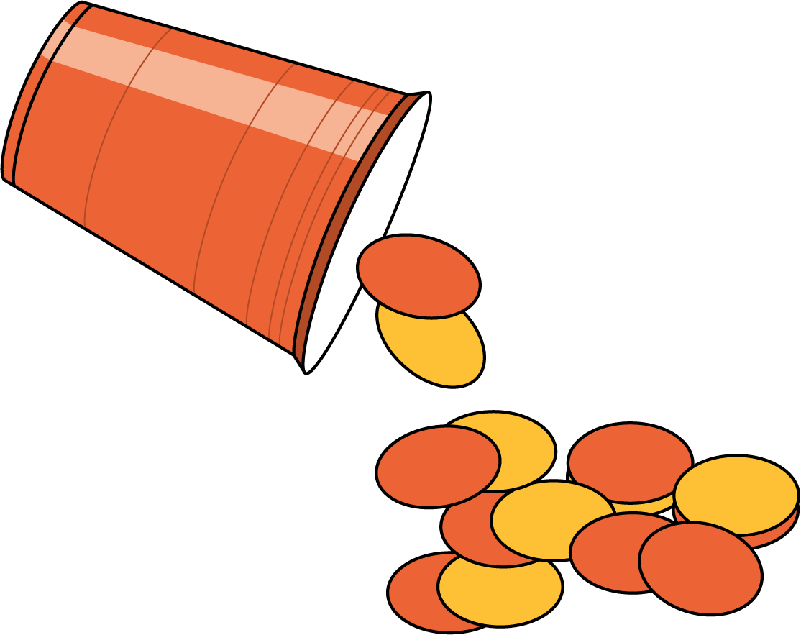
© CC BY 2021 Illustrative Mathematics®

