Lesson 8: Unknown Exponents
- Let’s find unknown exponents.

8.1: A Bunch of $x$’s
Solve each equation. Be prepared to explain your reasoning.
- $\frac{x}{3}=12$
- $3x^{2}=12$
- $x^{3}=12$
- $\sqrt[3]{x}=12$
- $\sqrt{3x}=12$
- $\frac{3}{x}=12$

8.2: A Tessellated Trapezoid
Here is a pattern showing a trapezoid being successively decomposed into four similar trapezoids at each step.
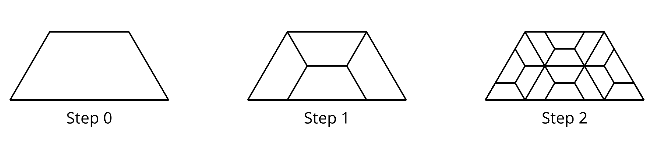
- If $n$ is the step number, how many of the smallest trapezoids are there when $n$ is 4? What about when $n$ is 10?
- At a certain step, there are 262,144 smallest trapezoids.
  - Write an equation to represent the relationship between $n$ and the number of trapezoids in that step.
  - Explain to a partner how you might find the value of that step number.

8.3: Successive Splitting
In a lab, a colony of 100 bacteria is placed on a petri dish. The population triples every hour.
- How would you estimate or find the population of bacteria in:
  - 4 hours?
  - 90 minutes?
  - $\frac{1}{2}$ hour?
- How would you estimate or find the number of hours it would take the population to grow to:
  - 1,000 bacteria?
  - double the initial population?

Are you ready for more?
A $1,000 investment increases in value by 5% each year. About how many years does it take for the value of the investment to double? Explain how you know.

8.4: Missing Values
Complete the tables.
$x$ |  |  | -1 | 0 | $\frac{1}{2}$ | 1 |  |  | 5
$2^{x}$ | $\frac{1}{32}$ | $\frac{1}{4}$ | $\frac{1}{2}$ |  |  |  | 4 | 16 |  | 256 | 1,024

$x$ |  |  |  | $\frac{1}{3}$ | $\frac{1}{2}$
$5^{x}$ | $\frac{1}{25}$ | $\frac{1}{5}$ | 1 |  |  | 5 | 125 | 625 | 3,125
Be prepared to explain how you found the missing values.

Lesson 8 Summary
Sometimes we know the value of an exponential expression but we don’t know the exponent that produces that value.
For example, suppose the population of a town was 1 thousand. Since then, the population has doubled every decade and is currently at 32 thousand. How many decades has it been since the population was 1 thousand?
If we say that $d$ is the number of decades since the population was 1 thousand, then $1⋅2^{d}$, or just $2^{d}$, represents the population, in thousands, after $d$ decades. To answer the question, we need to find the exponent in $2^{d}=32$. We can reason that since $2^{5}=32$, it has been 5 decades since the population was 1 thousand people.
When did the town have 250 people? Assuming that the doubling started before the population was measured to be 1 thousand, we can write: $2^{d}=0.25$ or $2^{d}=\frac{1}{4}$. We know that $2^{\text{-}2}=\frac{1}{4}$, so the exponent $d$ has a value of -2. The population was 250 two decades before it was 1,000.
But it may not always be so straightforward to calculate. For example, it is harder to tell the value of $d$ in $2^{d}=805$ or in $2^{d}=4.5$. In upcoming lessons, we’ll learn more ways to find unknown exponents.
© CC BY 2019 by Illustrative Mathematics®

