Lesson 24 Practice Problems
- The function $h$ represents the height of an object $t$ seconds after it is launched into the air. The function is defined by $h(t)=\text{-}5t^{2}+20t+18$. Height is measured in meters.
- Answer each question without graphing. Explain or show your reasoning.
  - After how many seconds does the object reach a height of 33 meters?
  - When does the object reach its maximum height?
  - What is the maximum height the object reaches?
- The graphs that represent a linear function and a quadratic function are shown here.
- The quadratic function is defined by $2x^{2}−5x$.
- Find the coordinates of $R$ without using graphing technology. Show your reasoning.
- Diego finds his neighbor's baseball in his yard, about 10 feet away from a five-foot fence. He wants to return the ball to his neighbors, so he tosses the baseball in the direction of the fence.
- Function $h$, defined by $h(x)=\text{-}0.078x^{2}+0.7x+5.5$, gives the height of the ball as a function of the horizontal distance away from Diego.
- Does the ball clear the fence? Explain or show your reasoning.
- Clare says, “I know that $\sqrt{3}$ is an irrational number, so its decimal never repeats or terminates. I also know that $\frac{2}{9}$ is a rational number, so its decimal repeats or terminates. But I don’t know how to add or multiply these decimals, so I am not sure if $\sqrt{3}+\frac{2}{9}$ and $\sqrt{3}⋅\frac{2}{9}$ are rational or irrational."
  - Here is an argument that explains why $\sqrt{3}+\frac{2}{9}$ is irrational. Complete the missing parts of the argument.
    - Let $x=\sqrt{3}+\frac{2}{9}$. If $x$ were rational, then $x−\frac{2}{9}$ would also be rational because . . . .
    - But $x−\frac{2}{9}$ is not rational because . . . .
    - Since $x$ is not rational, it must be . . . .
  - Use the same type of argument to explain why $\sqrt{3}⋅\frac{2}{9}$ is irrational.
- (From Unit 7, Lesson 21.)
- The following expressions all define the same quadratic function.
- $x^{2}+2x−8$
- $(x+4)(x−2)$
- $(x+1)^{2}−9$
  - What is the $y$-intercept of the graph of the function?
  - What are the $x$-intercepts of the graph?
  - What is the vertex of the graph?
  - Sketch a graph of the quadratic function without using technology. Make sure the $x$-intercepts, $y$-intercept, and vertex are plotted accurately.
- 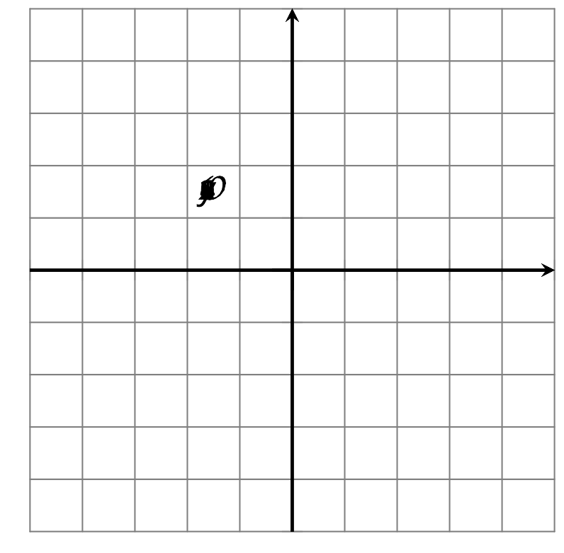
- (From Unit 7, Lesson 22.)
- Here are two quadratic functions: $f(x)=(x+5)^{2}+\frac{1}{2}$ and $g(x)=(x+5)^{2}+1$.
- Andre says that both $f$ and $g$ have a minimum value, and that the minimum value of $f$ is less than that of $g$. Do you agree? Explain your reasoning.
- (From Unit 7, Lesson 23.)
- Function $p$ is defined by the equation $p(x)=(x+10)^{2}−3$.
- Function $q$ is represented by this graph.
- Which function has the smaller minimum? Explain your reasoning.
- 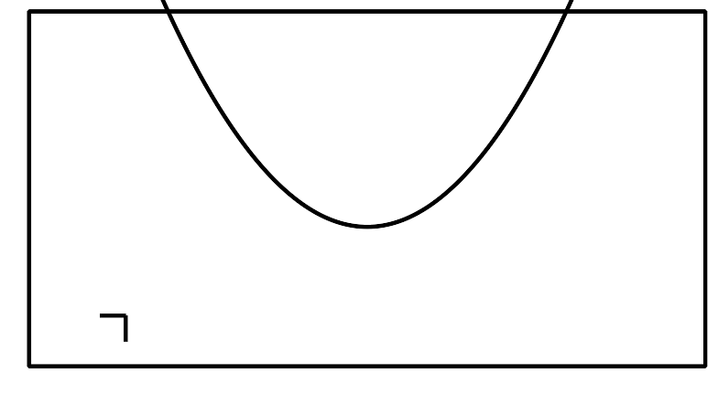
- (From Unit 7, Lesson 23.)
- Without using graphing technology, sketch a graph that represents each quadratic function. Make sure the $x$-intercepts, $y$-intercept, and vertex are plotted accurately.
- $f(x)=x^{2}+4x+3$
- 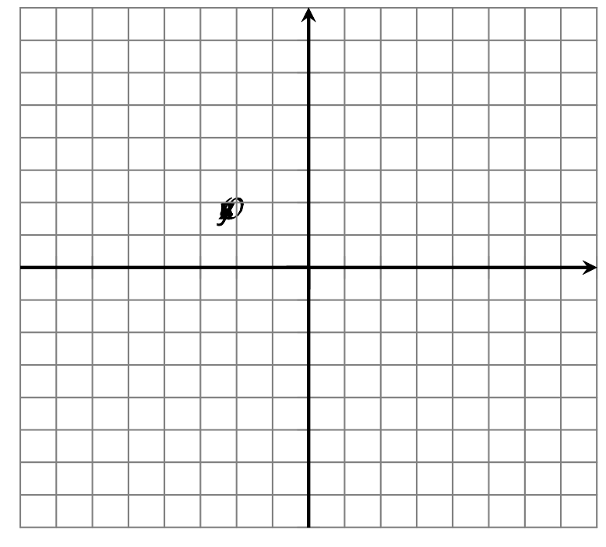
- $g(x)=x^{2}−4x+3$
- $h(x)=x^{2}−11x+28$
- (From Unit 7, Lesson 22.)
© CC BY 2019 by Illustrative Mathematics®

