Lesson 6: What about Other Bases?

6.1: True or False: Comparing Expressions with Exponents
Is each statement true or false? Be prepared to explain your reasoning.
- $3^{5}<4^{6}$
- ${\left(\text{-}3\right)}^{2}<3^{2}$
- ${\left(\text{-}3\right)}^{3}=3^{3}$
- ${\left(\text{-}5\right)}^{2}>\text{-}5^{2}$

6.2: What Happens with Zero and Negative Exponents?
Complete the table to show what it means to have an exponent of zero or a negative exponent.
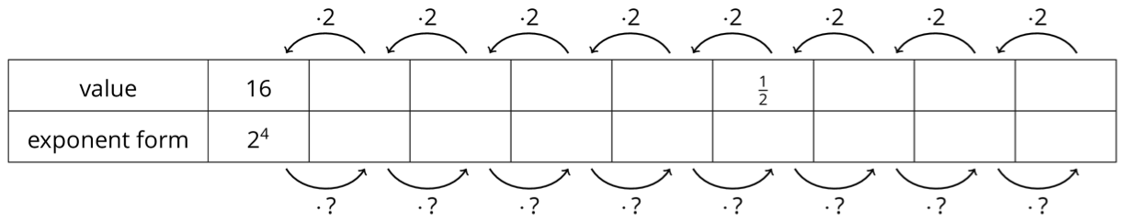
- As you move toward the left, each number is being multiplied by 2. What is the multiplier as you move toward the right?
- Use the patterns you found in the table to write $2^{\text{-}6}$ as a fraction.
- Write $\frac{1}{32}$ as a power of 2 with a single exponent.
- What is the value of $2^{0}$?
- From the work you have done with negative exponents, how would you write $5^{\text{-}3}$ as a fraction?
- How would you write $3^{\text{-}4}$ as a fraction?

Are you ready for more?
- Find an expression equivalent to ${\left(\frac{2}{3}\right)}^{\text{-}3}$ but with positive exponents.
- Find an expression equivalent to ${\left(\frac{4}{5}\right)}^{\text{-}8}$ but with positive exponents.
- What patterns do you notice when you start with a fraction raised to a negative exponent and rewrite it using a single positive exponent? Show or explain your reasoning.

6.3: Exponent Rules with Bases Other than 10
Lin, Noah, Diego, and Elena decide to test each other’s knowledge of exponents with bases other than 10. They each chose an expression to start with and then came up with a new list of expressions; some of which are equivalent to the original and some of which are not.
Choose 2 of the 4 lists to analyze. For each list of expressions you choose to analyze, decide which expressions are not equivalent to the original. Be prepared to explain your reasoning.
- Lin’s original expression is $5^{\text{-}9}$ and her list is:
- $(5^{3})^{\text{-}3}$
- $\text{-}5^{9}$
- $\frac{5^{\text{-}6}}{5^{3}}$
- $(5^{3})^{\text{-}2}$
- $\frac{5^{\text{-}4}}{5^{\text{-}5}}$
- $5^{\text{-}4}⋅5^{\text{-}5}$
- Noah’s original expression is $3^{10}$ and his list is:
- $3^{5}⋅3^{2}$
- $(3^{5})^{2}$
- $(3⋅3)(3⋅3)(3⋅3)(3⋅3)(3⋅3)$
- ${\left(\frac{1}{3}\right)}^{\text{-}10}$
- $3^{7}⋅3^{3}$
- $\frac{3^{20}}{3^{10}}$
- $\frac{3^{20}}{3^{2}}$
- Diego’s original expression is $x^{4}$ and his list is:
- $\frac{x^{8}}{x^{4}}$
- $x⋅x⋅x⋅x$
- $\frac{x^{\text{-}4}}{x^{\text{-}8}}$
- $\frac{x^{\text{-}4}}{x^{8}}$
- $(x^{2})^{2}$
- $4⋅x$
- $x⋅x^{3}$
- Elena’s original expression is $8^{0}$ and her list is:
- 1
- 0
- $8^{3}⋅8^{\text{-}3}$
- $\frac{8^{2}}{8^{2}}$
- ${10}^{0}$
- ${11}^{0}$

Lesson 6 Summary
Earlier we focused on powers of 10 because 10 plays a special role in the decimal number system. But the exponent rules that we developed for 10 also work for other bases. For example, if $2^{0}=1$ and $2^{\text{-}n}=\frac{1}{2^{n}}$, then
$\begin{matrix}2^{m}⋅2^{n} & =2^{m+n} \\ {\left(2^{m}\right)}^{n} & =2^{m⋅n} \\ \frac{2^{m}}{2^{n}} & =2^{m\text{-}n}.\end{matrix}$
These rules also work for powers of numbers less than 1. For example, ${\left(\frac{1}{3}\right)}^{2}=\frac{1}{3}⋅\frac{1}{3}$ and ${\left(\frac{1}{3}\right)}^{4}=\frac{1}{3}⋅\frac{1}{3}⋅\frac{1}{3}⋅\frac{1}{3}$. We can also check that ${\left(\frac{1}{3}\right)}^{2}⋅{\left(\frac{1}{3}\right)}^{4}={\left(\frac{1}{3}\right)}^{2+4}$.
Using a variable $x$ helps to see this structure. Since $x^{2}⋅x^{5}=x^{7}$ (both sides have 7 factors that are $x$), if we let $x=4$, we can see that $4^{2}⋅4^{5}=4^{7}$. Similarly, we could let $x=\frac{2}{3}$ or $x=11$ or any other positive value and show that these relationships still hold.
© CC BY Open Up Resources. Adaptations CC BY IM.

