Lesson 8 Practice Problems
- A fan blade spins counterclockwise once per second.
- Which of these graphs best depicts the height, $h$, of $P$ after $s$ seconds? The fan blades are 1 foot long and the height is measured in feet from the center of the fan blades.
- 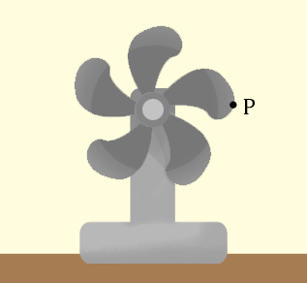
  - 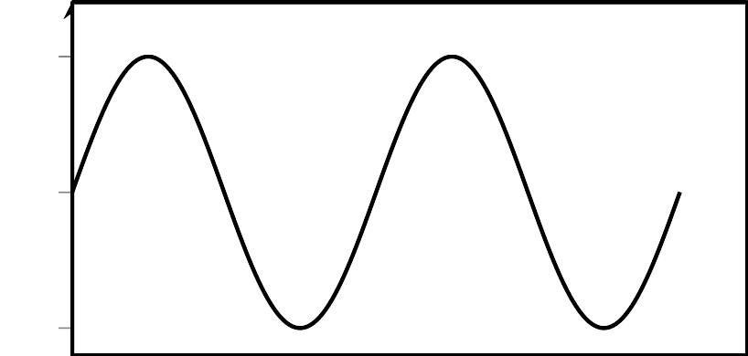
  - 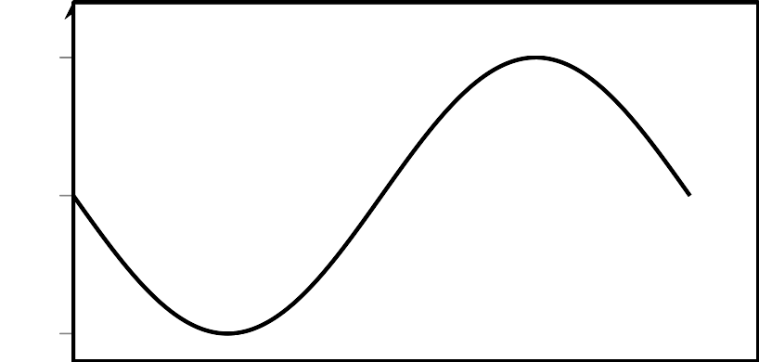
  - 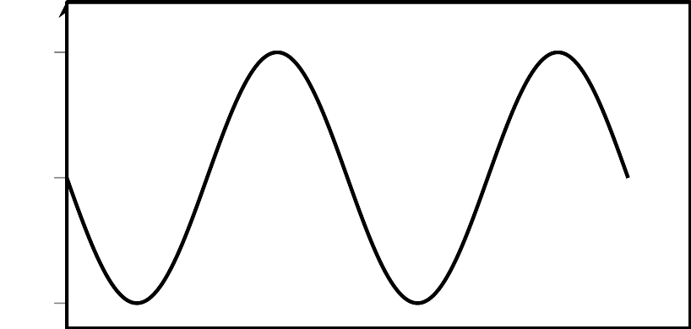
  - 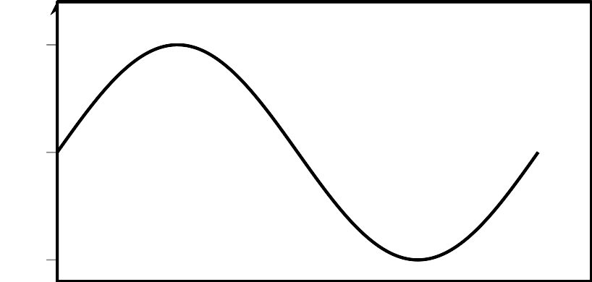
- Which situations are modeled accurately by a periodic function? Select all that apply.
  - the distance from the earth to the sun as a function of time
  - the vertical height of a point on a rotating wheel as a function of time
  - the area of a sheet of paper as a function of the number of times it is folded in half
  - the number of centimeters in $x$ inches
  - the height of a swinging pendulum as a function of time
  - the height of a ball tossed in the air as a function of time
- Here is the graph of a function for some values of $x$.
  - Can you extend the graph to the whole plane so that the function $f$ is periodic? Explain your reasoning.
  - Can you extend the graph to the whole plane so that the function $f$ is not periodic? Explain your reasoning.
  - Can a non-constant linear function be periodic? Explain your reasoning.
  - Can a quadratic function be periodic? Explain your reasoning.
- Do $(7,1)$ and $(\text{-}5,5)$ lie on the same circle centered at $(0,0)$? Explain how you know.
- (From Unit 6, Lesson 1.)
- The measure of angle $θ$ is between 0 and $2π$ radians. Which statements must be true of $\text{sin}(θ)$ and $\text{cos}(θ)$? Select all that apply.
  - ${\text{cos}}^{2}(θ)+{\text{sin}}^{2}(θ)=1$
  - If $\text{sin}(θ)=0$, then $\text{cos}(θ)=1$.
  - If $\text{sin}(θ)=1$, then $\text{cos}(θ)=0$.
  - $\text{cos}(θ)+\text{sin}(θ)=1$.
  - The point $(\text{cos}(θ),\text{sin}(θ))$ lies on the unit circle.
- (From Unit 6, Lesson 5.)
- The center of a clock is the origin $(0,0)$ in a coordinate system. The hour hand is 4 units long. What are the coordinates of the end of the hour hand at:
  - 3:00
  - 8:00
  - 11:00
- (From Unit 6, Lesson 7.)
© CC BY 2019 by Illustrative Mathematics®

