Lesson 11 Practice Problems

  - Graph these points in the coordinate plane: $\left(\text{-}2,3\right)$, $\left(2,3\right)$, $\left(\text{-}2,\text{-}3\right)$, $\left(2,\text{-}3\right)$.
  - 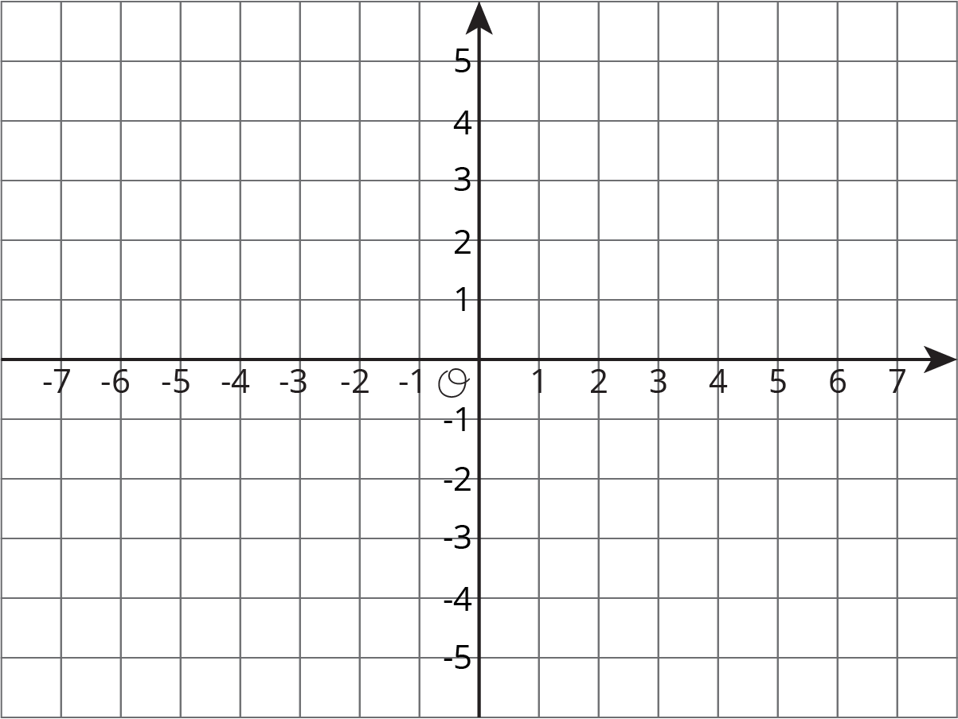
  - Connect all of the points. Describe the figure.
- Write the coordinates of each point.
- 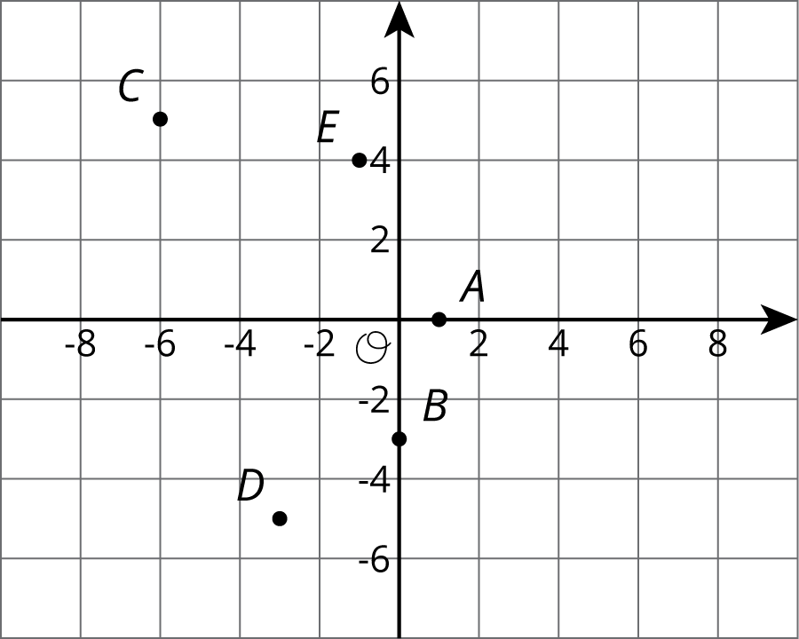
- These three points form a horizontal line: $\left(\text{-}3.5,4\right)$, $\left(0,4\right)$, and $\left(6.2,4\right)$. Name two additional points that fall on this line.
- One night, it is ${24}^{∘}\text{C}$ warmer in Tucson than it was in Minneapolis. If the temperatures in Tucson and Minneapolis are opposites, what is the temperature in Tucson?
  - $\text{-}{24}^{∘}\text{C}$
  - $\text{-}{12}^{∘}\text{C}$
  - ${12}^{∘}\text{C}$
  - ${24}^{∘}\text{C}$
- (From Unit 7, Lesson 2.)
- Lin ran 29 meters in 10 seconds. She ran at a constant speed.
  - How far did Lin run every second?
  - At this rate, how far can she run in 1 minute?
- (From Unit 2, Lesson 9.)
- Noah is helping his band sell boxes of chocolate to fund a field trip. Each box contains 20 bars and each bar sells for $1.50.
  - Complete the table for values of $m$.
- boxes sold $\left(b\right)$ | - money collected $\left(m\right)$
  - 1
  - 2
  - 3
  - 4
  - 5
  - 6
  - 7
  - 8
  - Write an equation for the amount of money, $m$, that will be collected if $b$ boxes of chocolate bars are sold. Which is the independent variable and which is the dependent variable in your equation?
  - Write an equation for the number of boxes, $b$, that were sold if $m$ dollars were collected. Which is the independent variable and which is the dependent variable in your equation?
- (From Unit 6, Lesson 16.)
© CC BY Open Up Resources. Adaptations CC BY IM.

