Lesson 6: Ubiquemos fracciones unitarias en la recta numérica

Standards Alignments
Addressing | 3.NF.A.2, 3.NF.A.2.a

Teacher-facing Learning Goals
- Partition the interval from 0 to 1 and locate unit fractions within that interval.

Student-facing Learning Goals
- Partamos la recta numérica para ubicar fracciones unitarias.

Lesson Purpose
The purpose of this lesson is for students to partition the interval from 0 to 1and locate unit fractions within that interval.
In previous lessons, students made sense of number lines that were partitioned into fractions. While this lesson focuses on partitioning and locating unit fractions within the interval from 0 to 1, the number lines in this lesson vary in length. This allows students to consider common misconceptions about partitioning the number line into fractional parts, such as partitioning the whole number line rather than each unit interval, such as from 0 to 1, 1 to 2, and so on, and counting tick marks rather than parts of the interval.
As students partition number lines in the rest of this unit, the most important thing is that they are accurate in relatively locating fractions on the number line and they understand the partitions should be equally spaced (MP6). It is not necessary that they locate fractions exactly or be overly concerned with making sure partitions are exactly the same size.

Access for:

Students with Disabilities
- Engagement (Activity 2)

English Learners
- MLR8 (Activity 2)

Instructional Routines
Which One Doesn’t Belong? (Warm-up)

Lesson Timeline
Warm-up | 10 min
Activity 1 | 15 min
Activity 2 | 20 min
Lesson Synthesis | 10 min
Cool-down | 5 min

Teacher Reflection Question
How did you see or hear students leverage their prior experiences with fractions to place fractions on the number line?

Cool-down
(to be completed at the end of the lesson) 5min
Ubica y marca

Standards Alignments
Addressing | 3.NF.A.2.a

Student-facing Task Statement
Ubica y marca $\frac{1}{8}$ en la recta numérica. Explica tu razonamiento.

Student Responses
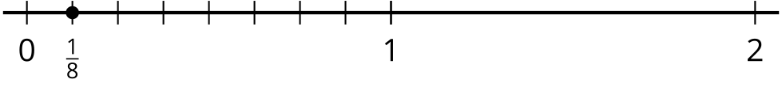
I know that 8 one-eighths are in 1, so I partitioned the number line from 0 to 1 into 8 equal parts and labeled the end of the first eighth.

