Lesson 1: What We Know About Shapes
- Let’s find and talk about shapes.

Warm-up: Which One Doesn’t Belong: Teddy Bears
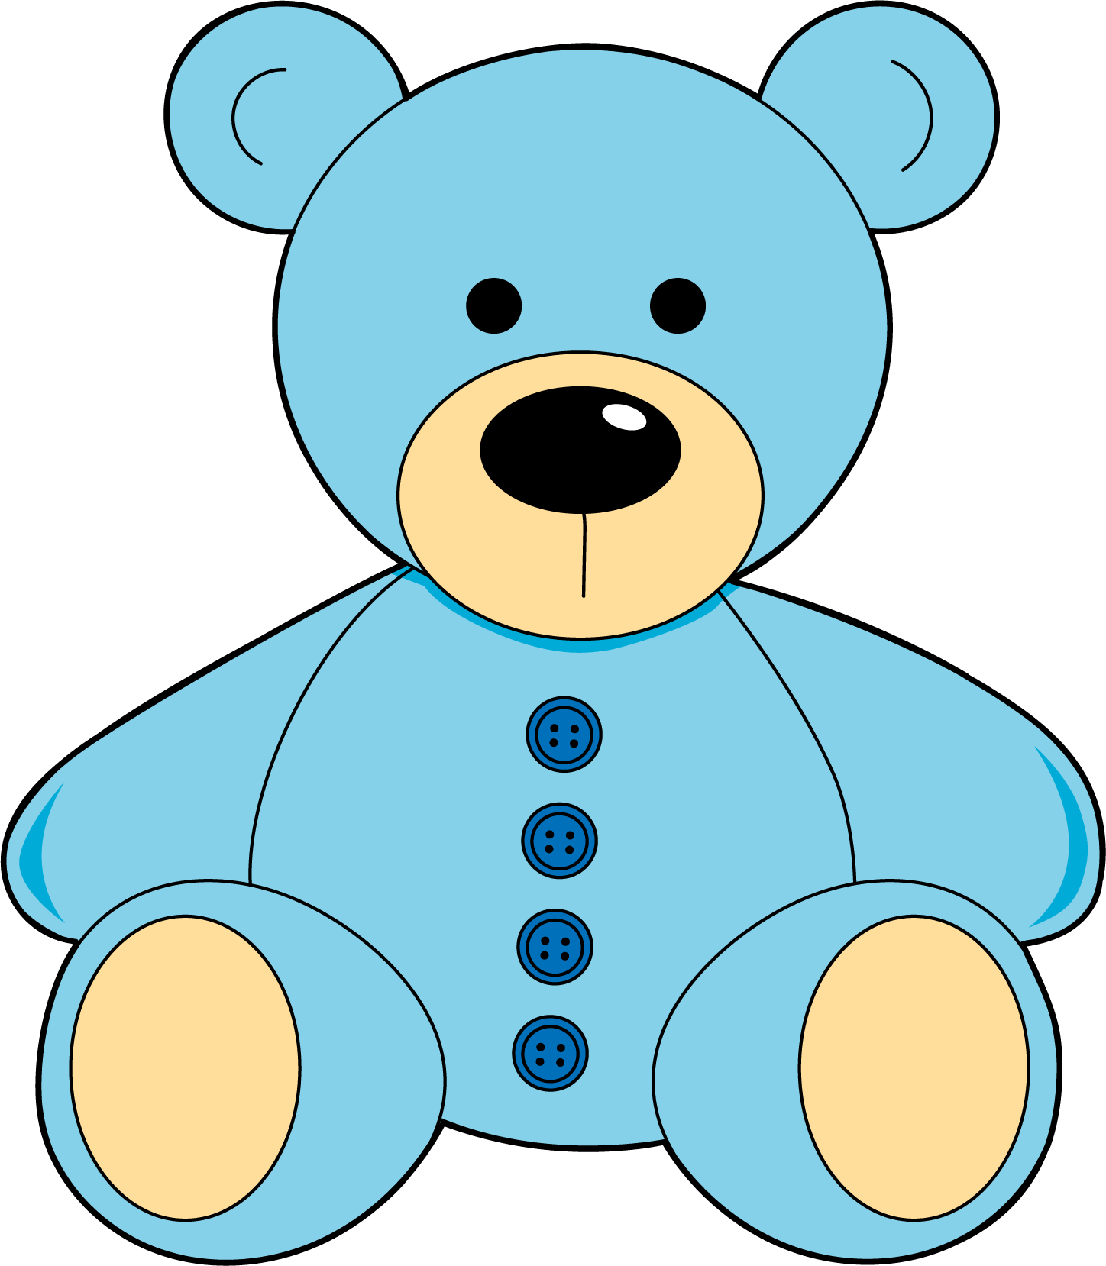
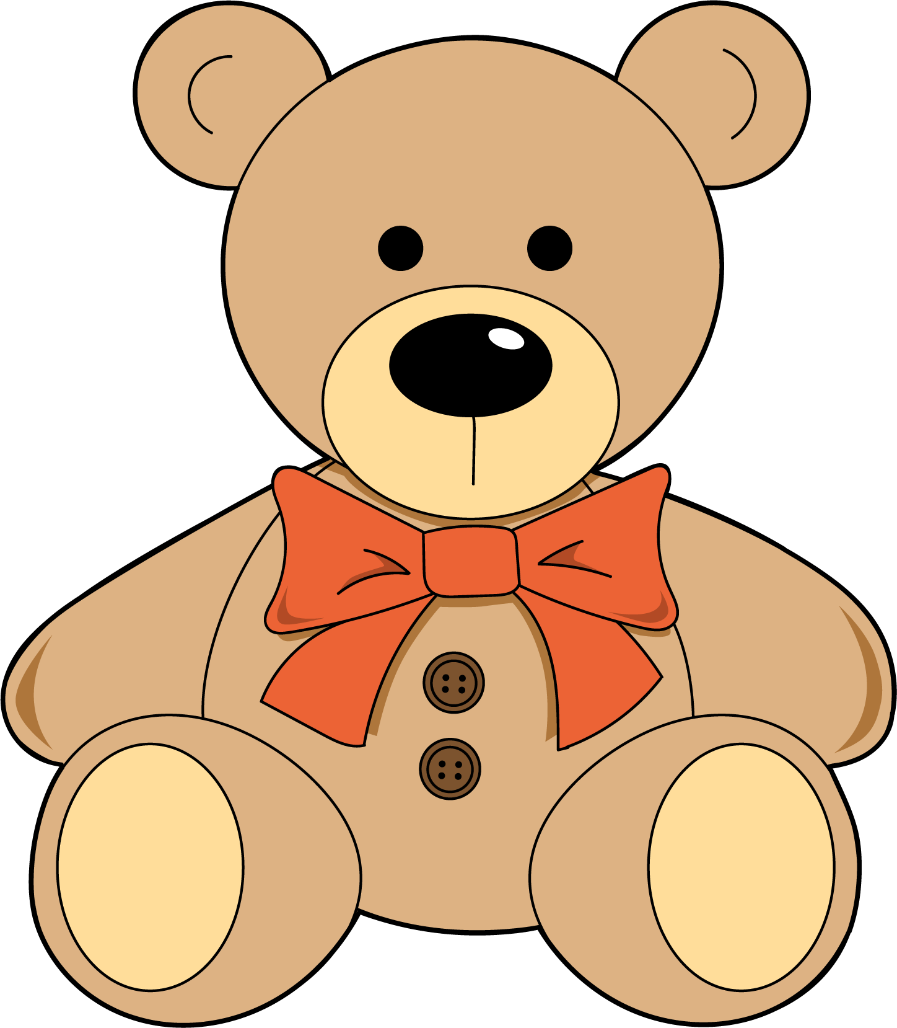
Which one doesn’t belong?
A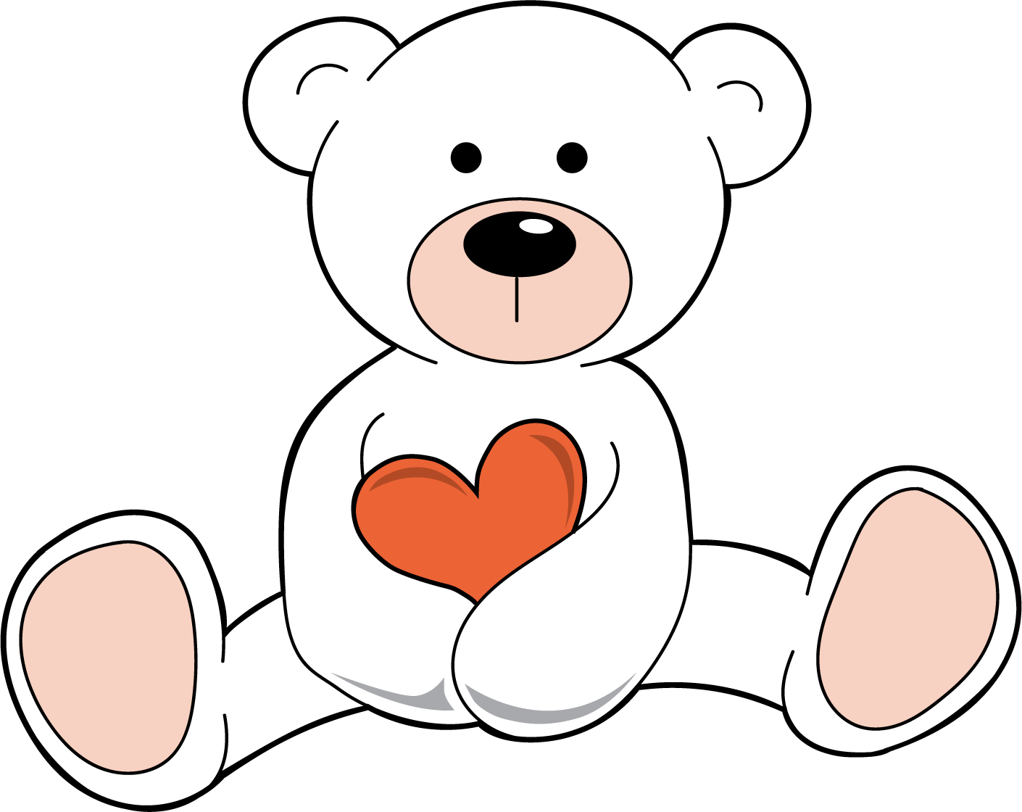
B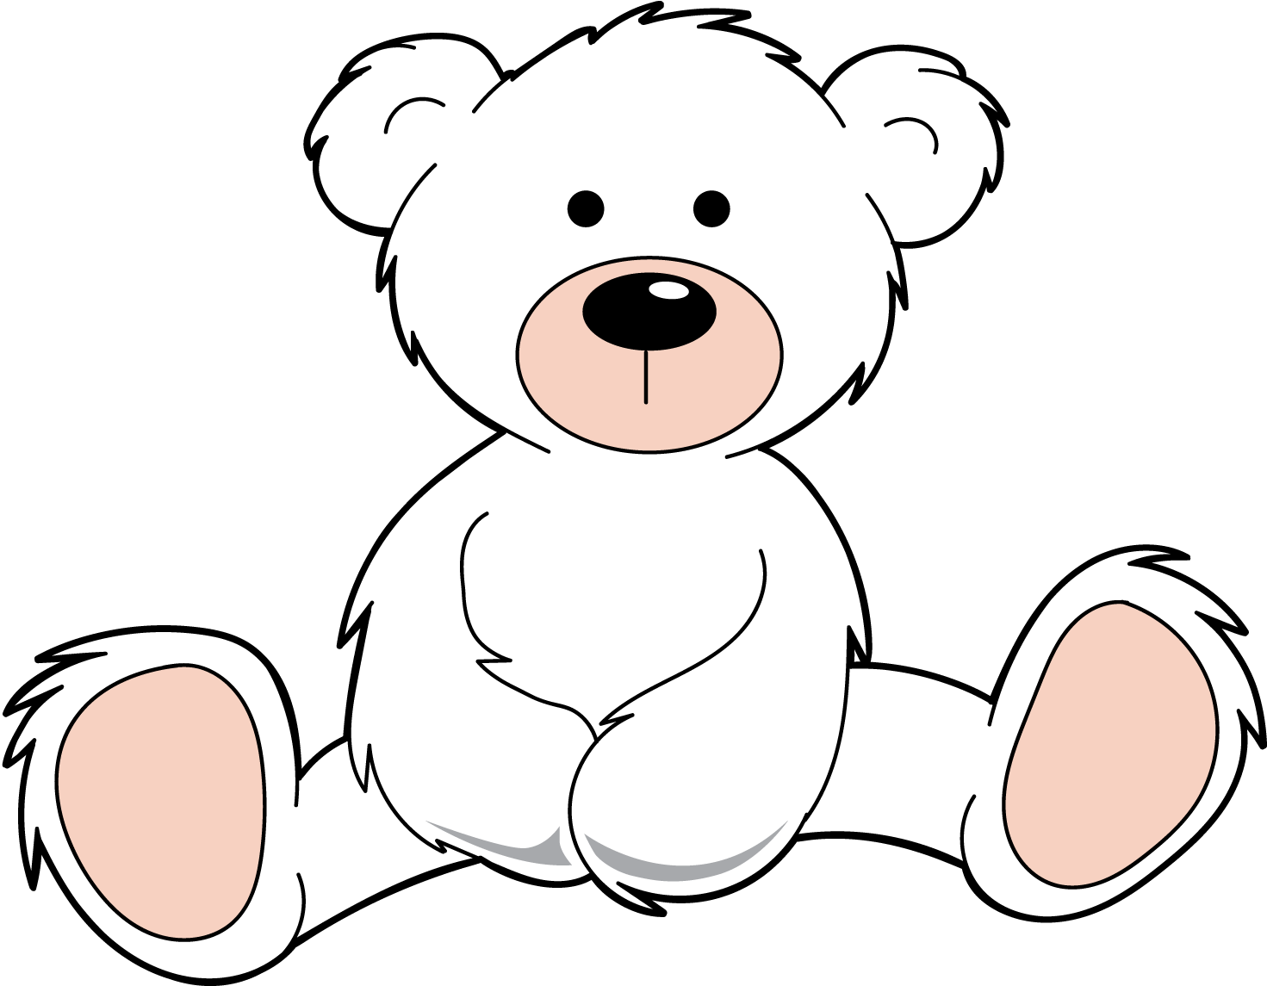
C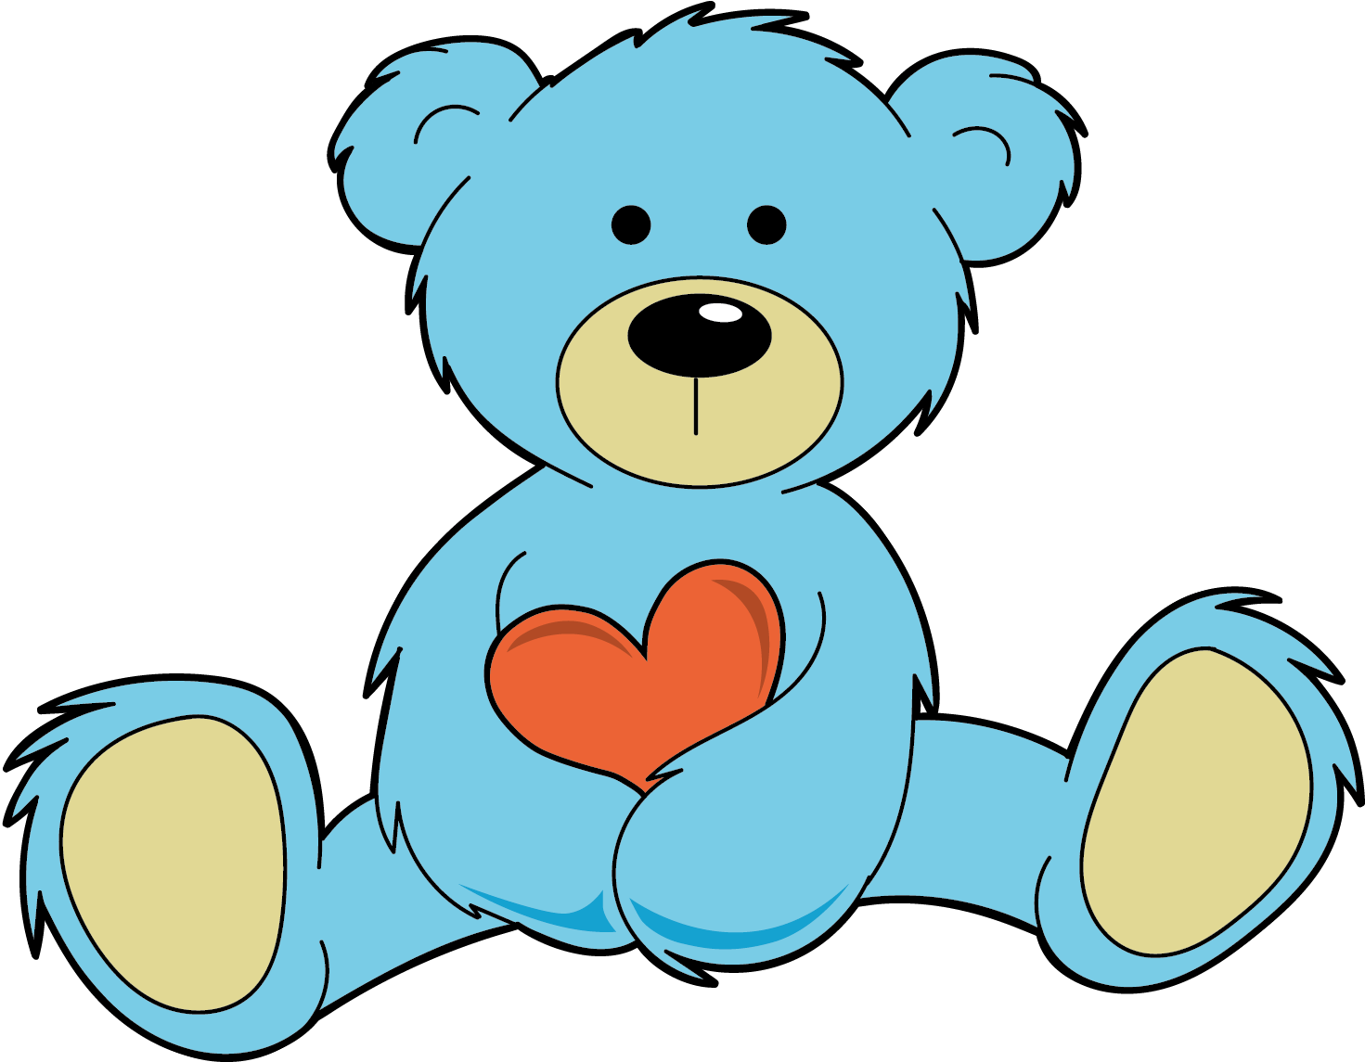

1.2: Shapes in a Picture
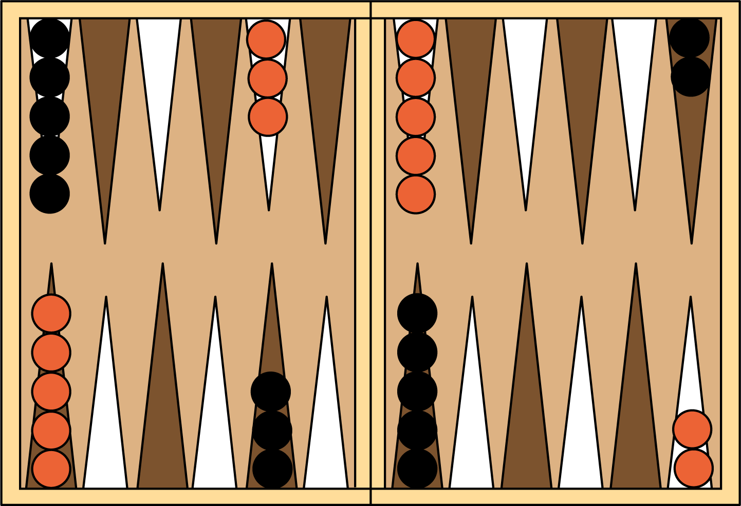

1.3: Centers: Choice Time
Choose a center.
Picture Books
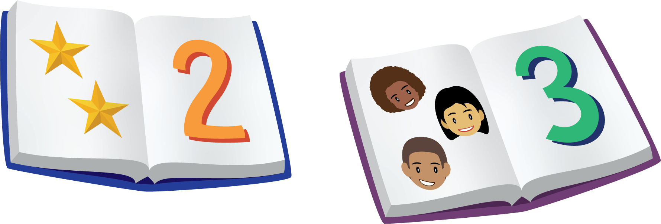
Bingo
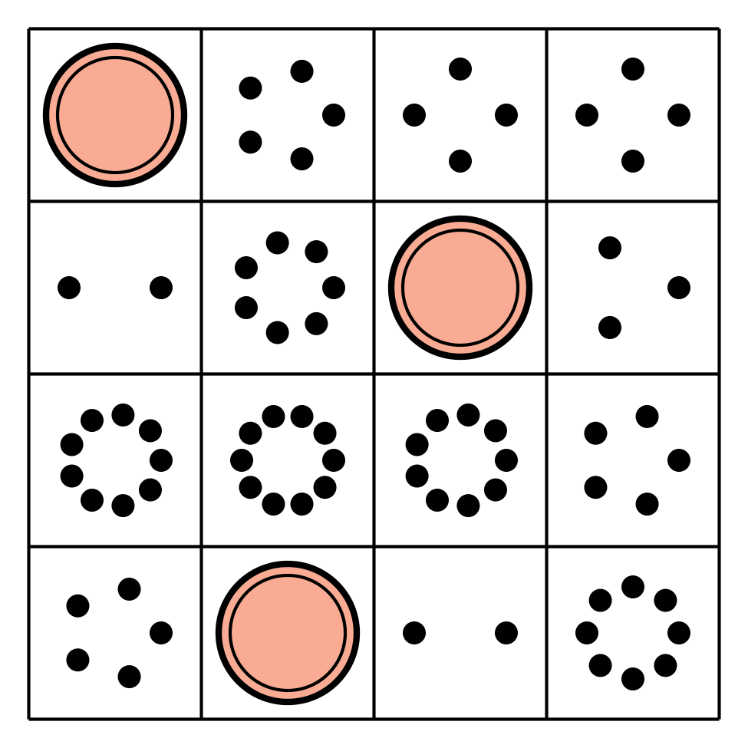
Shake and Spill
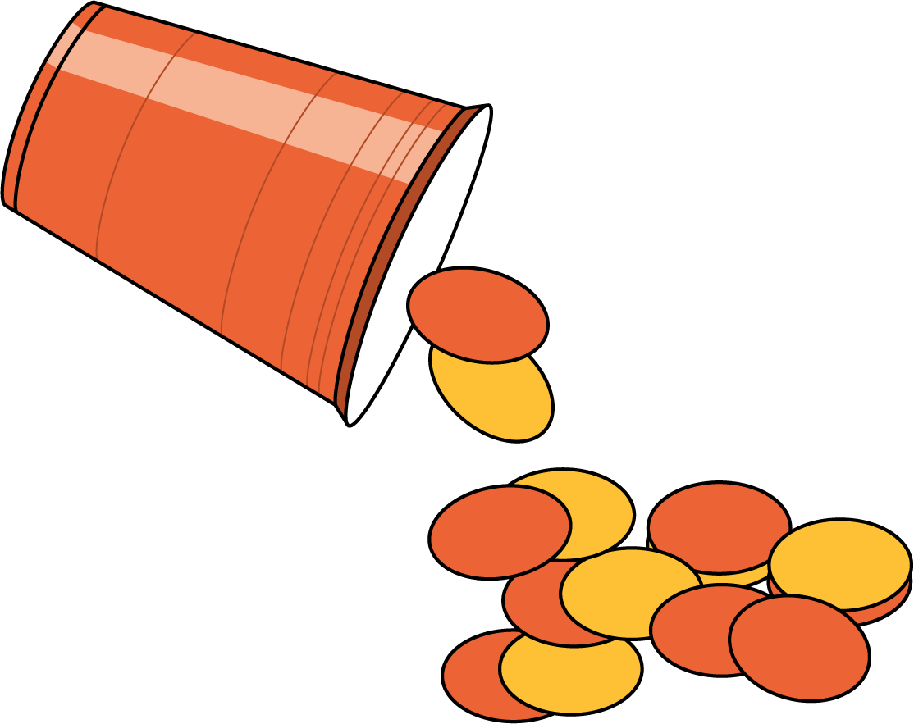
© CC BY 2021 Illustrative Mathematics®

