Unit 3 Lesson 8 Cumulative Practice Problems
- Select all the equations that have graphs with the same $y$-intercept.
  - $y=3x−8$
  - $y=3x−9$
  - $y=3x+8$
  - $y=5x−8$
  - $y=2x−8$
  - $y=\frac{1}{3}x−8$
- Create a graph showing the equations $y=\frac{1}{4}x$ and $y=\frac{1}{4}x−5$. Explain how the graphs are the same and how they are different.
- A cable company charges $70 per month for cable service to existing customers.
  - Find a linear equation representing the relationship between $x$, the number of months of service, and $y$, the total amount paid in dollars by an existing customer.
  - For new customers, there is an additional one-time $100 service fee. Repeat the previous problem for new customers.
  - When the two equations are graphed in the coordinate plane, how are they related to each other geometrically?
- A mountain road is 5 miles long and gains elevation at a constant rate. After 2 miles, the elevation is 5500 feet above sea level. After 4 miles, the elevation is 6200 feet above sea level.
  - Find the elevation of the road at the point where the road begins.
  - Describe where you would see the point in part (a) on a graph where $y$ represents the elevation in feet and $x$ represents the distance along the road in miles.
- (From Unit 3, Lesson 6.)
- Match each graph to a situation.
- 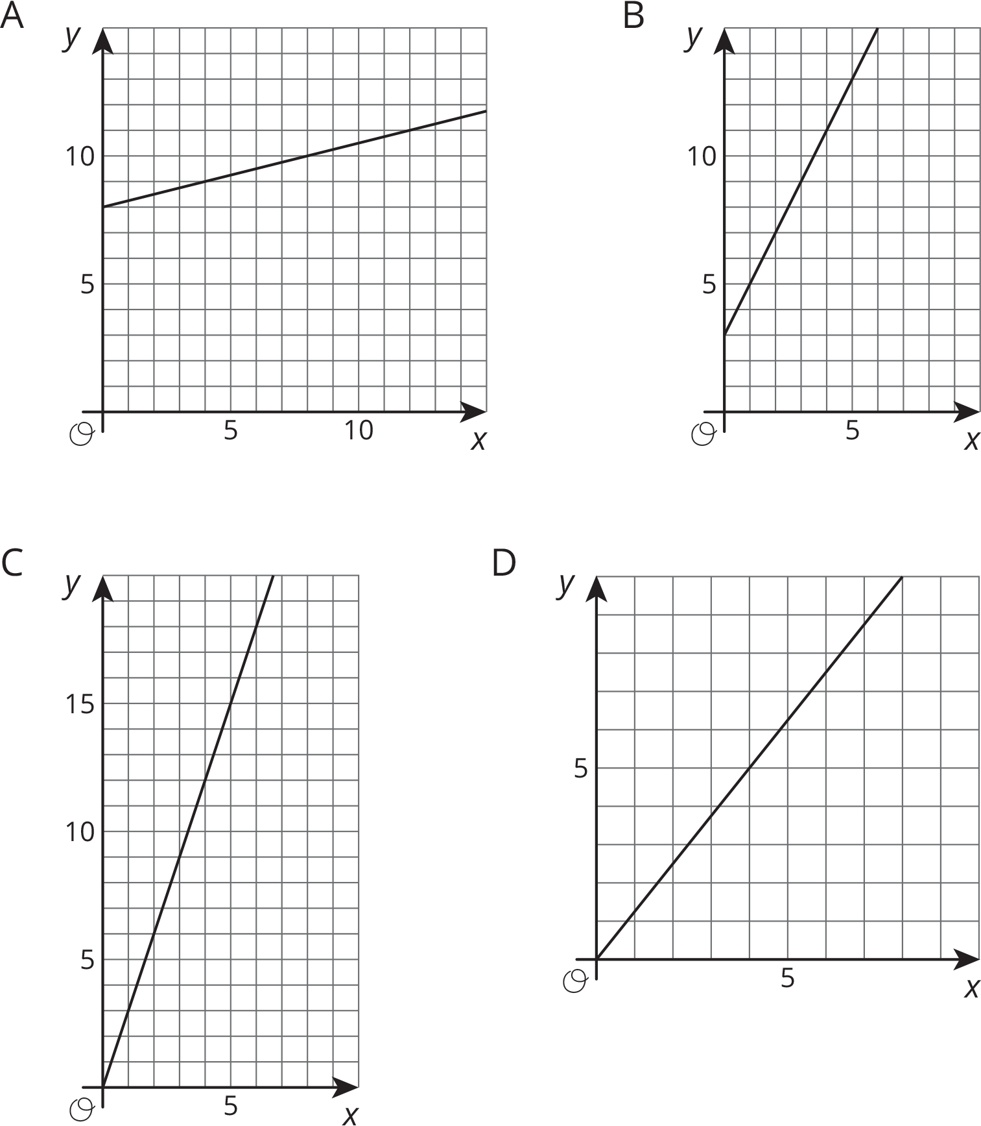
  - Graph A
  - Graph B
  - Graph C
  - Graph D
  - The graph represents the perimeter, $y$, in units, for an equilateral triangle with side length of $x$ units. The slope of the line is 3.
  - The amount of money, $y$, in a cash box after $x$ tickets are purchased for carnival games. The slope of the line is $\frac{1}{4}$.
  - The number of chapters read, $y$, after $x$ days. The slope of the line is $\frac{5}{4}$.
  - The graph shows the cost in dollars, $y$, of a muffin delivery and the number of muffins, $x$, ordered. The slope of the line is 2.
- (From Unit 3, Lesson 6.)
© CC BY Open Up Resources. Adaptations CC BY IM.

