Unit 6 Lesson 1: Identify and Sort Shapes

WU Notice and Wonder: Groups of Shapes (Warm up)

Student Task Statement
What do you notice? What do you wonder?
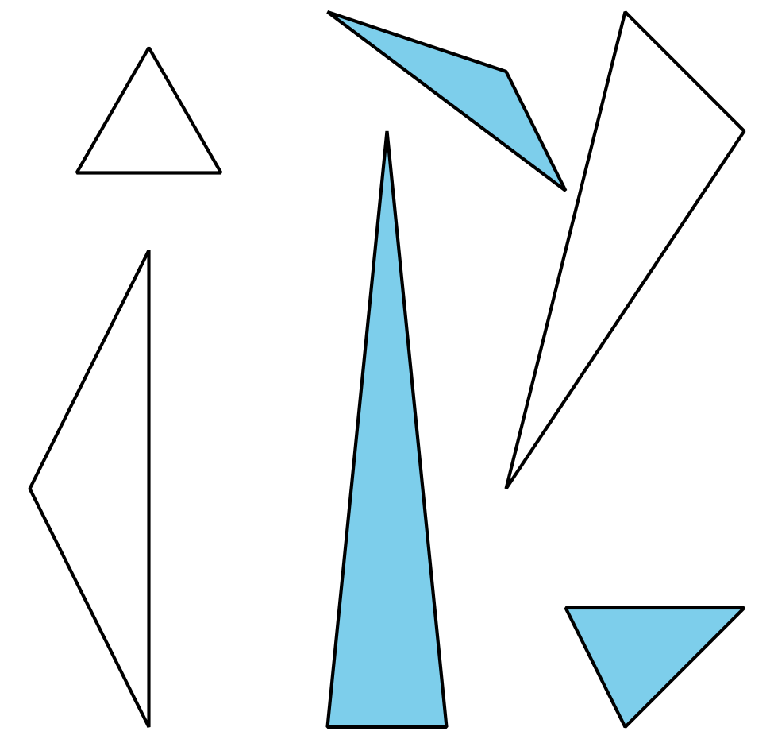
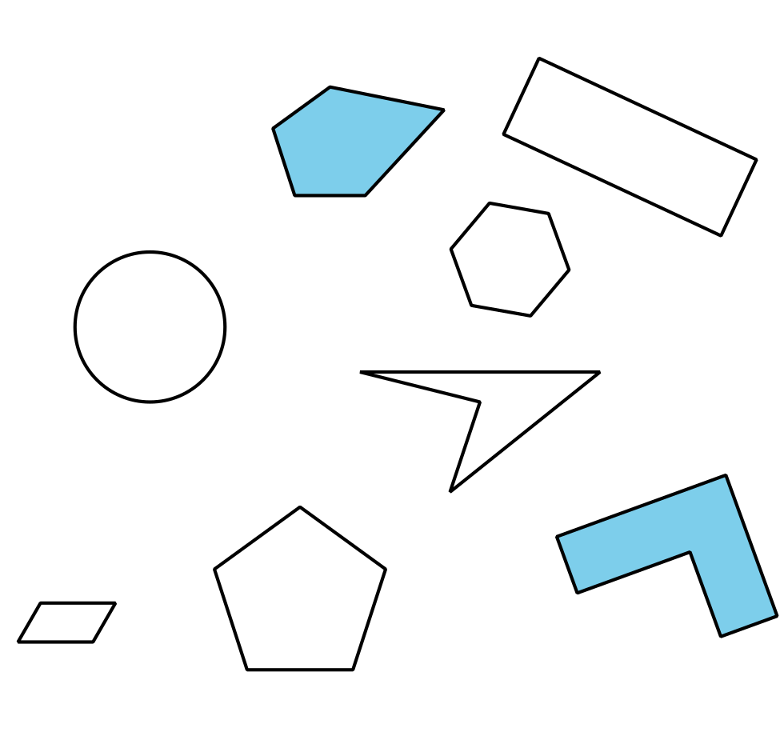

1 Card Sort: Shapes

Student Task Statement
Sort the shapes into categories in a way that makes sense to you. Be prepared to explain how you sorted the shapes.

2 Penta-what?

Student Task Statement
Gather clues to find out what kind of shapes belong in each of these categories.
triangle
pentagon
hexagon
quadrilateral
- Ask the teacher whether a shape card belongs with one of these categories.
- Use this question frame:
- Is Shape _______ a ______________________________?
- Use the clues you gathered to make a true statement.
- Shape _______ is a ______________________________ because it has
- Would these shapes belong to any of these categories? Explain.
- A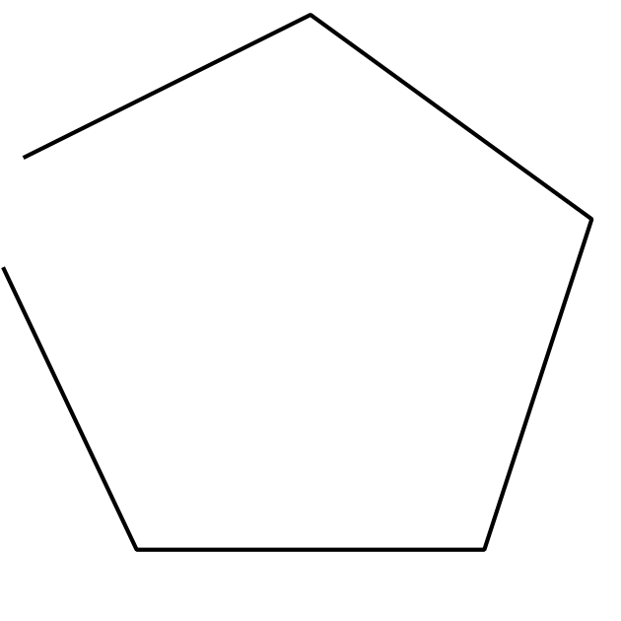
- B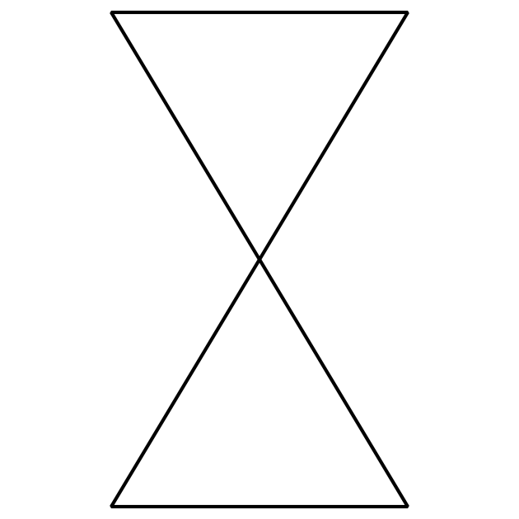
- C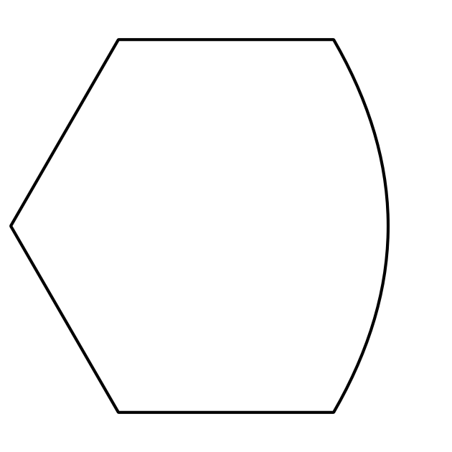

3 Compare Shapes

Student Task Statement
Pick 1 shape card.
Be prepared to name and describe your shape to a partner.

Images for Activity Synthesis
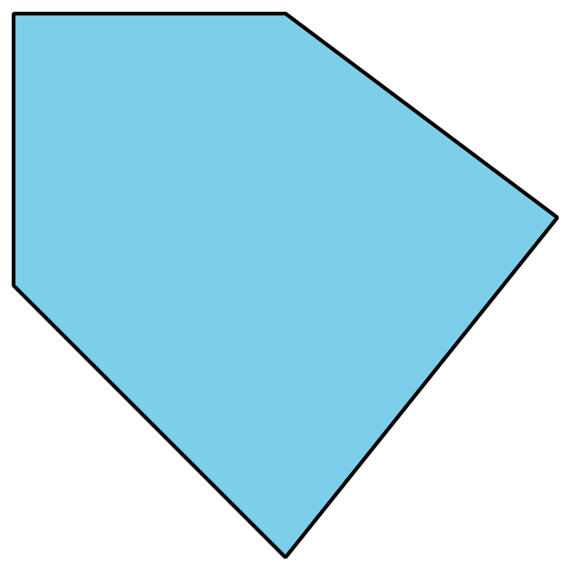
© CC BY 2021 Illustrative Mathematics®

