Lesson 2: Measure in Fourths of an Inch
- Let’s measure lengths in quarters of an inch.

Warm-up: Estimation Exploration: Measure in Inches
What is the length of the paper clip?
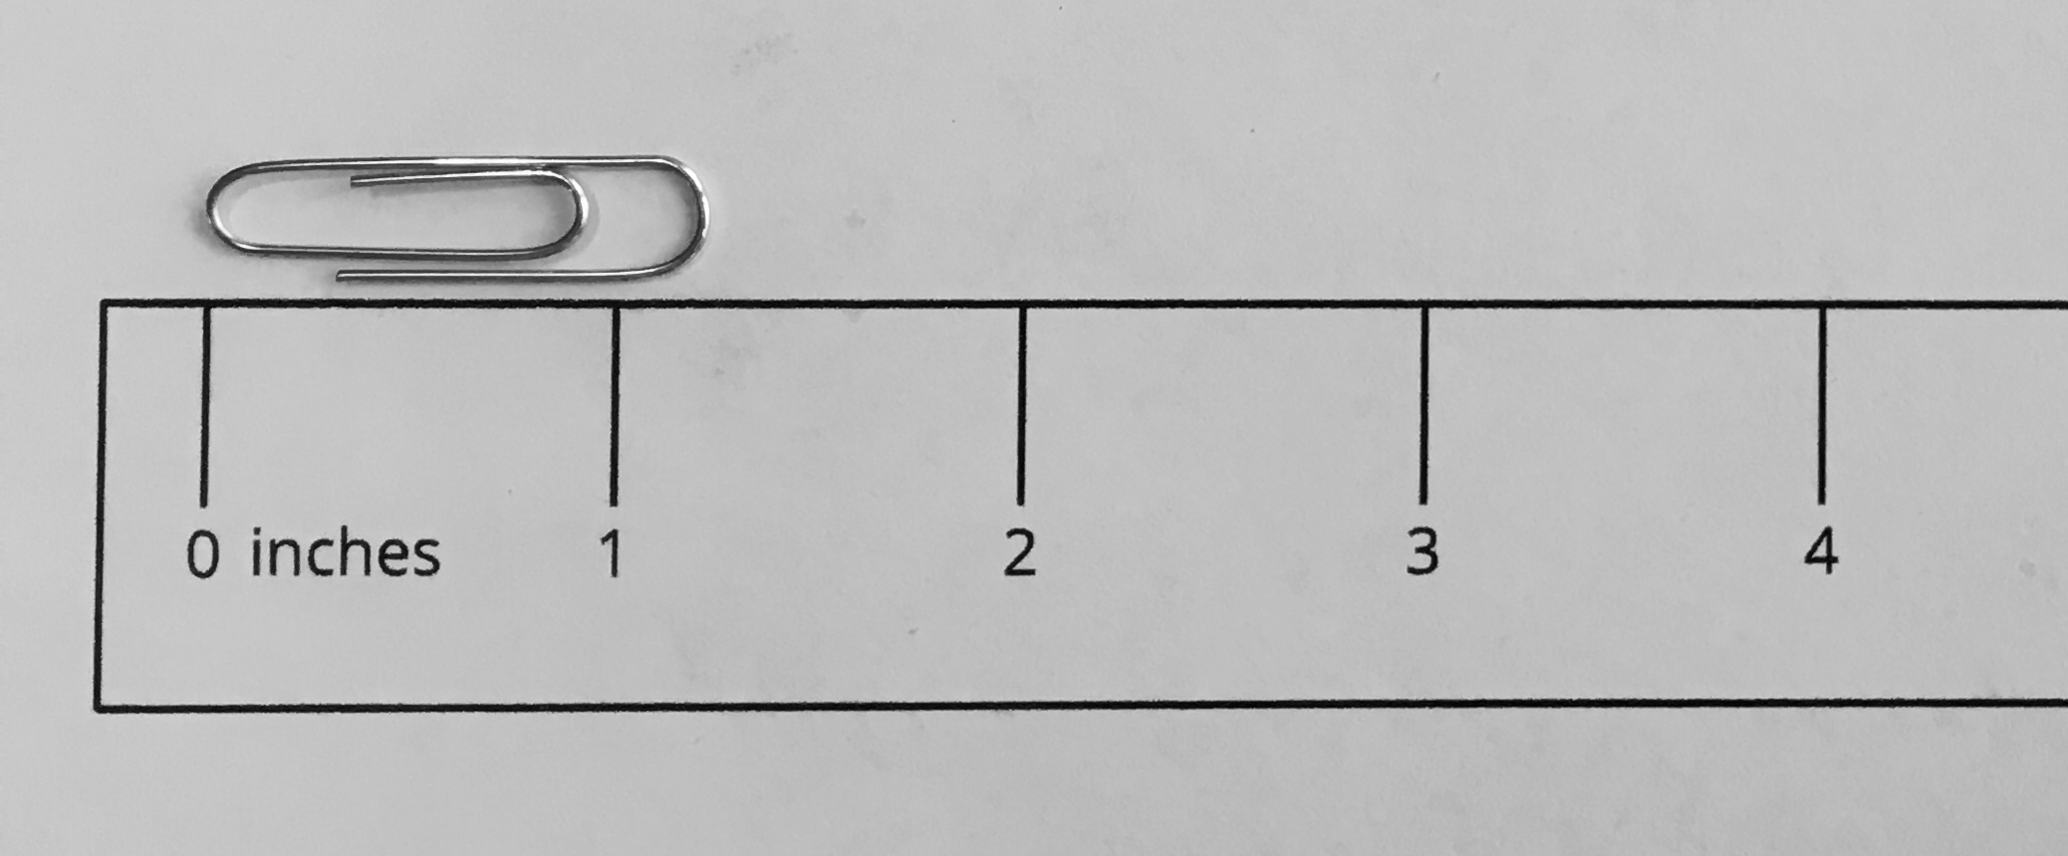
Record an estimate that is:
too low | just right | too high

2.1: Partition Inches into Fourths
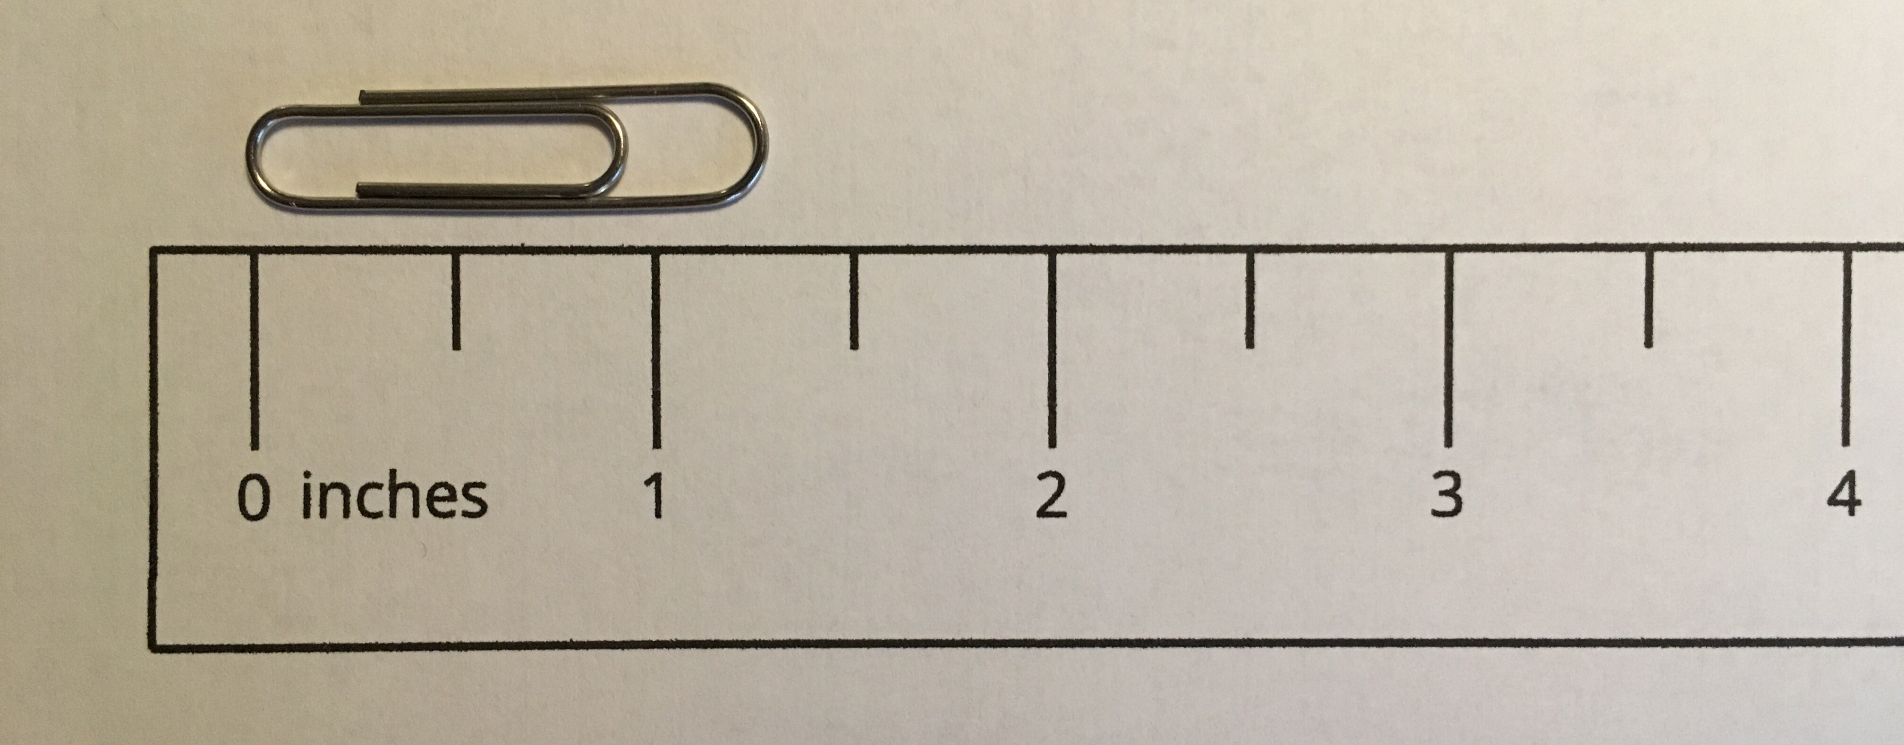
You will need the ruler that was not partitioned in an earlier activity.
- With your partner, partition the ruler to show fourths of an inch.
- Take turns using this ruler to measure the length of 4 objects around the room.
object | length

2.2: Find Some Lengths
You will need the rulers you partitioned for this activity.
With your partner:
- Find at least 4 objects in the classroom that have the lengths shown in the table.
- Practice saying each measurement.
- Record the object in the table. If you find an object that is a whole number plus a fraction of an inch, write the exact measurement.
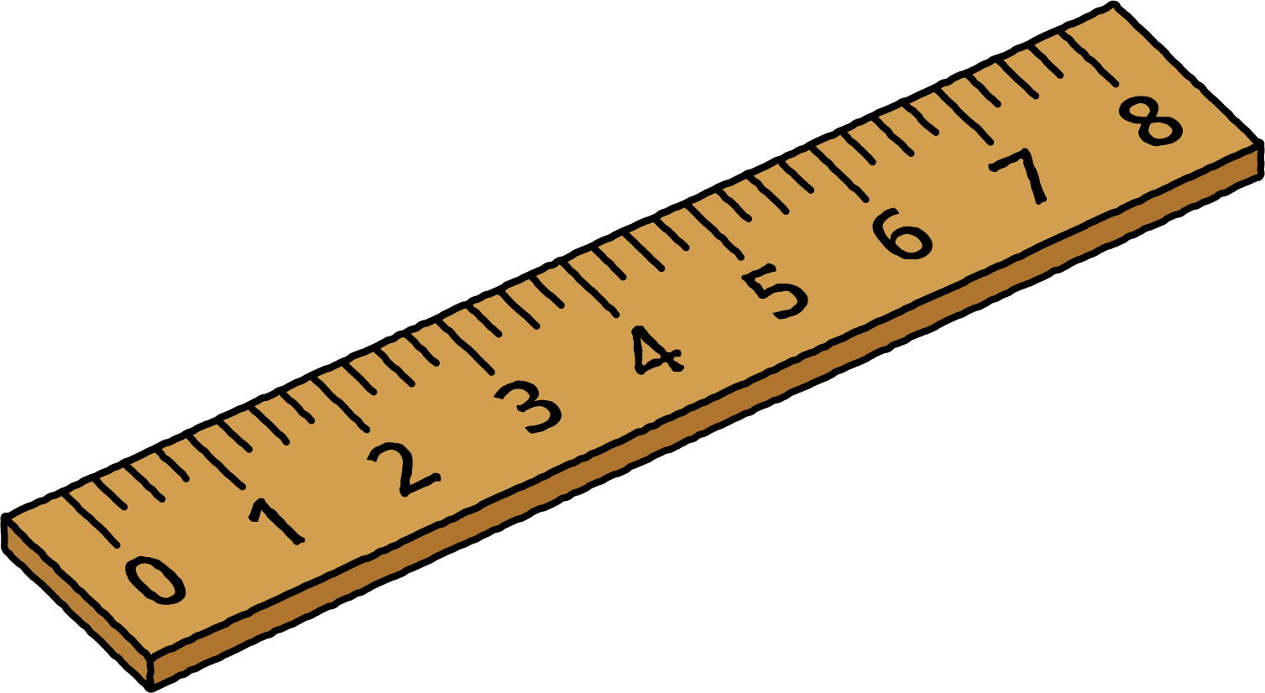
object | length
 | $2\frac{1}{2}$ inches
 | $1\frac{1}{4}$ inches
 | $3\frac{3}{4}$ inches
 | $8\frac{1}{2}$ inches
 | a whole number of inches
 | a whole number and $\frac{1}{4}$ inches
 | a whole number and $\frac{2}{4}$ inches
 | a whole number and $\frac{3}{4}$ inches
© CC BY 2021 Illustrative Mathematics®

