Unit 5 Lesson 1 Cumulative Practice Problems
- Priya jogs at a constant speed. The relationship between her distance and time is shown on the graph. Diego bikes at a constant speed twice as fast as Priya. Sketch a graph showing the relationship between Diego’s distance and time.
- 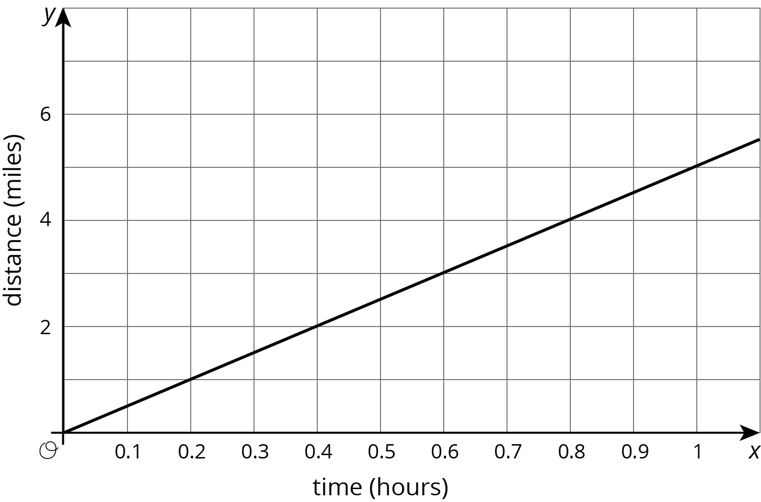
- A you-pick blueberry farm offers 6 lbs of blueberries for $16.50.
- Sketch a graph of the relationship between cost and pounds of blueberries.
- 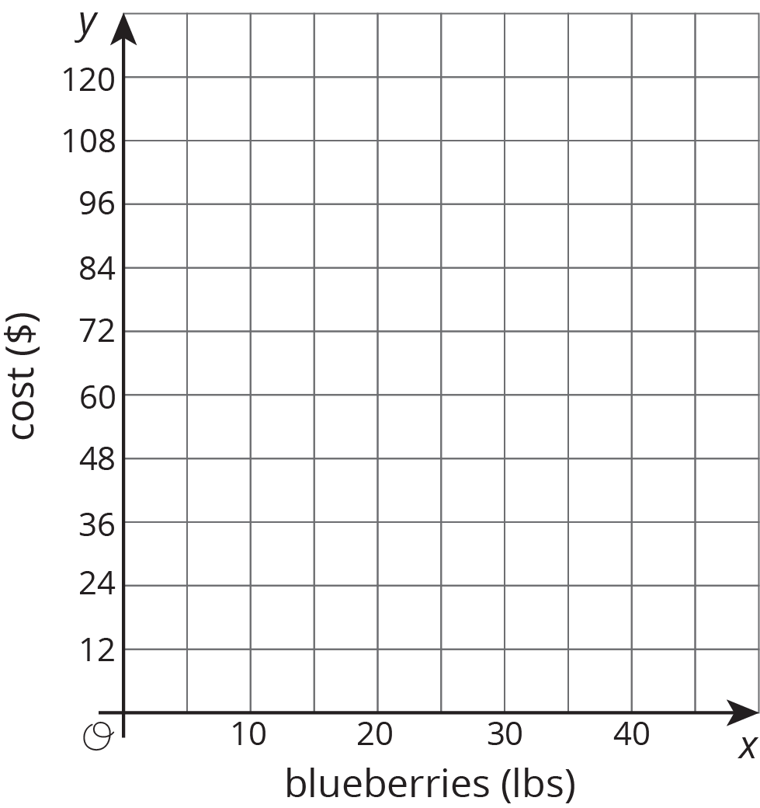
- A line contains the points $(\text{-}4,1)$ and $(4,6)$. Decide whether or not each of these points is also on the line:
  - $(0,3.5)$
  - $(12,11)$
  - $(80,50)$
  - $(\text{-}1,2.875)$
- (From Unit 2, Lesson 17.)
- Select all the inequalities that have the same solutions as $\text{-}4x<20$.
  - $\text{-}x<5$
  - $4x>\text{-}20$
  - \(4x
  - $x<\text{-}5$
  - $x>5$
  - $x>\text{-}5$
- (From Unit 4, Lesson 3.)
© CC BY Open Up Resources. Adaptations CC BY IM.

