Teacher Presentation Materials

Unit 6 Lesson 12: Meaning of Exponents

1 Notice and Wonder: Dots and Lines (Warm up)

Student Task Statement
What do you notice? What do you wonder?
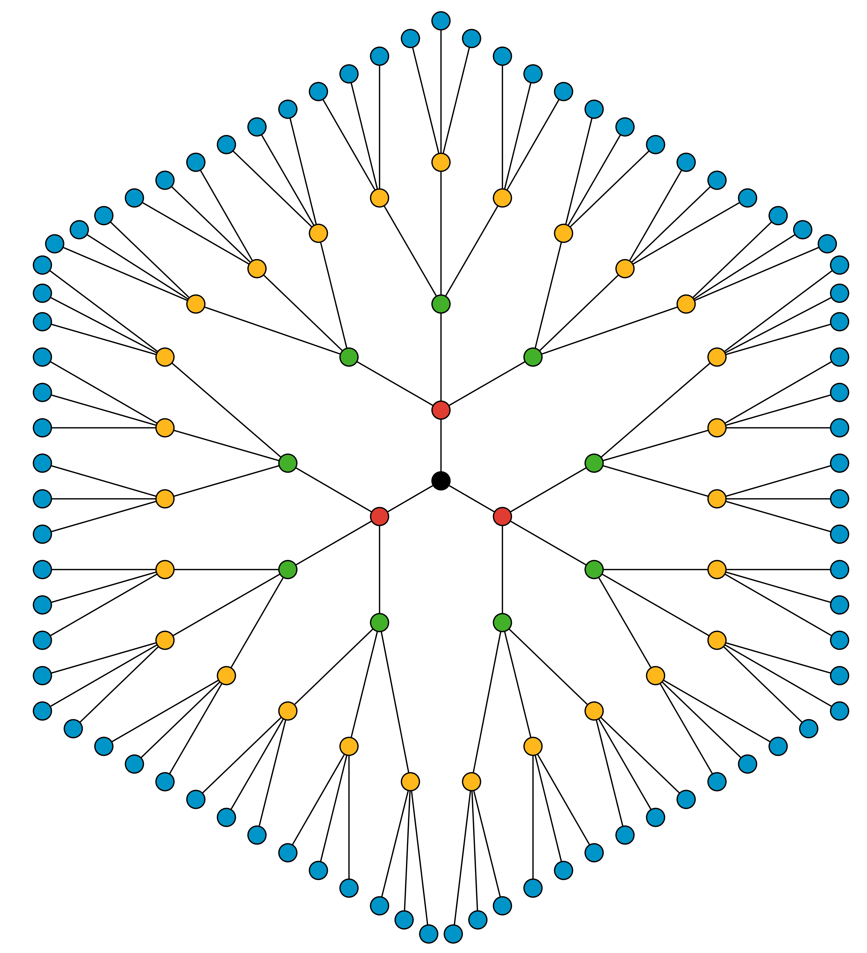

2 The Genie’s Offer

Student Task Statement
You find a brass bottle that looks really old. When you rub some dirt off of the bottle, a genie appears! The genie offers you a reward. You must choose one:
$50,000 or a magical $1 coin.
The coin will turn into two coins on the first day. The two coins will turn into four coins on the second day. The four coins will double to 8 coins on the third day. The genie explains the doubling will continue for 28 days.
- The number of coins on the third day will be $2⋅2⋅2$. Write an equivalent expression using exponents.
- What do $2^{5}$ and $2^{6}$ represent in this situation? Evaluate $2^{5}$ and $2^{6}$ without a calculator. Pause for discussion.
- How many days would it take for the number of magical coins to exceed $50,000?
- Will the value of the magical coins exceed a million dollars within the 28 days? Explain or show your reasoning.

3 Make 81

Student Task Statement
- Here are some expressions. All but one of them equals 16. Find the one that is not equal to 16 and explain how you know.
- $2^{3}⋅2$
- $4^{2}$
- $\frac{2^{5}}{2}$
- $8^{2}$
- Write three expressions containing exponents so that each expression equals 81.
© CC BY Open Up Resources. Adaptations CC BY IM.

