Lesson 13 Practice Problems
- Here are 2 polygons:
- Select all sequences of translations, rotations, and reflections below that would take polygon $P$ to polygon $Q$.
- 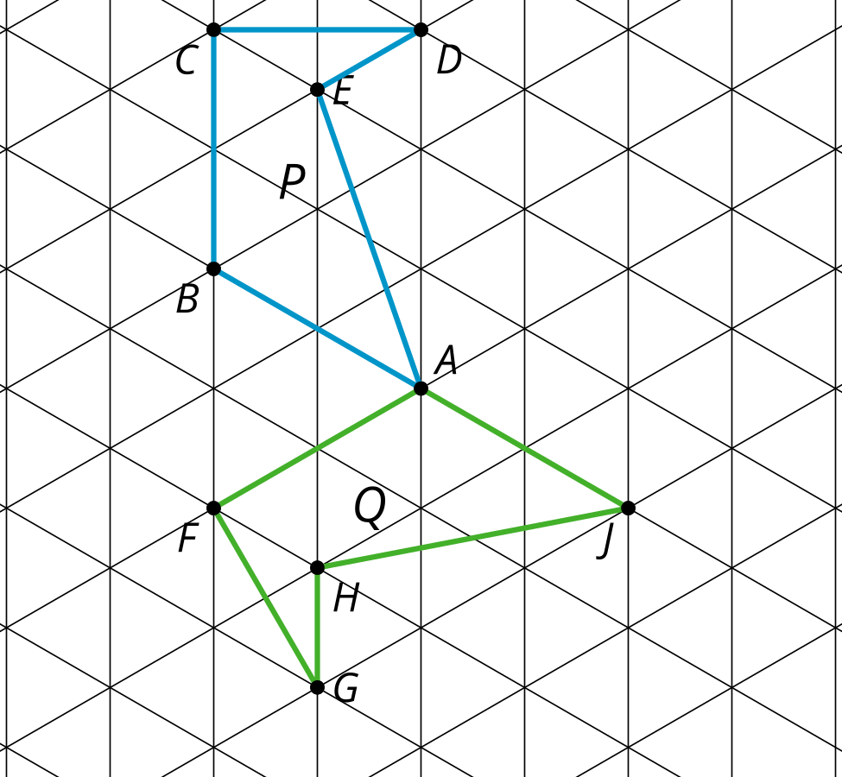
  - Rotate ${180}^{∘}$ around point $A$.
  - Rotate ${60}^{∘}$ counterclockwise around point $A$ and then reflect over the line $FA$.
  - Translate so that $A$ is taken to $J$. Then reflect over line $BA$.
  - Reflect over line $BA$ and then translate by directed line segment $BA$.
  - Reflect over the line $BA$ and then rotate ${60}^{∘}$ counterclockwise around point $A$.
- The semaphore alphabet is a way to use flags to signal messages. Here's how to signal the letter Q. Describe a transformation that would take the left hand flag to the right hand flag.

- Q
- 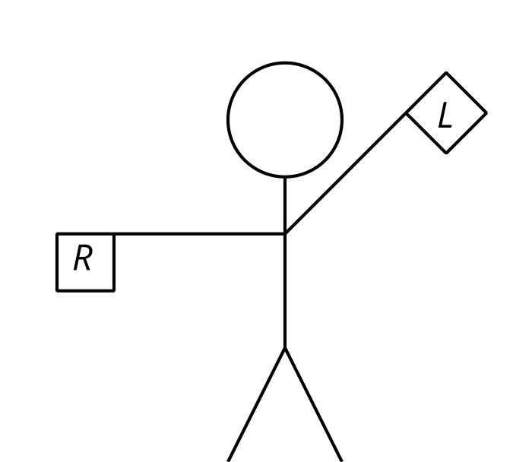

- Match the directed line segment with the image of Polygon $P$ being transformed to Polygon $Q$ by translation by that directed line segment.

- Translation 1
- 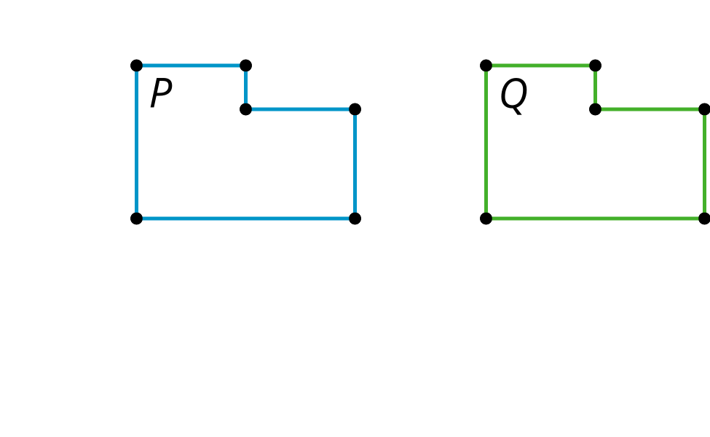

- Translation 2
- 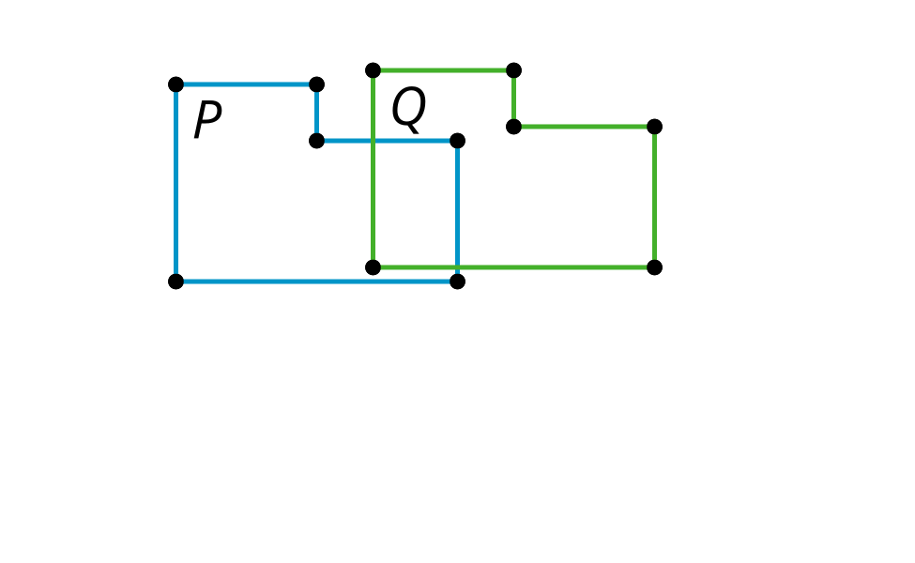

- Translation 3
- 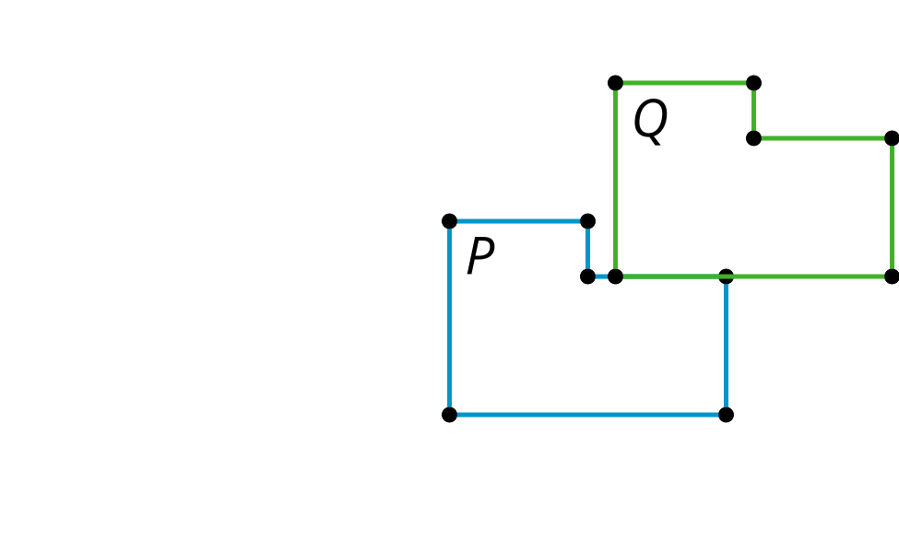

- Translation 4
- 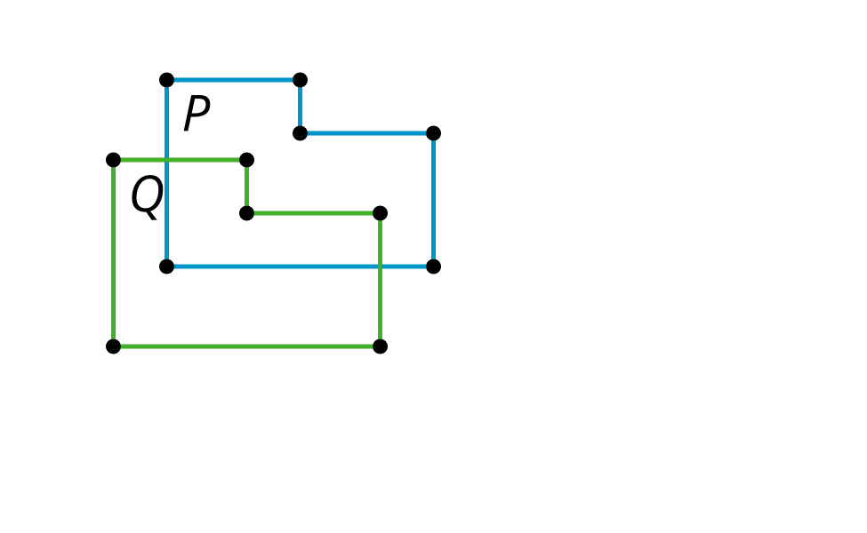
  - Translation 1
  - Translation 2
  - Translation 3
  - Translation 4
- (From Unit 1, Lesson 12.)
- Draw the image of quadrilateral $ABCD$ when translated by the directed line segment $v$. Label the image of $A$ as $A^{′}$, the image of $B$ as $B^{′}$, the image of $C$ as $C^{′}$, and the image of $D$ as $D^{′}$.
- 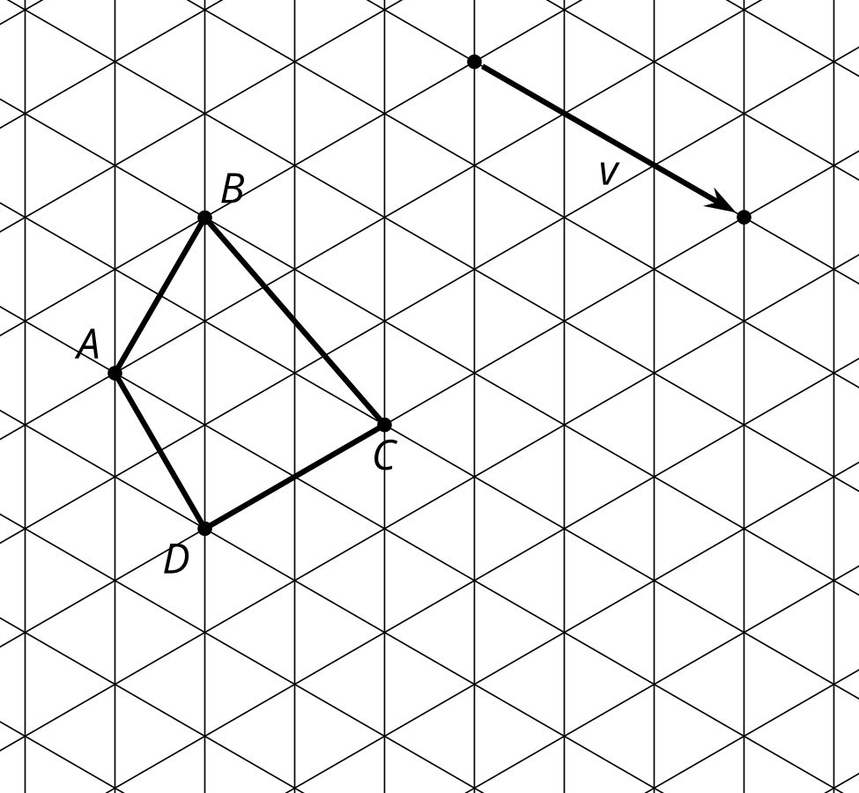
- (From Unit 1, Lesson 12.)
- Here is a line $ℓ$.
- Plot 2 points, $A$ and $B$, which stay in the same place when they are reflected over $ℓ$. Plot 2 other points, $C$ and $D$, which move when they are reflected over $ℓ$.
- (From Unit 1, Lesson 11.)
- Here are 3 points in the plane. Select all the straightedge and compass constructions needed to locate the point that is the same distance from all 3 points.
- 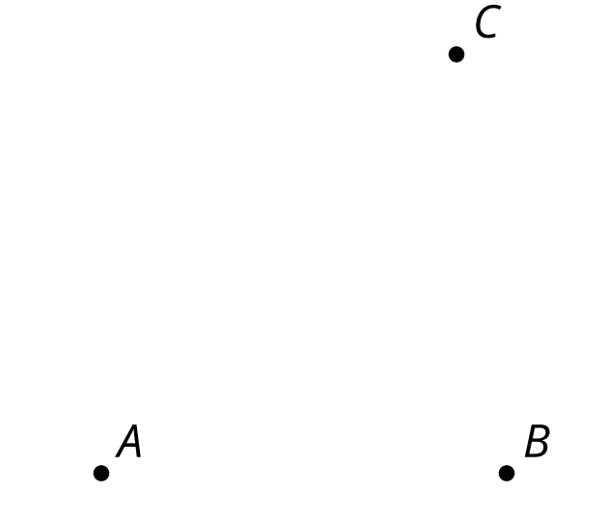
  - Construct the bisector of angle $CAB$.
  - Construct the bisector of angle $CBA$.
  - Construct the perpendicular bisector of $BC$.
  - Construct the perpendicular bisector of $AB$.
  - Construct a line perpendicular to $AB$ through point $C$.
  - Construct a line perpendicular to $BC$ through point $A$.
- (From Unit 1, Lesson 9.)
- This straightedge and compass construction shows quadrilateral $ABCD$. Is $ABCD$ a rhombus? Explain how you know.
- 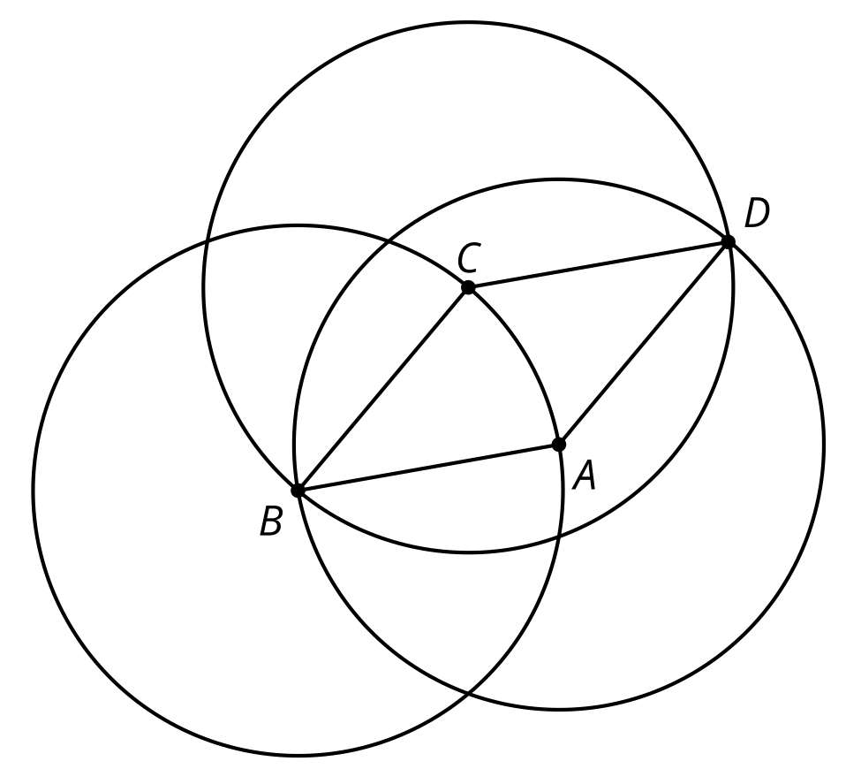
- (From Unit 1, Lesson 7.)
© CC BY 2019 by Illustrative Mathematics®

