Lesson 10 Practice Problems
- Draw a rough sketch of the graph of $g(x)=(x−3)(x+1)(7x−2)$.
- Draw a rough sketch of the graph of $f(x)=(x+1)^{2}(x−4)$.
- Technology required. Predict the end behavior of each polynomial function, then check your prediction using technology.
  - $A(x)=(x+3)(x−4)(3x−7)(4x−3)$
  - $B(x)=(3−x)^{2}(6−x)$
  - $C(x)=\text{-}(4−3x)(x^{4})$
  - $D(x)=(6−x)^{6}$
- Which term can be added to the polynomial expression $5x^{7}−6x^{6}+4x^{4}−4x^{2}$ to make it into a 10th degree polynomial?​​
  - 10
  - $5x^{3}$
  - $5x^{7}$
  - $x^{10}$
- (From Unit 2, Lesson 3.)
- $f(x)=(x+1)(x−6)$ and $g(x)=2(x+1)(x−6)$. The graphs of each are shown.
- 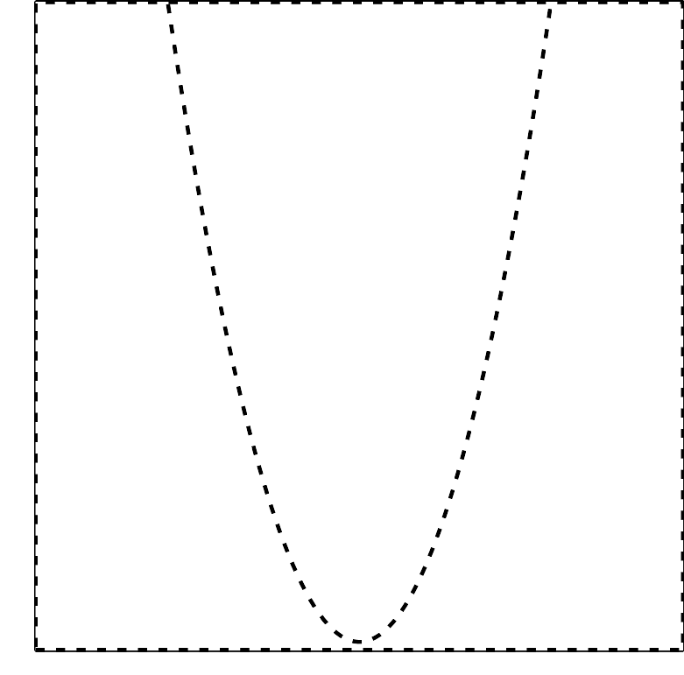
  - Which graph represents which polynomial function? Explain how you know.
- (From Unit 2, Lesson 6.)
- State the degree and end behavior of $f(x)=8x^{3}+2x^{4}−5x^{2}+9$. Explain or show your reasoning.
- (From Unit 2, Lesson 8.)
- The graph of a polynomial function $f$ is shown. Select all the true statements about the polynomial.
- 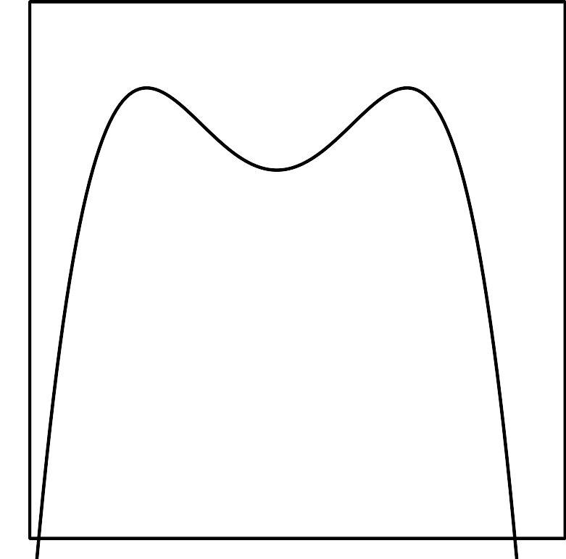
  - The degree of the polynomial is even.
  - The degree of the polynomial is odd.
  - The leading coefficient is positive.
  - The leading coefficient is negative.
  - The constant term of the polynomial is positive.
  - The constant term of the polynomial is negative.
- (From Unit 2, Lesson 9.)
© CC BY 2019 by Illustrative Mathematics®

