Unit 2 Lesson 13: Compare Favorite Art Supply Data

WU Notice and Wonder: More and Fewer (Warm up)

Student Task Statement
What do you notice?
What do you wonder?
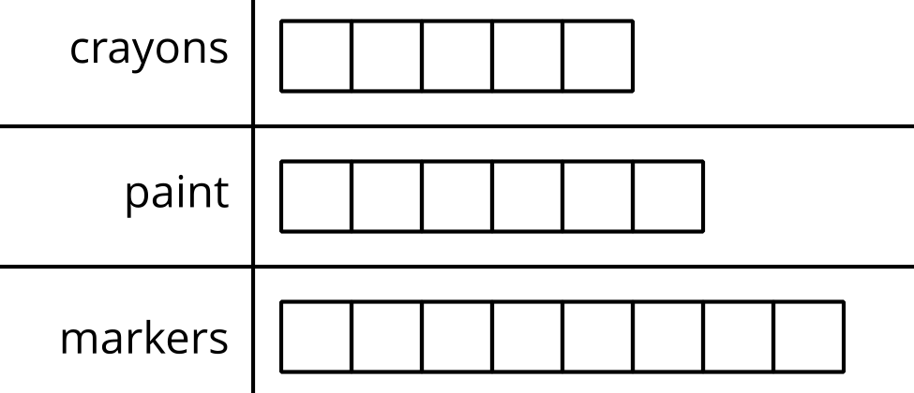

1 Compare Data (Part 1)

Student Task Statement
A group of students was asked, “What is your favorite art supply?”
Their responses are shown in this chart.
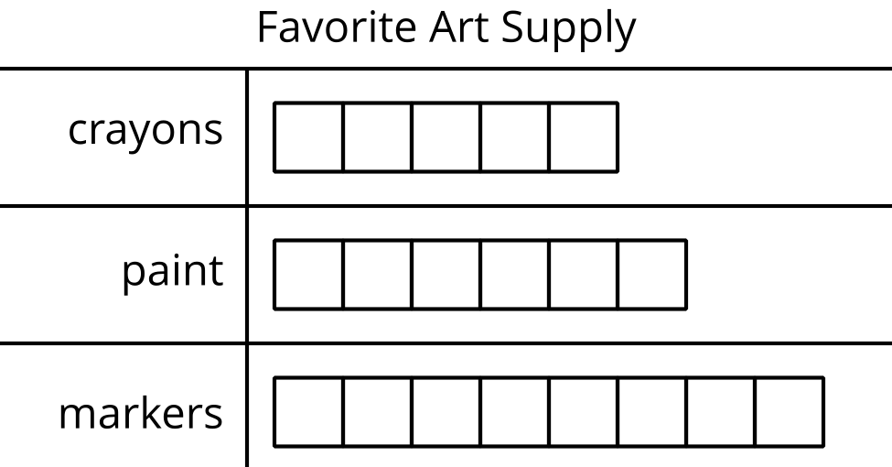
- More students voted for crayons than markers.
- Fewer students voted for crayons than paint.
- Three more students voted for markers than crayons.
- Show your thinking using drawings, numbers, or words.
- One more student voted for paint than crayons.
- Show your thinking using drawings, numbers, or words.
- One fewer student voted for paint than markers.
- Show your thinking using drawings, numbers, or words.
If you have time: Change the false statements to make them true.

2 Compare Data (Part 2)

Student Task Statement
Another group of students was asked, “What is your favorite art supply?”
Their responses are shown in this chart.
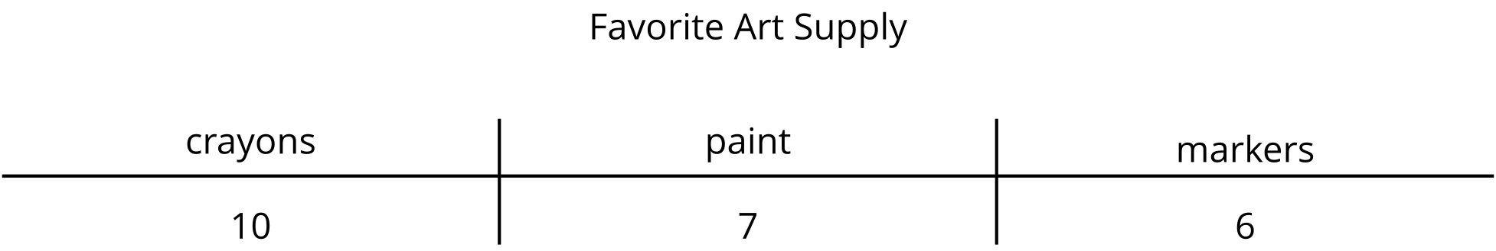
- How many more students voted for crayons than for paint?
Show your thinking using drawings, numbers, or words.
- How many fewer students voted for markers than paint?
Show your thinking using drawings, numbers, or words.
- How many more students voted for crayons than markers?
Show your thinking using drawings, numbers, or words.
- How many fewer students voted for markers than crayons?
Show your thinking using drawings, numbers, or words.

Activity Synthesis
© CC BY 2021 Illustrative Mathematics®

