Lesson 12: Compare Measurements
- Let’s solve story problems in which we compare lengths.

Warm-up: Notice and Wonder: 6, 8, and 14
What do you notice?
What do you wonder?
$6+8=14$
$8+6=14$
$14−6=8$
14−8=aaaiaaai

12.1: Friendship Bracelets
Priya and Han are comparing the lengths of their friendship bracelets.
Han’s bracelet is 14 cubes long.
The length of Priya’s bracelet is 4 cubes fewer than Han’s bracelet.
How long is Priya’s bracelet?
Show your thinking using drawings, numbers, or words.
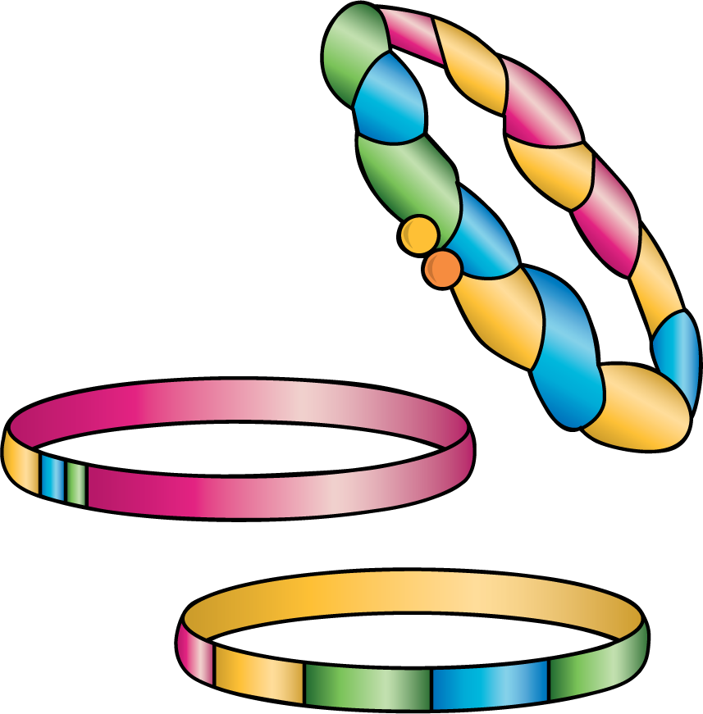

12.2: Same Bracelets, Different Story
Han’s bracelet is 4 cubes longer than Priya’s bracelet.
Priya’s bracelet is 10 cubes long.
How long is Han’s bracelet?
Show your thinking using drawings, numbers, or words.
© CC BY 2021 Illustrative Mathematics®

