Lesson 3: Measure in Halves and Fourths of an Inch
- Let’s measure lengths in halves of an inch and quarters of an inch.

Warm-up: Notice and Wonder: Rulers
Look at the rulers you have been using to measure and the ruler your teacher gave you.
What do you notice? What do you wonder?

3.1: Halves and Quarters
- Kiran and Jada are discussing the length of a worm.
- 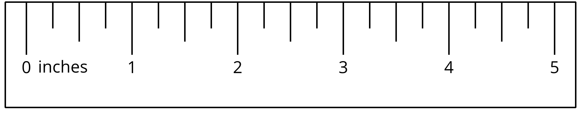
  - Kiran says that the worm is $4\frac{2}{4}$ inches long.
  - Jada says that the worm is $4\frac{1}{2}$ inches long.
- Use the ruler to explain how both of their measurements are correct.
- Measure the length of the following worms.
- A
- B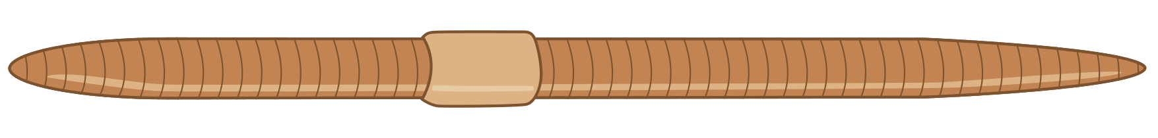
- C
- D

3.2: Measure and Describe
- Use the ruler you received today to measure some objects around the room.
- Find at least 1 object whose length is a whole number of inches and at least 3 objects whose lengths are not whole numbers.
- object | - length
- Trade lists with another group. Find a length that could be written a different way.
- object | - length | - equivalent length
© CC BY 2021 Illustrative Mathematics®

