Unit 5 Lesson 3 Cumulative Practice Problems
- Here is a base-ten diagram that represents 1.13. Use the diagram to find $1.13−0.46$.
- Explain or show your reasoning.

- Compute the following sums. If you get stuck, consider drawing base-ten diagrams.
  - $0.027+0.004$
  - $0.203+0.01$
  - $1.2+0.145$
- A student said we cannot subtract 1.97 from 20 because 1.97 has two decimal digits and 20 has none. Do you agree with him? Explain or show your reasoning.
- Decide which calculation shows the correct way to find $0.3−0.006$ and explain your reasoning.
- 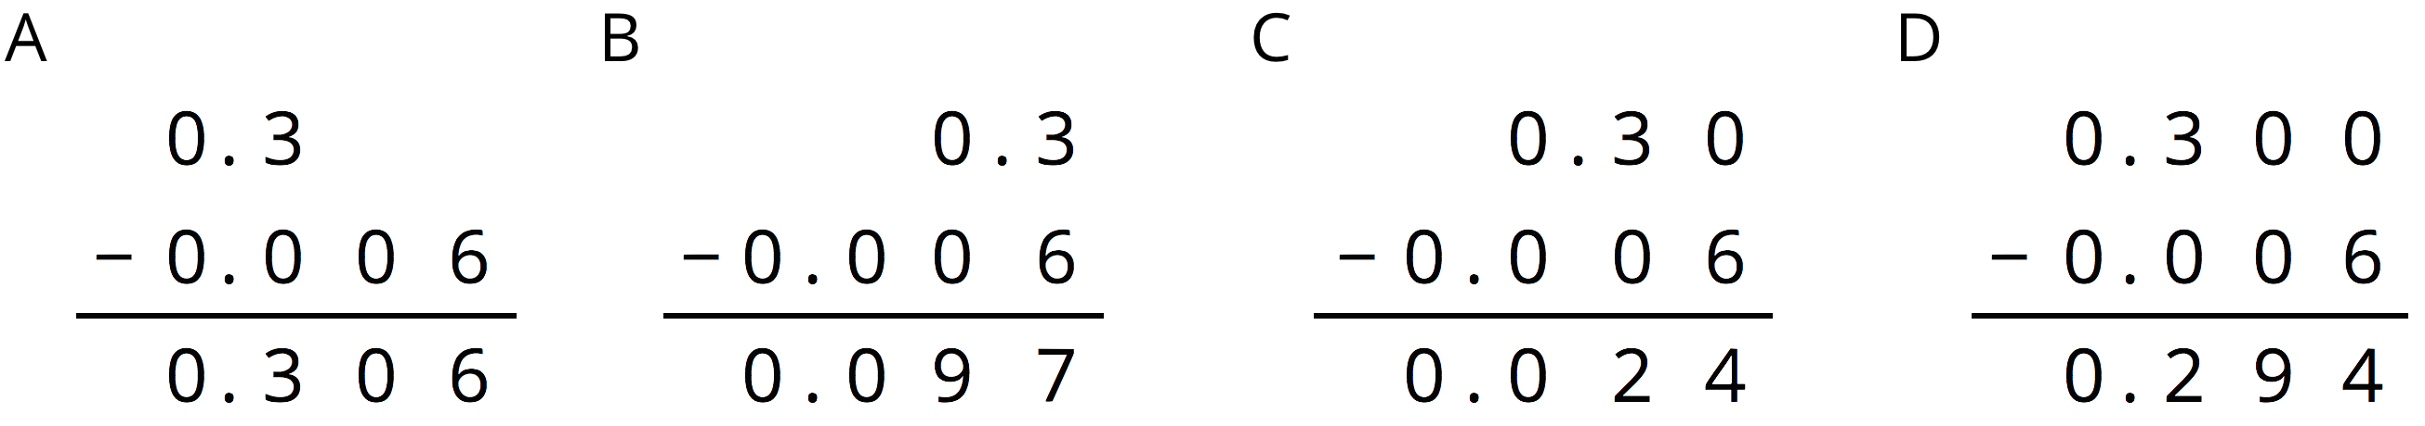

- Complete the calculations so that each shows the correct difference.
- 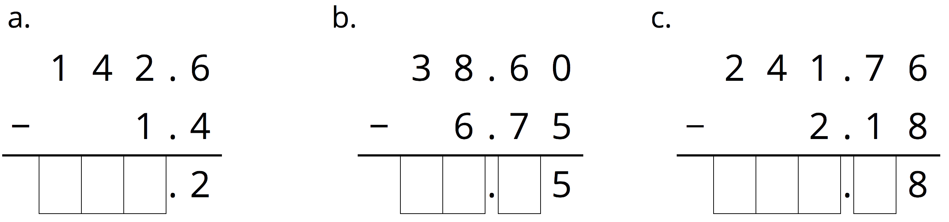

- The school store sells pencils for $0.30 each, hats for $14.50 each, and binders for $3.20 each. Elena would like to buy 3 pencils, a hat, and 2 binders. She estimated that the cost will be less than $20.
  - Do you agree with her estimate? Explain your reasoning.
  - Estimate the number of pencils could she buy with $5. Explain or show your reasoning.
- (From Unit 5, Lesson 1.)
- A rectangular prism measures $7\frac{1}{2}$ cm by 12 cm by $15\frac{1}{2}$ cm.
  - Calculate the number of cubes with edge length $\frac{1}{2}$ cm that fit in this prism.
  - What is the volume of the prism in ${\text{cm}}^{3}$? Show your reasoning. If you are stuck, think about how many cubes with $\frac{1}{2}$-cm edge lengths fit into $1{\text{ cm}}^{3}$.
- (From Unit 4, Lesson 15.)
- At a constant speed, a car travels 75 miles in 60 minutes. How far does the car travel in 18 minutes? If you get stuck, consider using the table.
- minutes | - distance in miles
- 60 | - 75
- 6
- 18
- (From Unit 2, Lesson 12.)
© CC BY Open Up Resources. Adaptations CC BY IM.

