Unit 5 Lesson 2 Cumulative Practice Problems
- The tortoise and the hare are having a race. After the hare runs 16 miles the tortoise has only run 4 miles.
- The relationship between the distance $x$ the tortoise “runs” in miles for every $y$ miles the hare runs is $y=4x$. Graph this relationship.
- 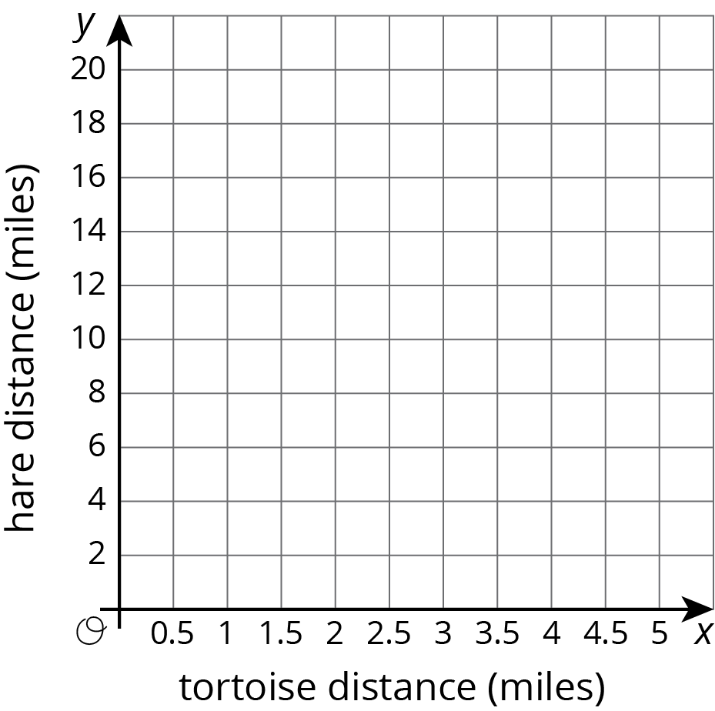
- The table shows a proportional relationship between the weight on a spring scale and the distance the spring has stretched.
  - Complete the table.
  - Describe the scales you could use on the $x$ and $y$ axes of a coordinate grid that would show all the distances and weights in the table.
- distance (cm) | - weight (newtons)
- 20 | - 28
- 55
 | - 140
- 1
- Students are selling raffle tickets for a school fundraiser. They collect $24 for every 10 raffle tickets they sell.
  - Suppose $M$ is the amount of money the students collect for selling $R$ raffle tickets. Write an equation that reflects the relationship between $M$ and $R$.
  - Label and scale the axes and graph this situation with $M$ on the vertical axis and $R$ on the horizontal axis. Make sure the scale is large enough to see how much they would raise if they sell 1000 tickets.
- Describe how you can tell whether a line’s slope is greater than 1, equal to 1, or less than 1.
- (From Unit 2, Lesson 15.)
© CC BY Open Up Resources. Adaptations CC BY IM.

