Unit 5 Lesson 7: Graphs of Proportional Relationships

1 Notice These Points (Warm up)

Student Task Statement
- Plot the points $(0,10),(1,8),(2,6),(3,4),(4,2)$.
- 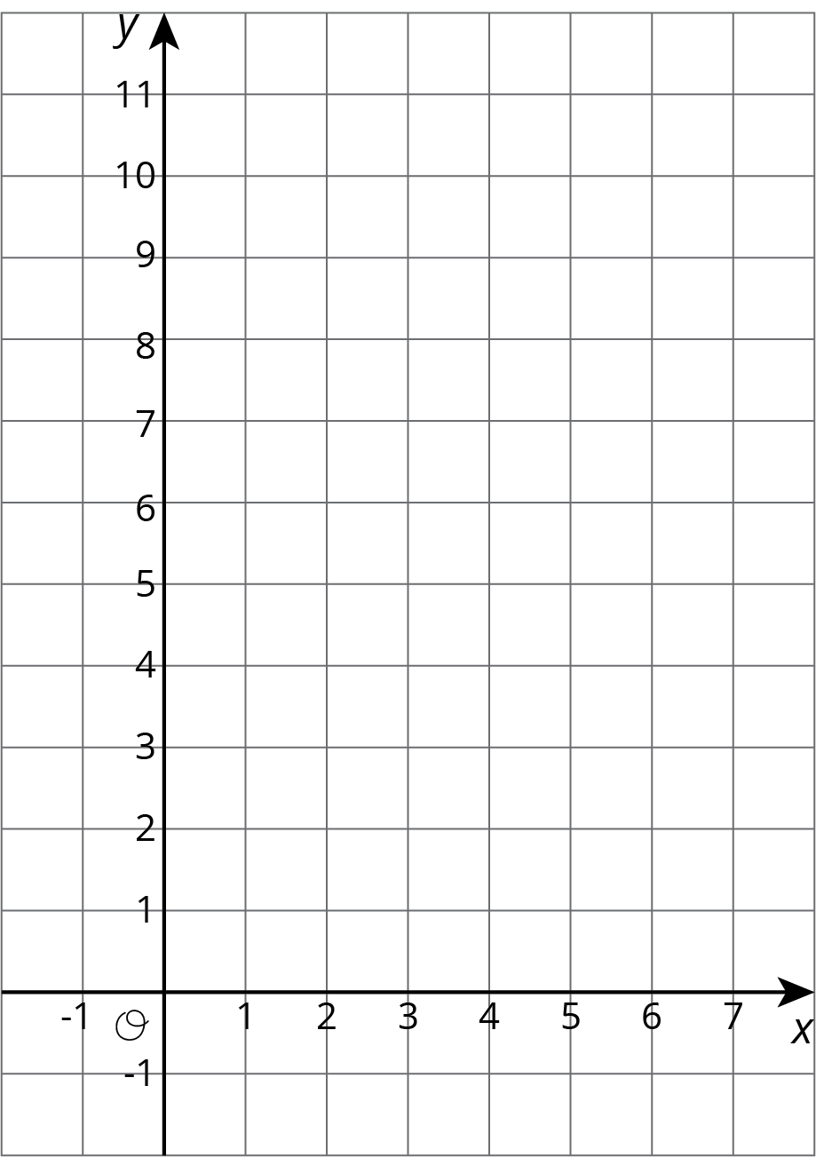
- What do you notice about the graph?

2 T-shirts for Sale

Student Task Statement
Some T-shirts cost $8 each.
$x$ | $y$
1 | 8
2 | 16
3 | 24
4 | 32
5 | 40
6 | 48
- Use the table to answer these questions.
  - What does $x$ represent?
  - What does $y$ represent?
  - Is there a proportional relationship between $x$ and $y$?
- Plot the pairs in the table on the coordinate plane.
- What do you notice about the graph?

3 Tyler's Walk

Student Task Statement
Tyler was at the amusement park. He walked at a steady pace from the ticket booth to the bumper cars.
- The point on the graph shows his arrival at the bumper cars. What do the coordinates of the point tell us about the situation?
- The table representing Tyler's walk shows other values of time and distance. Complete the table. Next, plot the pairs of values on the grid.
- What does the point $(0,0)$ mean in this situation?
- How far away from the ticket booth was Tyler after 1 second? Label the point on the graph that shows this information with its coordinates.
- What is the constant of proportionality for the relationship between time and distance? What does it tell you about Tyler's walk? Where do you see it in the graph?
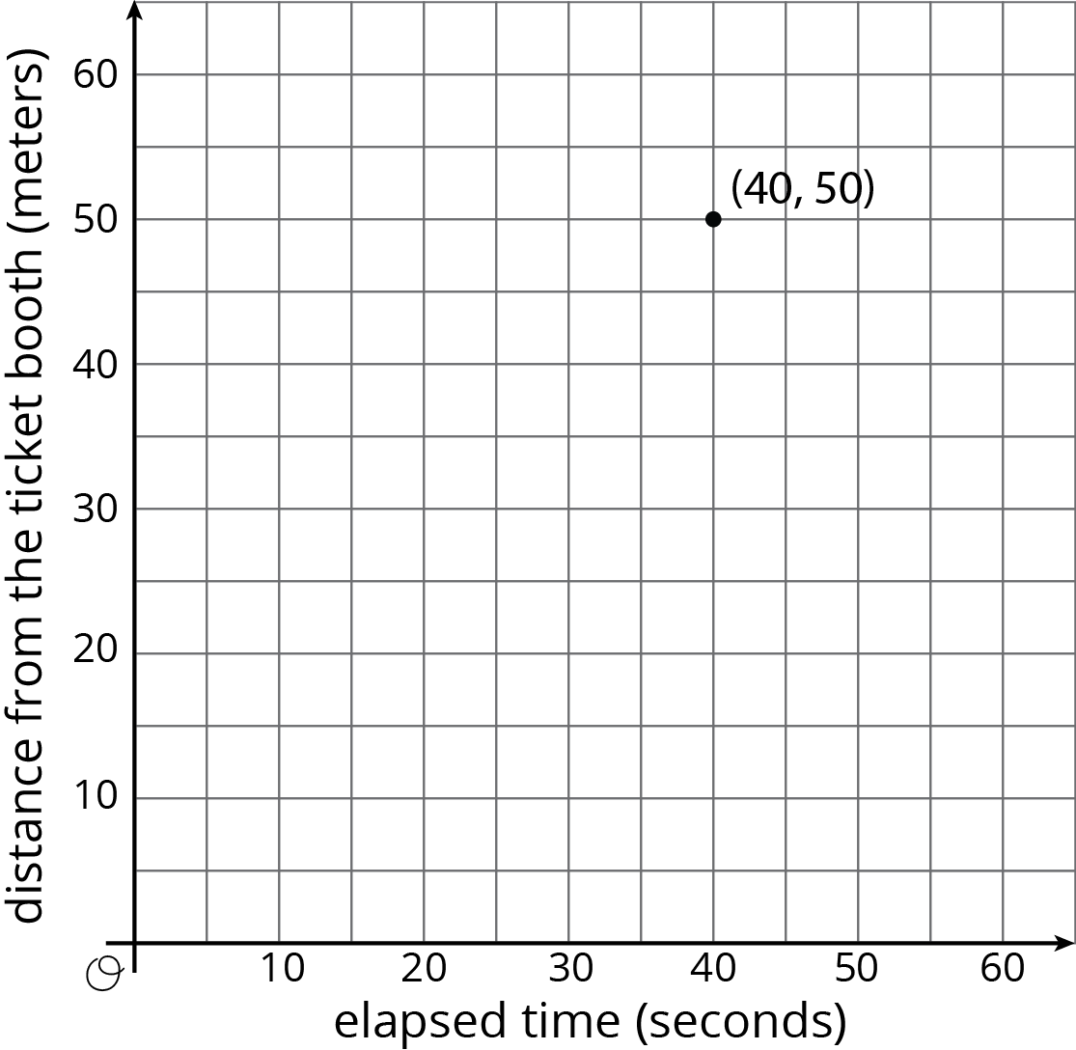
time  (seconds) | distance  (meters)
0 | 0
20 | 25
30 | 37.5
40 | 50
1
© CC BY Open Up Resources. Adaptations CC BY IM.

