## Lesson 3: Describe and Compare Shapes

* Let’s compare shapes.

### Warm-up: Which One Doesn’t Belong: Compare Shapes

Which one doesn’t belong?

A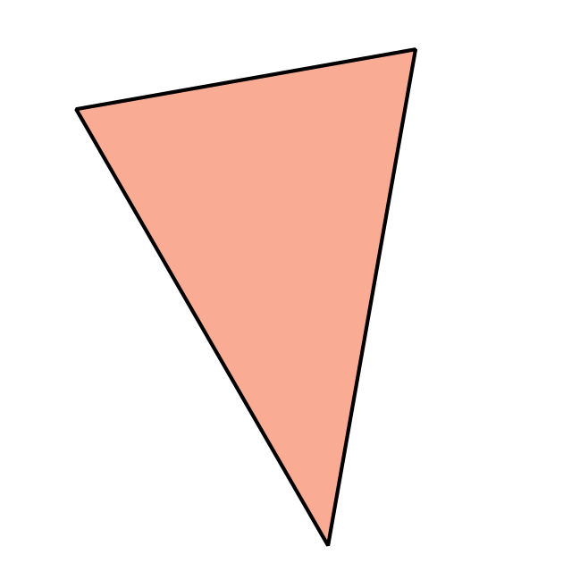

B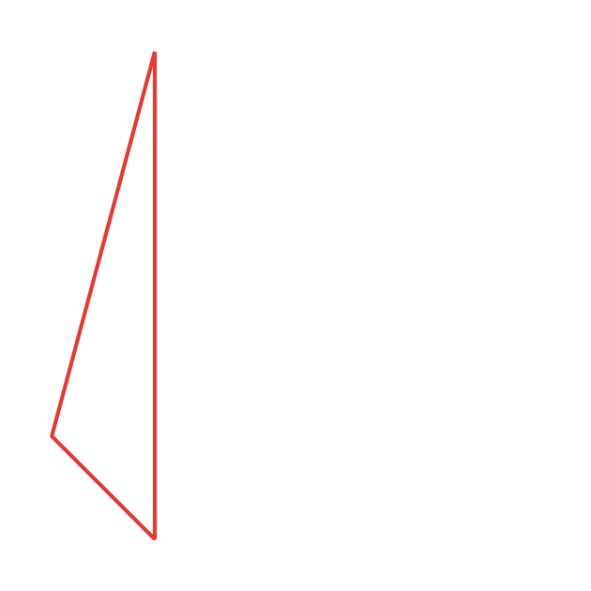

C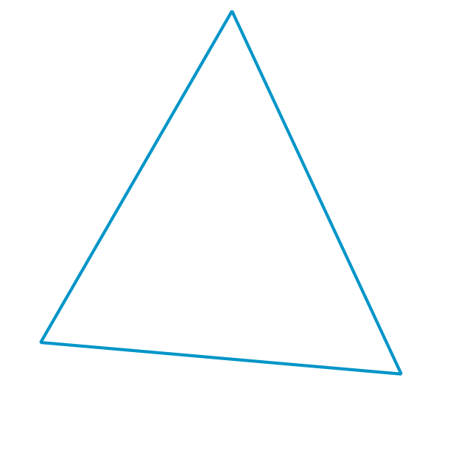

D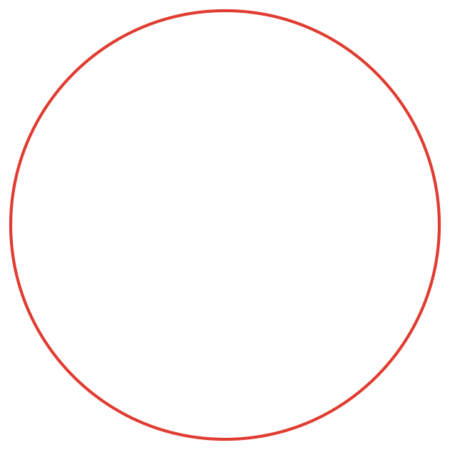

### 3.3: Introduce Which One, Shapes

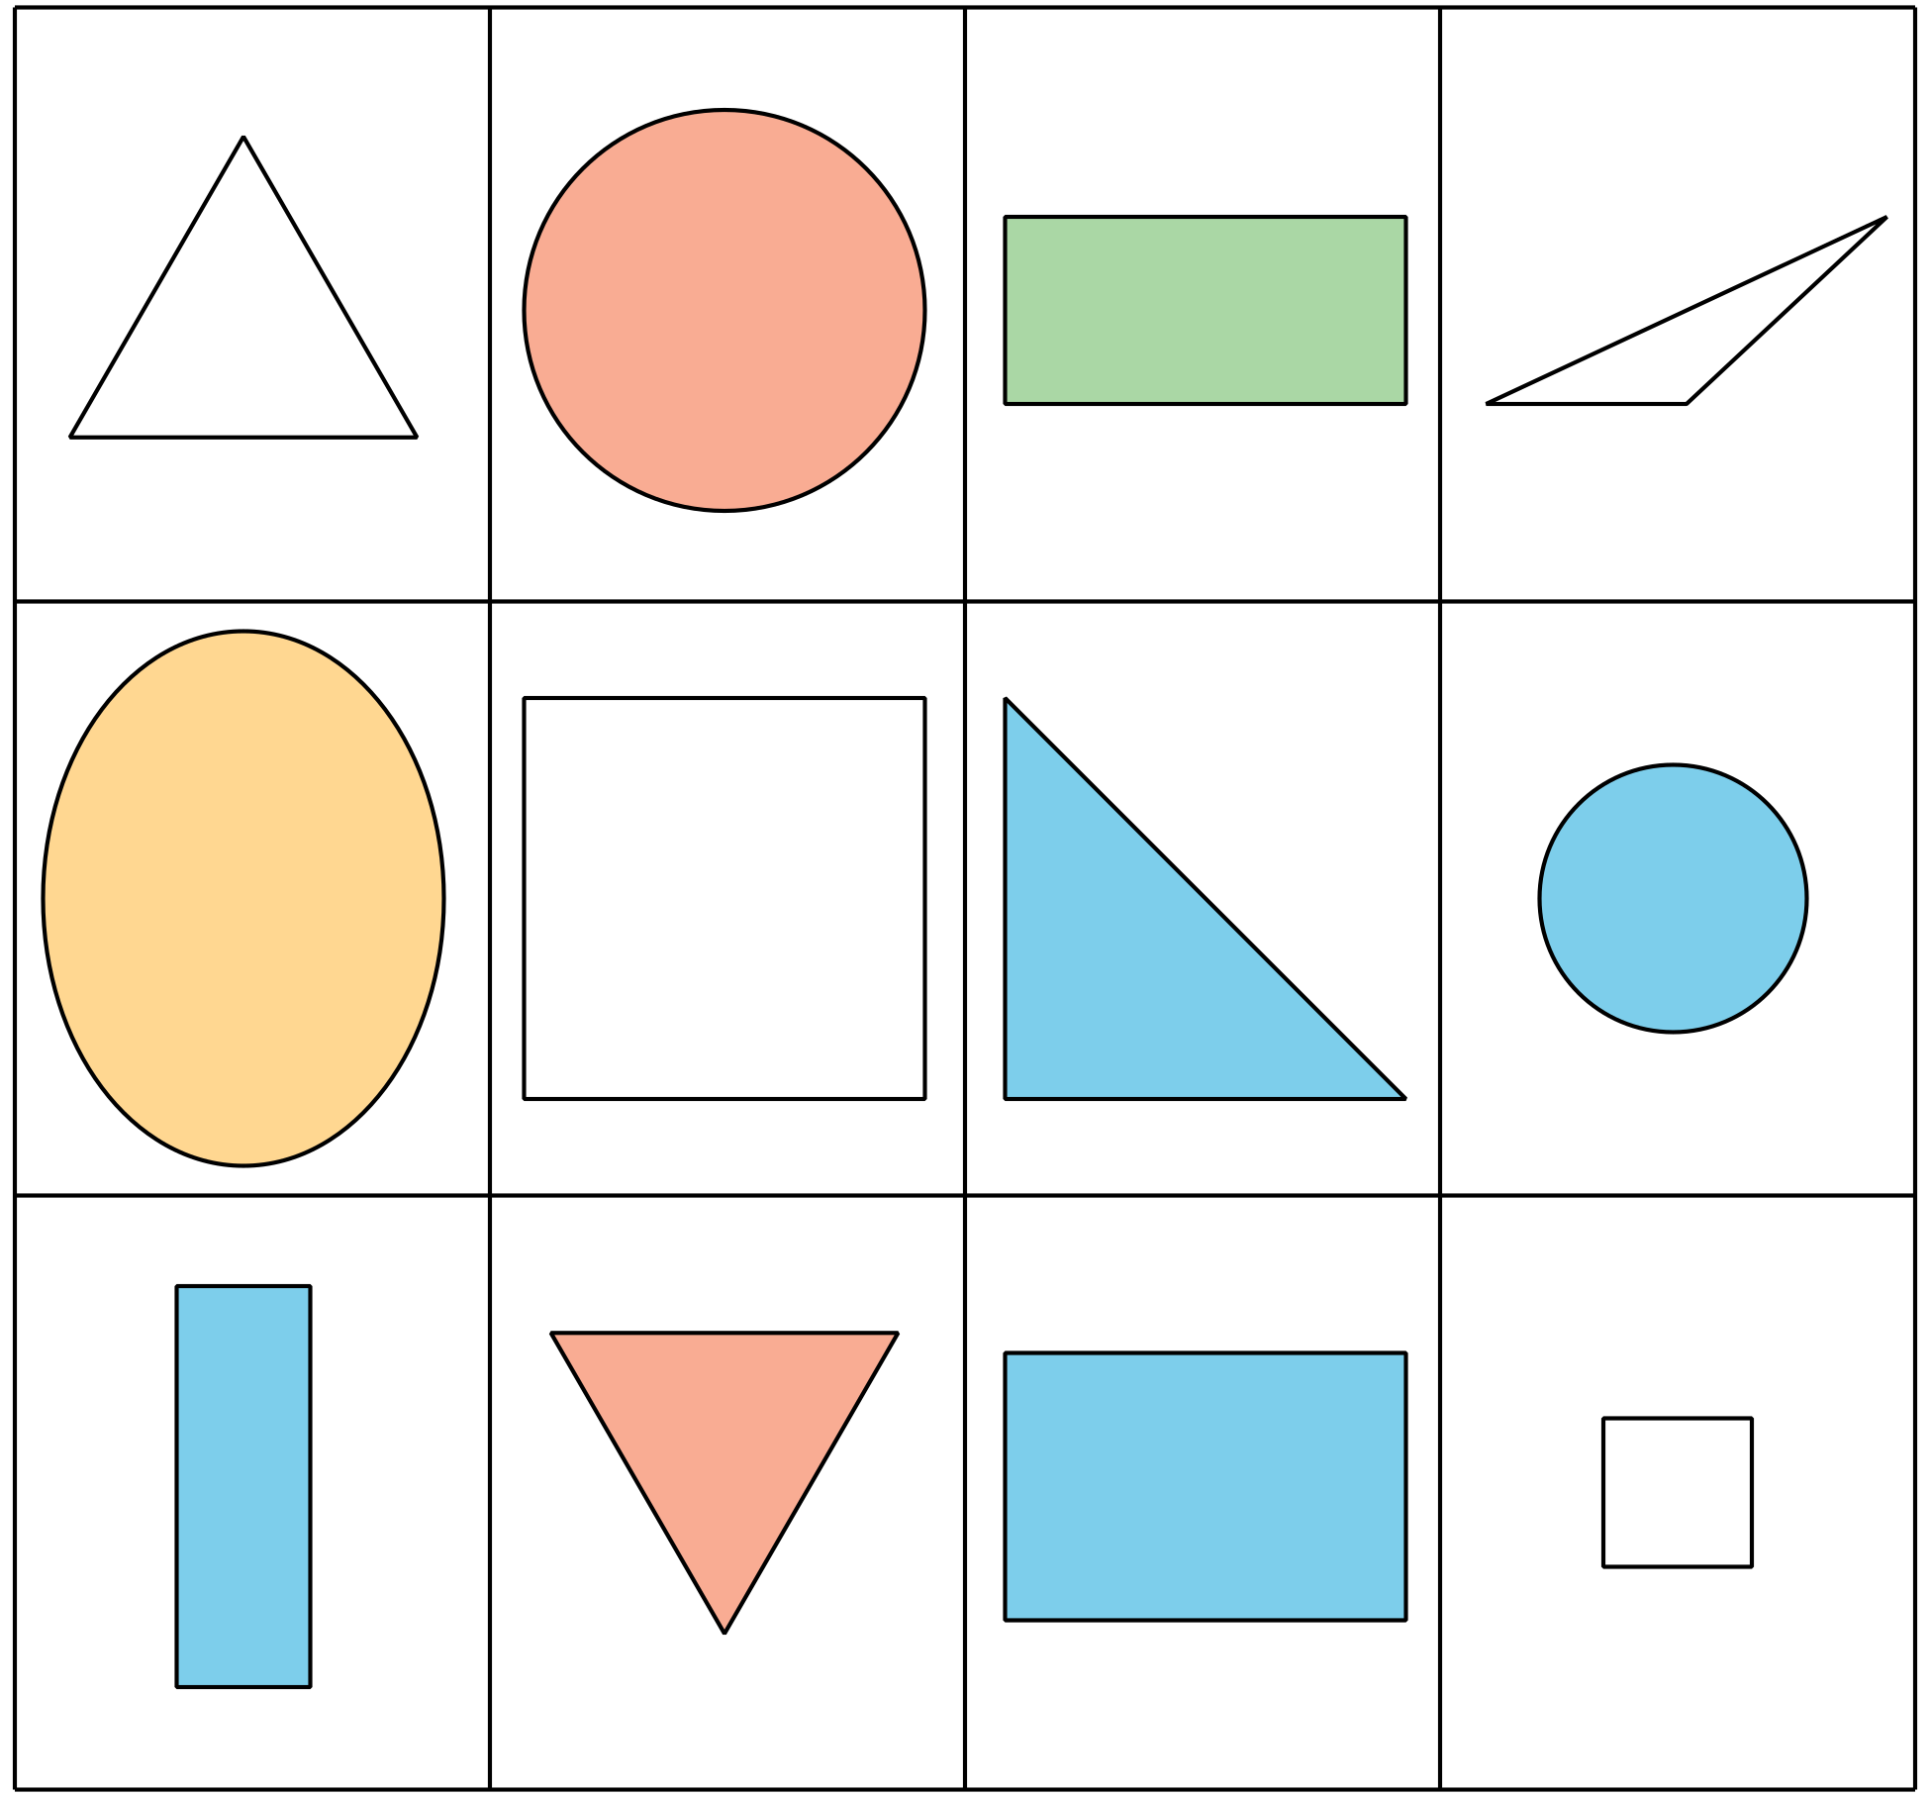

Choose a center.

Which One

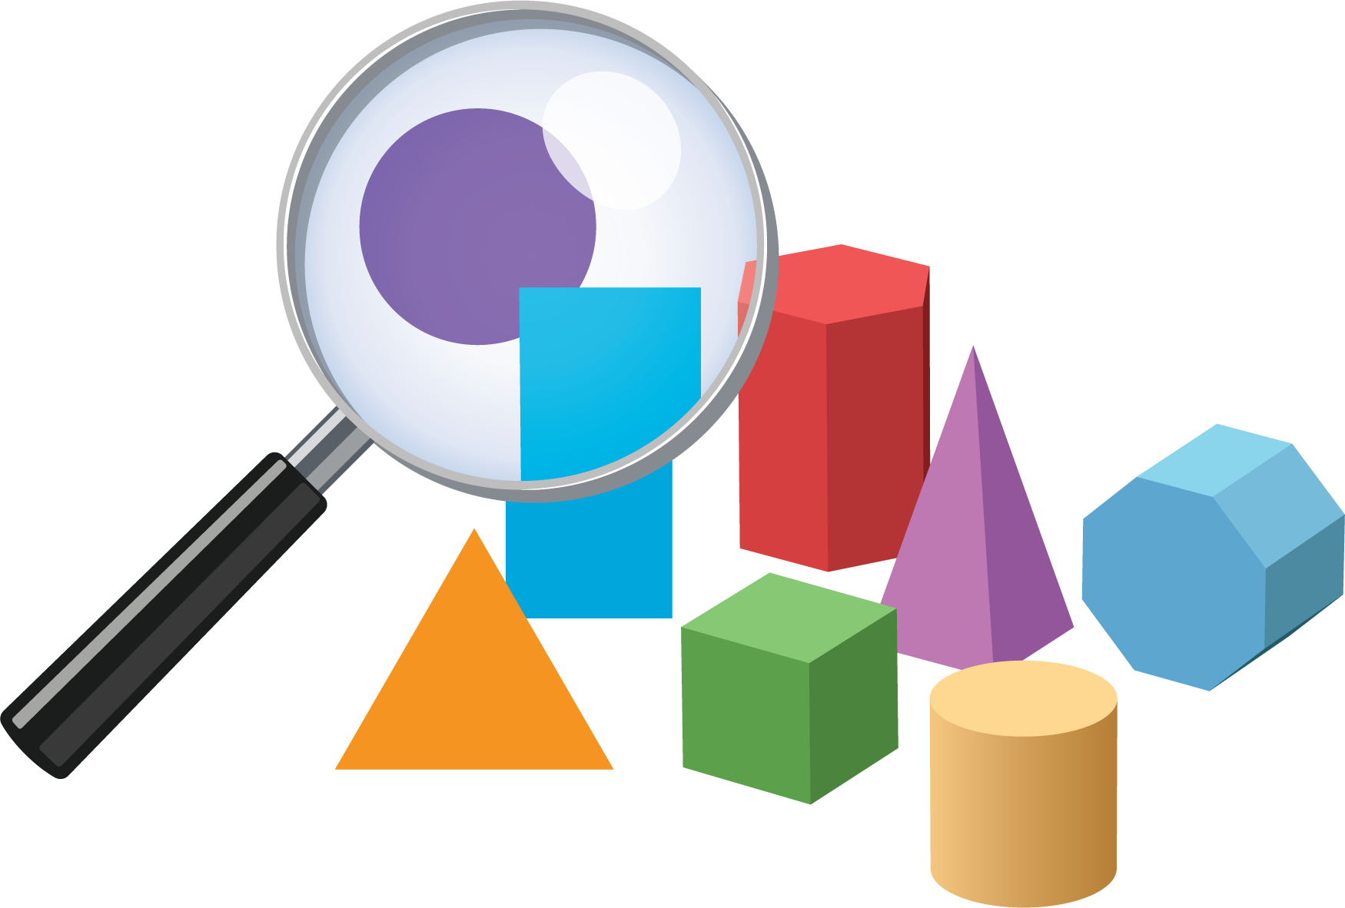

Picture Books

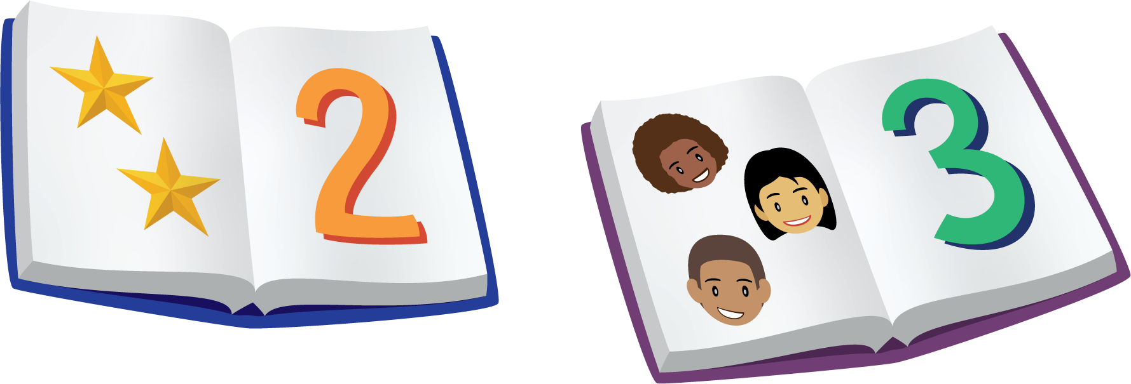

Bingo

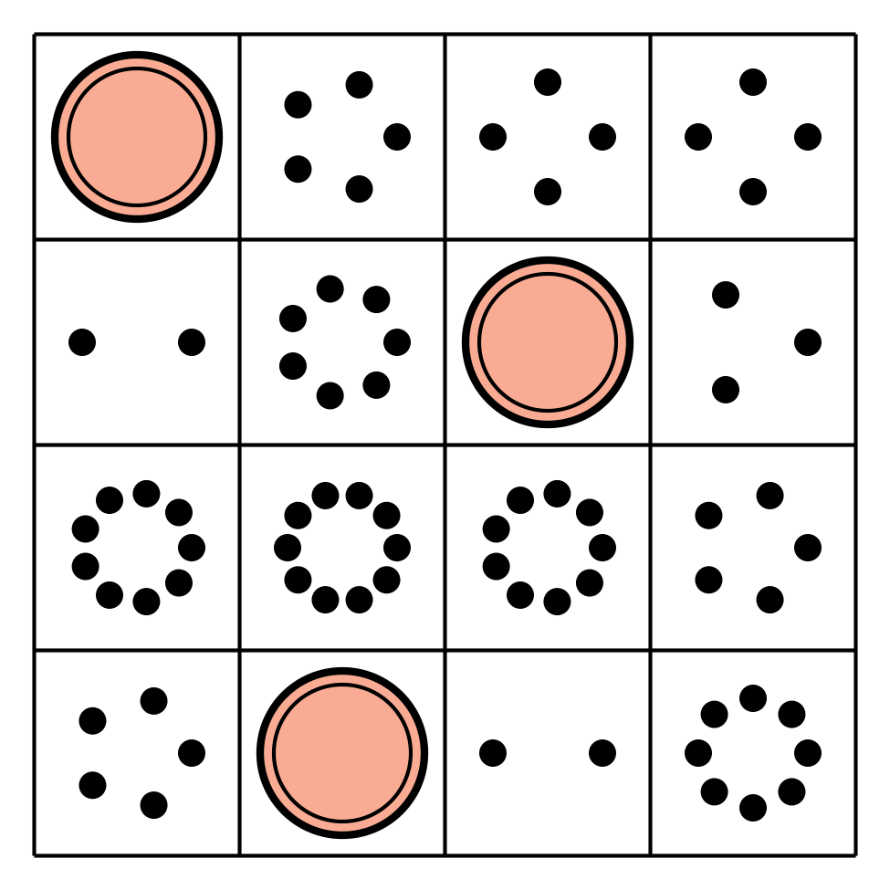

Shake and Spill

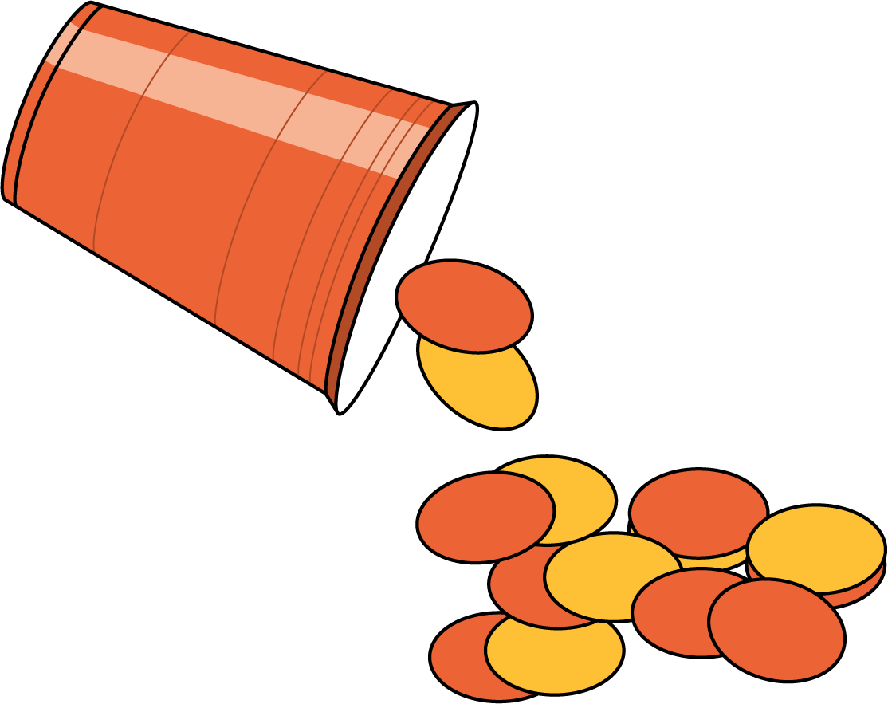



© CC BY 2021 Illustrative Mathematics®