Lesson 14 Practice Problems
- Draw the image of quadrilateral $ABCD$ when rotated ${120}^{∘}$ counterclockwise around the point $D$.
- 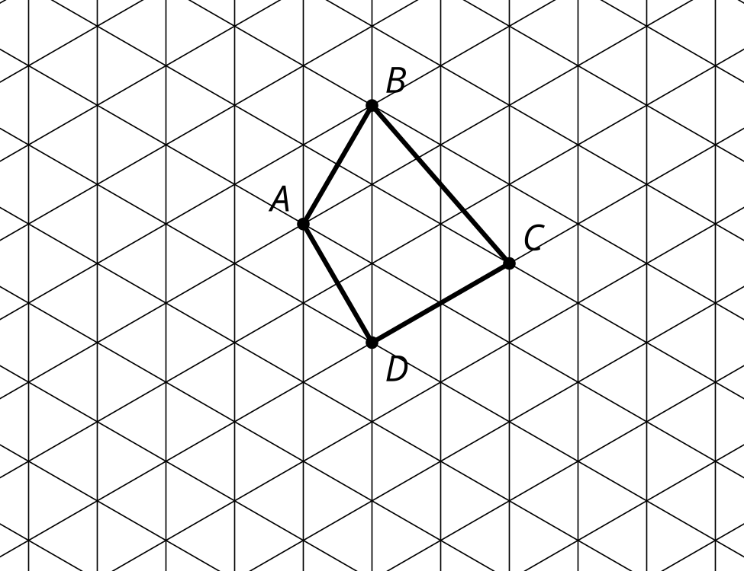
- ​​​​​​
- There is an equilateral triangle, $ABC$, inscribed in a circle with center $D$. What is the smallest angle you can rotate triangle $ABC$ around $D$ so that the image of $A$ is $B$?
  - ${60}^{∘}$
  - ${90}^{∘}$
  - ${120}^{∘}$
  - ${180}^{∘}$
- Which segment is the image of $AB$ when rotated ${90}^{∘}$ counterclockwise around point $P$?
- 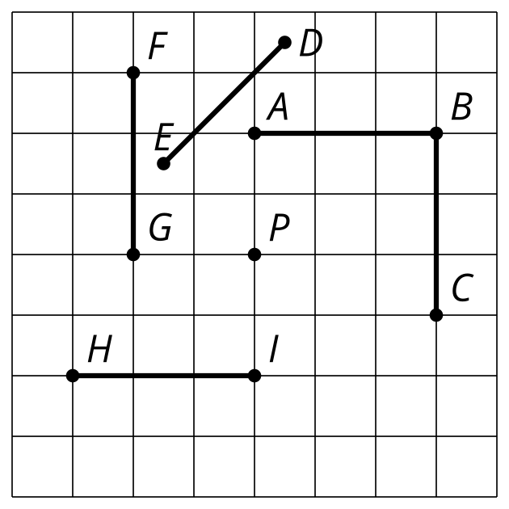
- The semaphore alphabet is a way to use flags to signal messages. Here's how to signal the letter Q. Describe a transformation that would take the right hand flag to the left hand flag.

- Q
- 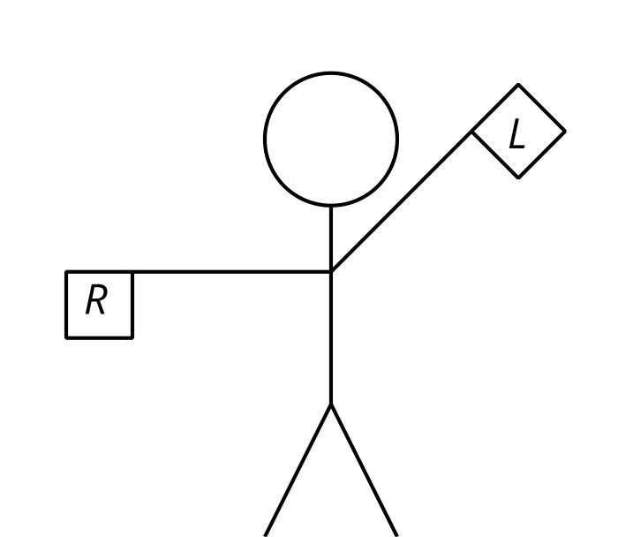
- (From Unit 1, Lesson 13.)
- Here are 2 polygons:
- 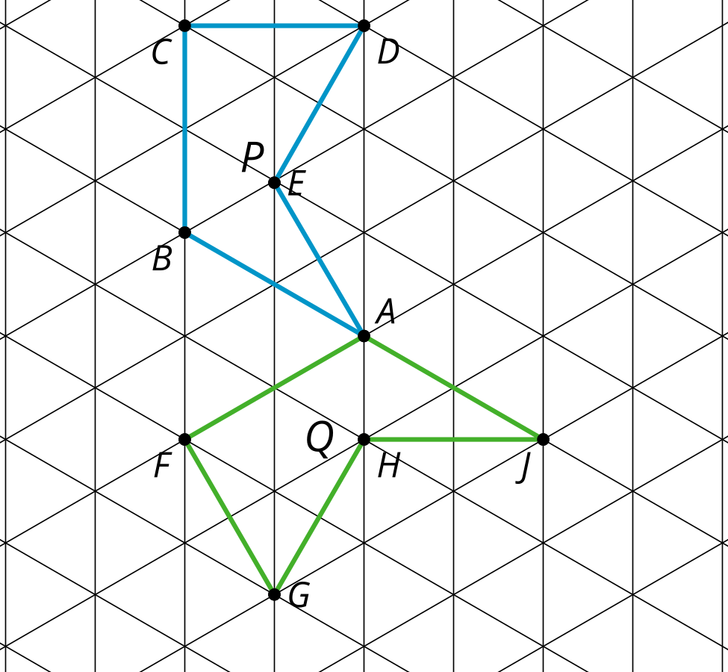
- Select all sequences of translations, rotations, and reflections below that would take polygon $P$ to polygon $Q$.
  - Rotate ${180}^{∘}$ around point $A$.
  - Translate so that $A$ is taken to $J$. Then reflect over line $BA$.
  - Rotate ${60}^{∘}$ counterclockwise around point $A$ and then reflect over the line $FA$.
  - Reflect over the line $BA$ and then rotate ${60}^{∘}$ counterclockwise around point $A$.
  - Reflect over line $BA$ and then translate by directed line segment $BA$.
- (From Unit 1, Lesson 13.)

  - Draw the image of figure $ABC$ when translated by directed line segment $u$. Label the image of $A$ as $A^{′}$, the image of $B$ as $B^{′}$, and the image of $C$ as $C^{′}$.
  - Explain why the line containing $AB$ is parallel to the line containing $A^{′}B^{′}$.
- 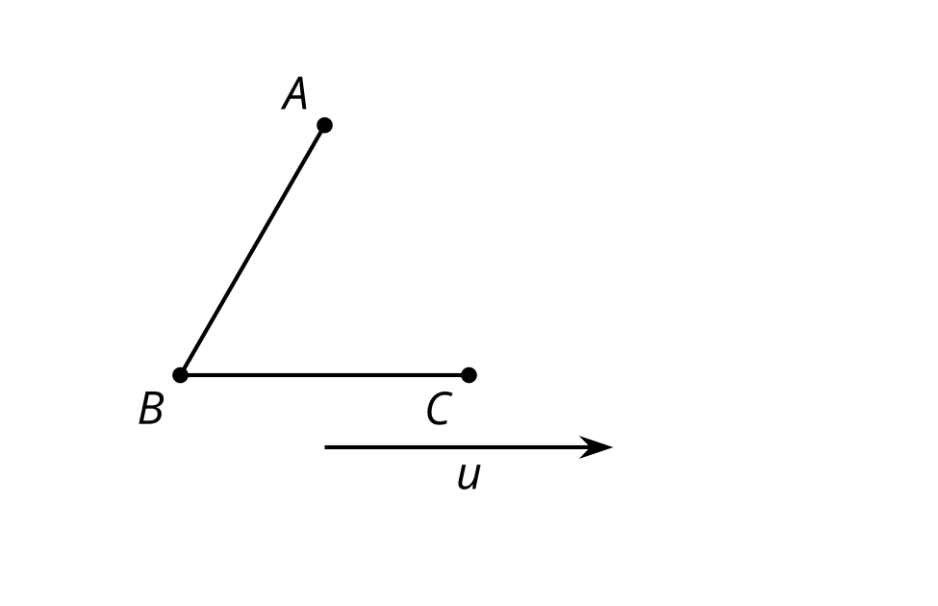
- (From Unit 1, Lesson 12.)
- There is a sequence of rigid transformations that takes $A$ to $A^{′}$, $B$ to $B^{′}$, and $C$ to $C^{′}$. The same sequence takes $D$ to $D^{′}$. Draw and label $D^{′}$:
- 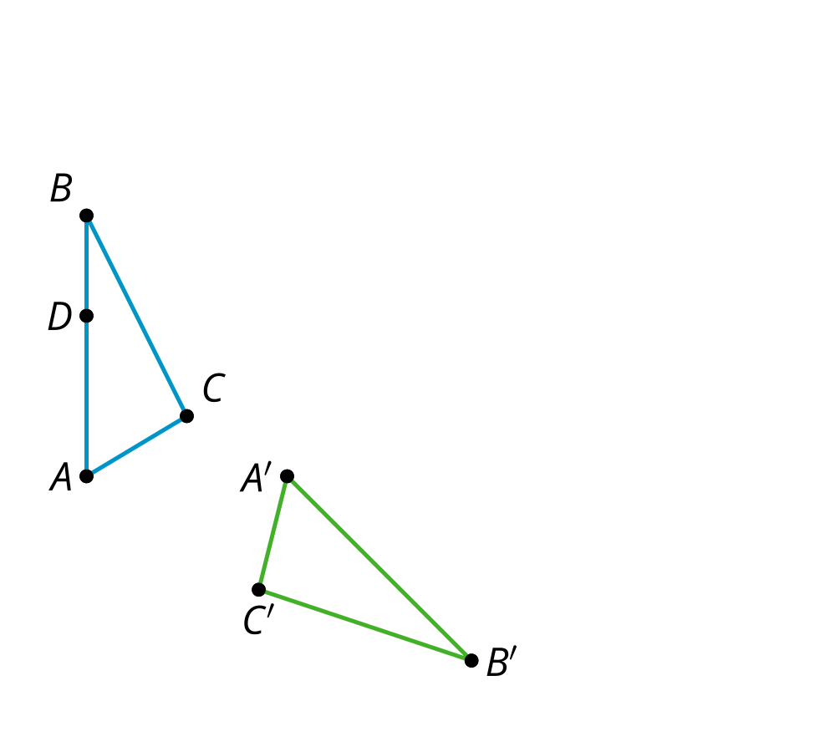
- (From Unit 1, Lesson 10.)
© CC BY 2019 by Illustrative Mathematics®

