Lesson 11 Practice Problems
- What are the points of intersection between the graphs of the functions $f(x)=x^{2}(x+1)$ and $g(x)=x+1$?
- Select all the points of intersection between the graphs of the functions $f(x)=(x+5)(x−2)$ and $g(x)=(2x+1)(x−2)$.
  - $(\text{-}5,0)$
  - $(\text{-}\frac{1}{2},0)$
  - $(\text{-}2,\text{-}12)$
  - $(2,0)$
  - $(4,18)$
  - $(5,30)$
- What are the solutions to the equation $(x−3)(x+5)=\text{-}15$?
- What are the $x$-intercepts of the graph of $y=(5x+7)(2x−1)(x−4)$?
  - $\text{-}\frac{7}{5},\text{-}\frac{1}{2},4$
  - $\frac{5}{7},\frac{1}{2},4$
  - $\text{-}\frac{7}{5},\frac{1}{2},4$
  - $\frac{5}{7},2,4$
- (From Unit 2, Lesson 5.)
- Which polynomial function’s graph is shown here?
- 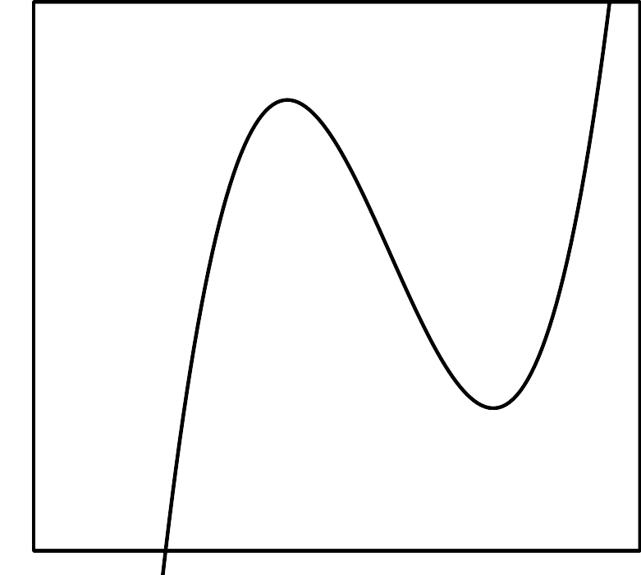
  - $f(x)=(x+1)(x+2)(x+4)$
  - $f(x)=(x+1)(x−2)(x+4)$
  - $f(x)=(x−1)(x+2)(x−4)$
  - $f(x)=(x−1)(x−2)(x−4)$
- (From Unit 2, Lesson 7.)
- Draw a rough sketch of the graph of $g(x)=\text{-}x^{2}(x+2)$.
- (From Unit 2, Lesson 10.)
- The graph of a polynomial function $f$ is shown.
- 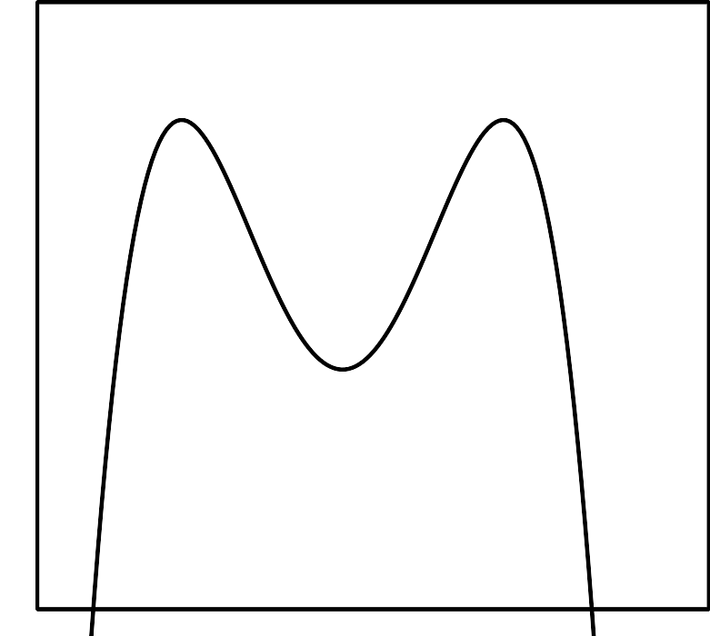
  - Is the degree of the polynomial odd or even? Explain how you know.
  - What is the constant term of the polynomial?
- (From Unit 2, Lesson 9.)
© CC BY 2019 by Illustrative Mathematics®

