Unit 6 Lesson 3: Specific Side Lengths

WU Which One Doesn’t Belong: Different Shapes (Warm up)

Student Task Statement
Which one doesn’t belong?
A
B
C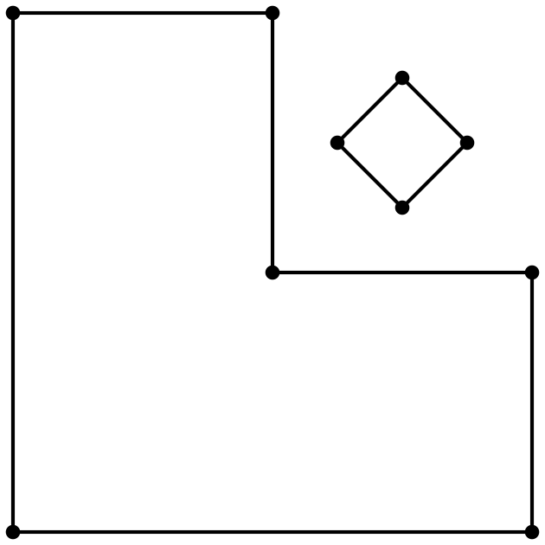
D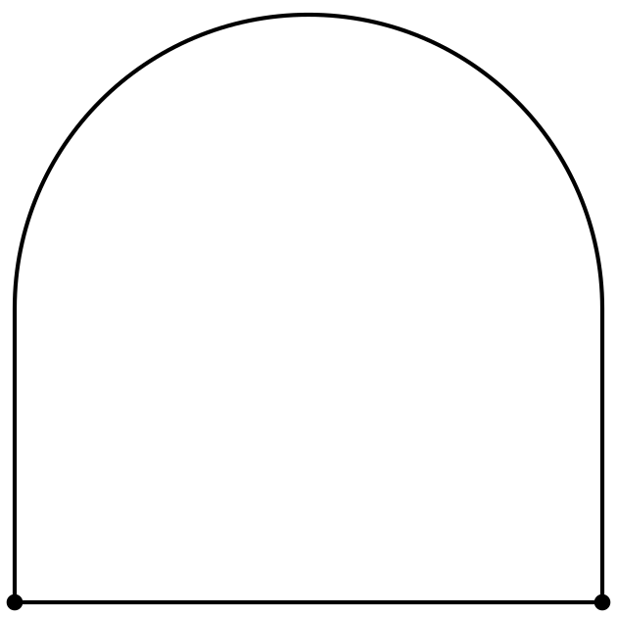

1 Measure Twice, Draw Once

Student Task Statement
- Diego drew a shape that has fewer than 5 sides. Two sides are 3 centimeters long. Circle shapes that could be Diego’s shape.
- 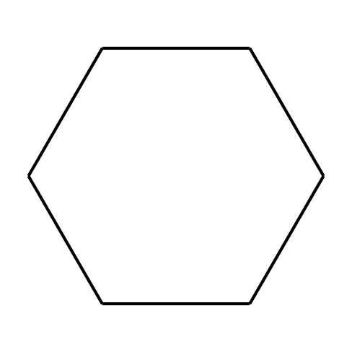
- 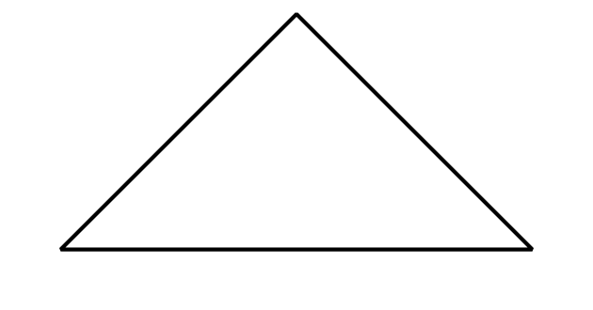
- Tyler drew a shape that has 4 sides. Each side is 2 inches long.
  - Circle shapes that could be Tyler’s shape.
  - Draw another shape that could be Tyler’s shape.
- Priya drew a shape that has more sides than Tyler’s shape. Only one side of her shape is 2 inches long. Draw two shapes that could be Priya’s shape.

Activity Synthesis
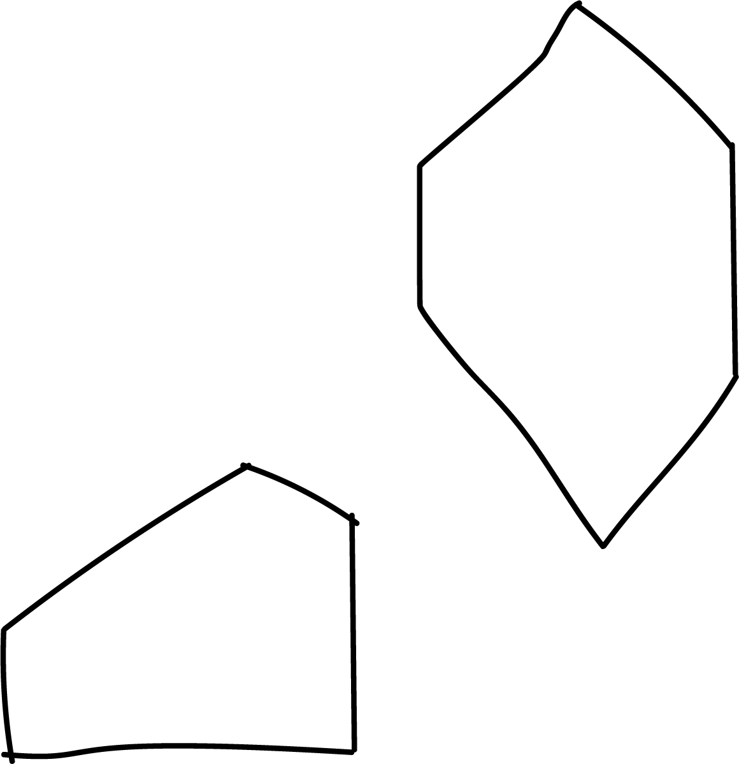

2 Build a Shape

Student Task Statement
- Choose your own attributes. Circle an attribute from each row.
- sides | - 3 | - 4 | - 5 | - 6
- corners | - 3 | - 4 | - 5 | - 6
- side length | - 1 side is 2 in. | - 2 sides are 2 in. | - 2 sides are 3 in. | - 4 sides are 2 in.
- square  corners | - 0 | - 1 | - 2 | - all square corners
- Draw and name a shape with the attributes you chose. If you cannot draw the shape, explain why.
- Shape:
- Name: ______________________________
- Choose your own attributes. Circle an attribute from each row.
- sides | - 3 | - 4 | - 5 | - 6
- corners | - 3 | - 4 | - 5 | - 6
- side length | - 1 side is 2 in. | - 2 sides are 2 in. | - 2 sides are 3 in. | - 4 sides are 2 in.
- square  corners | - 0 | - 1 | - 2 | - all square corners
- Draw and name a shape with the attributes you chose. If you cannot draw the shape, explain why.
- Shape:
- Name: ______________________________
- Choose your own attributes. Circle an attribute from each row.
- sides | - 3 | - 4 | - 5 | - 6
- corners | - 3 | - 4 | - 5 | - 6
- side length | - 1 side is 2 in. | - 2 sides are 2 in. | - 2 sides are 3 in. | - 4 sides are 2 in.
- square  corners | - 0 | - 1 | - 2 | - all square corners
- Draw and name a shape with the attributes you chose. If you cannot draw the shape, explain why.
- Shape:
- Name: ______________________________
- Cover your attribute table and trade papers with your partner. Guess which attributes they used to draw their shape.
- If you have time: Are there any attributes that are impossible to put together to make a shape? Show or explain.

Activity Synthesis
© CC BY 2021 Illustrative Mathematics®

