Unit 2 Lesson 14: Compare with Addition and Subtraction

WU True or False: Equal Sign (Warm up)

Student Task Statement
Decide if each statement is true or false.
Be prepared to explain your reasoning.
- $7+3=10$
- $10=7+3$
- $10=3+6$

1 Is It Addition or Subtraction?

Student Task Statement
There are 8 glue sticks and 3 scissors at the art station.
How many fewer scissors are there than glue sticks?
Mai created a picture.
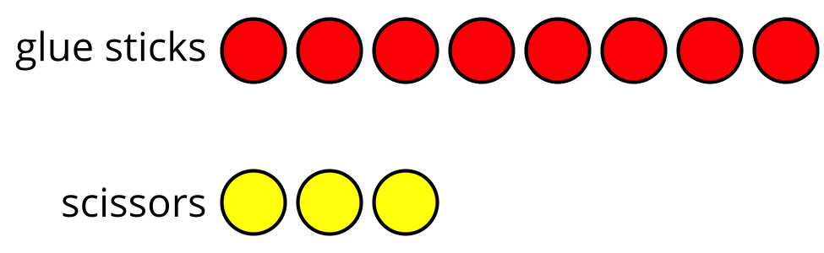
She is not sure which equation she should use to find the difference.
$8−3=\boxed{5}$
$3+\boxed{5}=8$
Help her decide.
Show your thinking using drawings, numbers, or words.

2 Which Equation?

Student Task Statement
- There are 5 red pillows and 3 blue pillows on the reading rug.
How many more red pillows are there than blue pillows?
Show your thinking using drawings, numbers, or words.
- Circle the equation that matches the problem.
- 5+3=8
- 5−3=2
- 5+2=3
- 3+2=5
- There are 7 calculators on the table.
There are 8 math books.
How many more math books are there than calculators?
Show your thinking using drawings, numbers, or words.
- Circle the equation that matches the problem.
- 7+1=8
- 8−7=1
- 7−8=0
- 8+1=7
- In Mr. Green’s class, 3 students have purple backpacks and 7 students have black backpacks.
How many more students have black backpacks than purple backpacks?
Show your thinking using drawings, numbers, or words.
- Circle the equation that matches the problem.
- 3+7=10
- 3+4=7
- 7−4=3
- 7+1=3

3 Centers: Choice Time

Student Task Statement
Choose a center.
Capture Squares
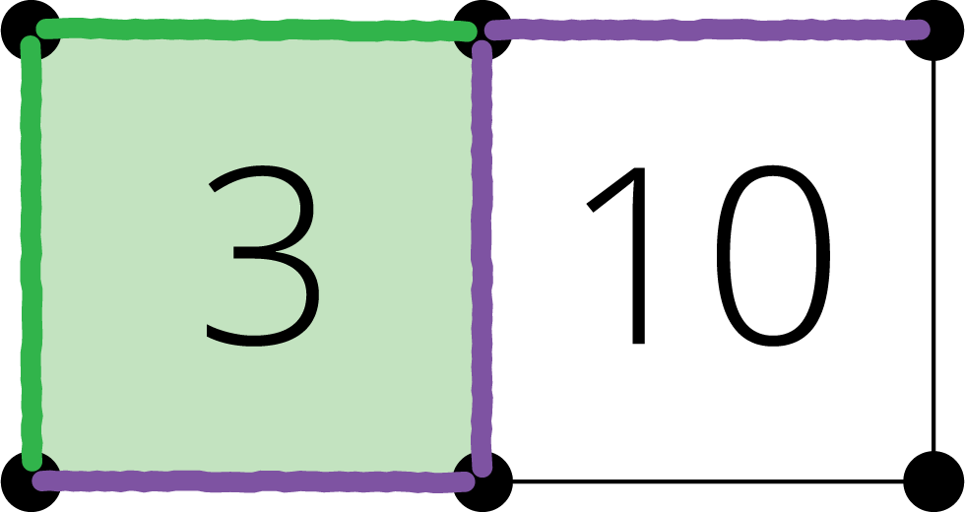
Math Stories
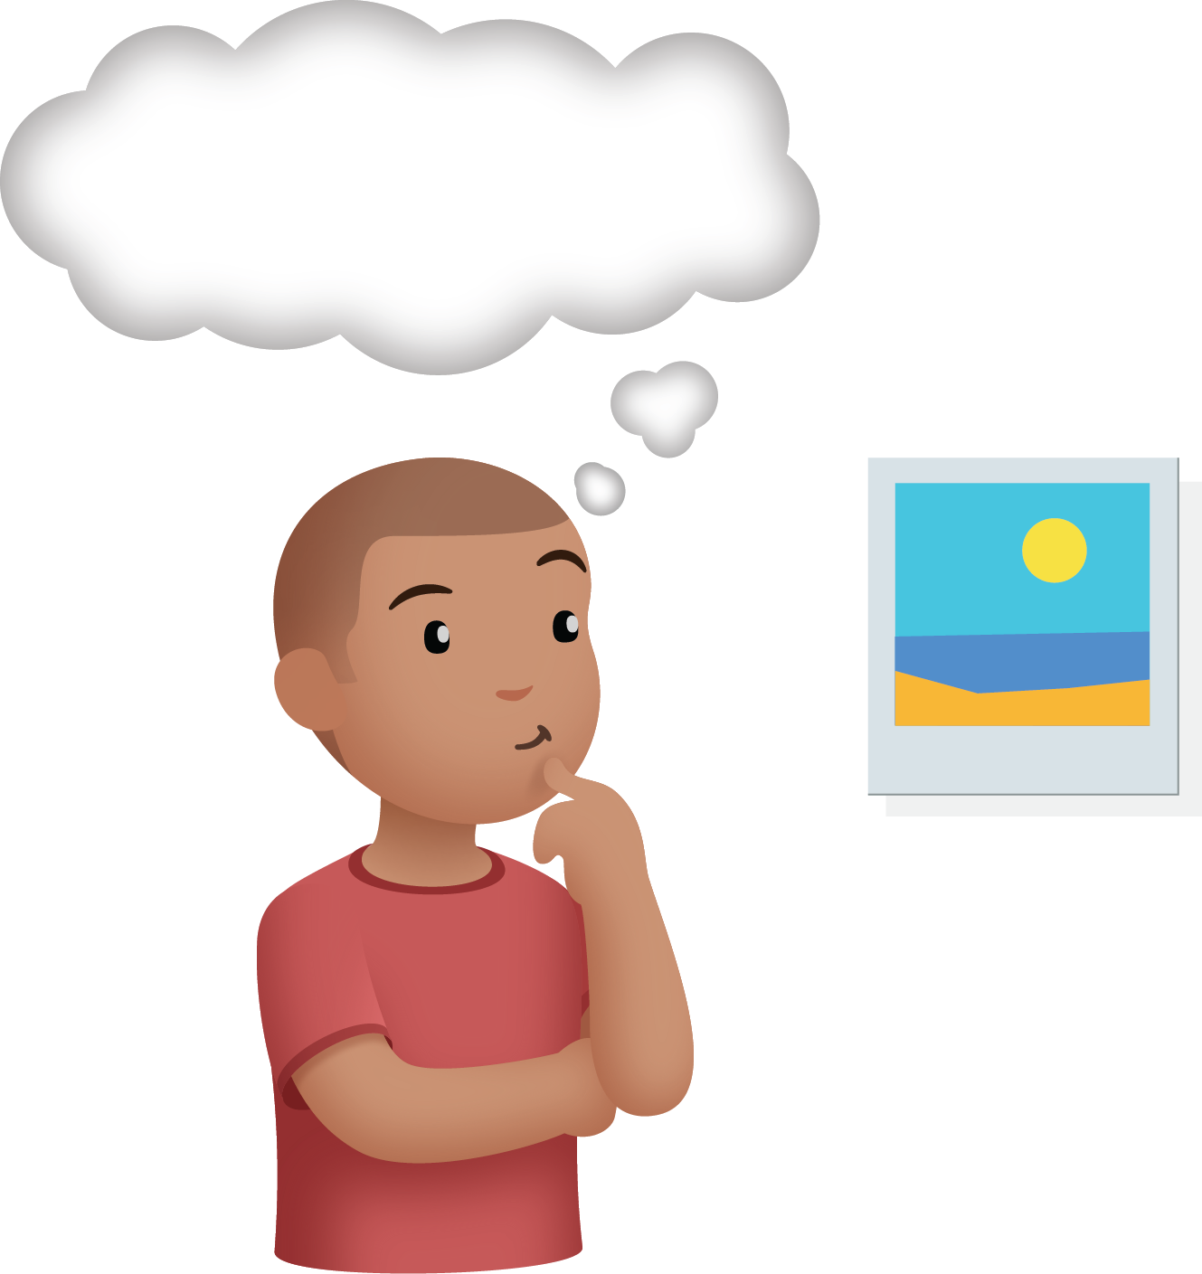
Shake and Spill
© CC BY 2021 Illustrative Mathematics®

