Lesson 8: Ten as a Unit

Standards Alignments
Building On | K.NBT.A.1
Addressing | 1.NBT.B.2.a, 1.NBT.B.2.b
Building Towards | 1.NBT.B.2.a, 1.NBT.B.2.b

Teacher-facing Learning Goals
- Compose and decompose teen numbers into 1 ten and some number of ones.
- Understand 10 ones as a unit called a ten.

Student-facing Learning Goals
- Let's explore teen numbers.

Lesson Purpose
The purpose of this lesson is for students to understand that 10 ones make a unit called a ten. Students compose and decompose teen numbers with a ten and some ones.
In this lesson, students build on their work from kindergarten where they composed and decomposed teen numbers with ten ones and some more ones. They learn that 10 ones is equivalent to a unit called a ten. In the first activity students count a collection of 16 objects and represent their count. In the second activity, students compose teen numbers with a ten and some ones. This lays the groundwork for a later unit in which students compose and decompose 2-digit numbers into tens and ones.

Access for:

Students with Disabilities
- Representation (Activity 2)

English Learners
- MLR7 (Activity 1)

Instructional Routines
Which One Doesn’t Belong? (Warm-up)

Materials to Gather
- 10-frames: Activity 1
- Bags: Activity 1
- Connecting cubes: Activity 1, Activity 2

Materials to Copy
- Counting Collections Stages 1 and 2 Recording Sheet (groups of 1): Activity 1

Lesson Timeline
Warm-up | 10 min
Activity 1 | 20 min
Activity 2 | 15 min
Lesson Synthesis | 10 min
Cool-down | 5 min

Teacher Reflection Question
Which students had opportunities to share their representations and thinking during whole-class discussion? How did you select these students?

Cool-down
(to be completed at the end of the lesson) 5min
How Many Connecting Cubes?

Standards Alignments
Addressing | 1.NBT.B.2.a, 1.NBT.B.2.b

Student-facing Task Statement
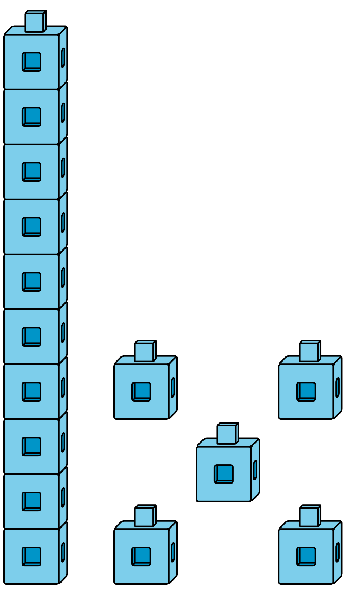
How many connecting cubes are there?
There are ___________ cubes.
Show your thinking using drawings, numbers, or words.

Student Responses
15. Sample response:
- There is 1 ten and 5 ones, which is $10+5$ or 15.
- I counted on. 10…11, 12, 13, 14, 15
- I counted them all.

