Unit 8 Lesson 10: Multiplication and Division

WU Which One Doesn’t Belong: Multiplication and Division (Warm up)

Student Task Statement
Which one doesn’t belong?
A
B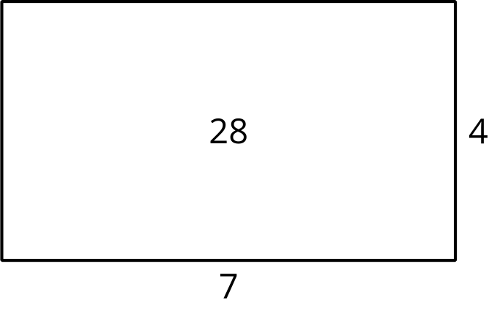
C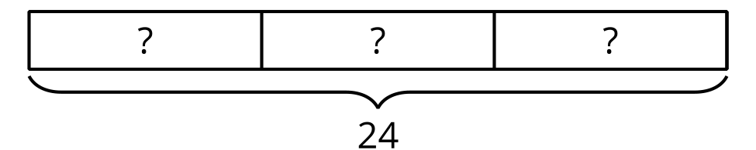
D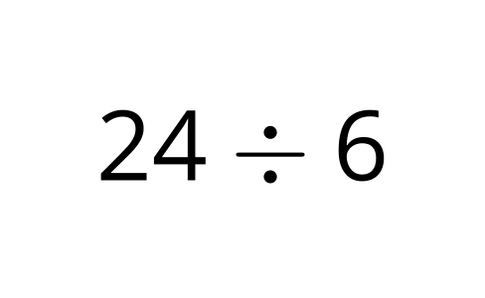

1 Card Sort: Find the Match

Student Task Statement
Your teacher will give you a card that shows an equation or a diagram.
- Find a classmate whose card represents the same situation or quantities as your card does. Be prepared to explain why your cards belong together.
- Work with your partner to create a poster that includes:
  - your cards
  - a different diagram that your division equation could represent
  - a situation that your division equation could represent
- Show your thinking and organize it so it can be followed by others.

2 Find the Match Gallery Walk

Student Task Statement
As you visit the posters with your partner, answer these questions:
- Describe a representation you saw that was different from the ones you showed in your poster.
- Choose a poster that is not yours. Describe one way that it shows the relationship between multiplication and division.
© CC BY 2021 Illustrative Mathematics®

