Unit 3 Lesson 11 Cumulative Practice Problems
- Suppose you wanted to graph the equation $y=\text{-}4x−1$.
  - Describe the steps you would take to draw the graph.
  - How would you check that the graph you drew is correct?
- Draw the following lines and then write an equation for each.
  - Slope is 0, $y$-intercept is 5
  - Slope is 2, $y$-intercept is -1
  - Slope is -2, $y$-intercept is 1
  - Slope is $\text{-}\frac{1}{2}$, $y$-intercept is -1
- 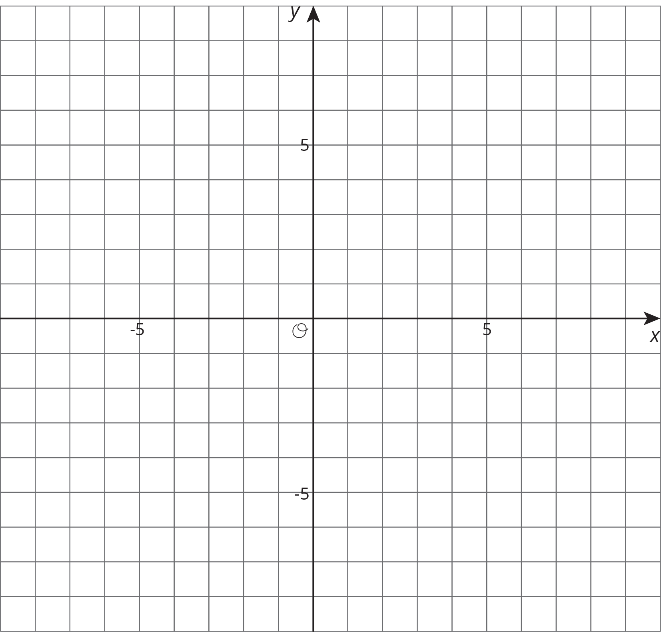
- Write an equation for each line.
- 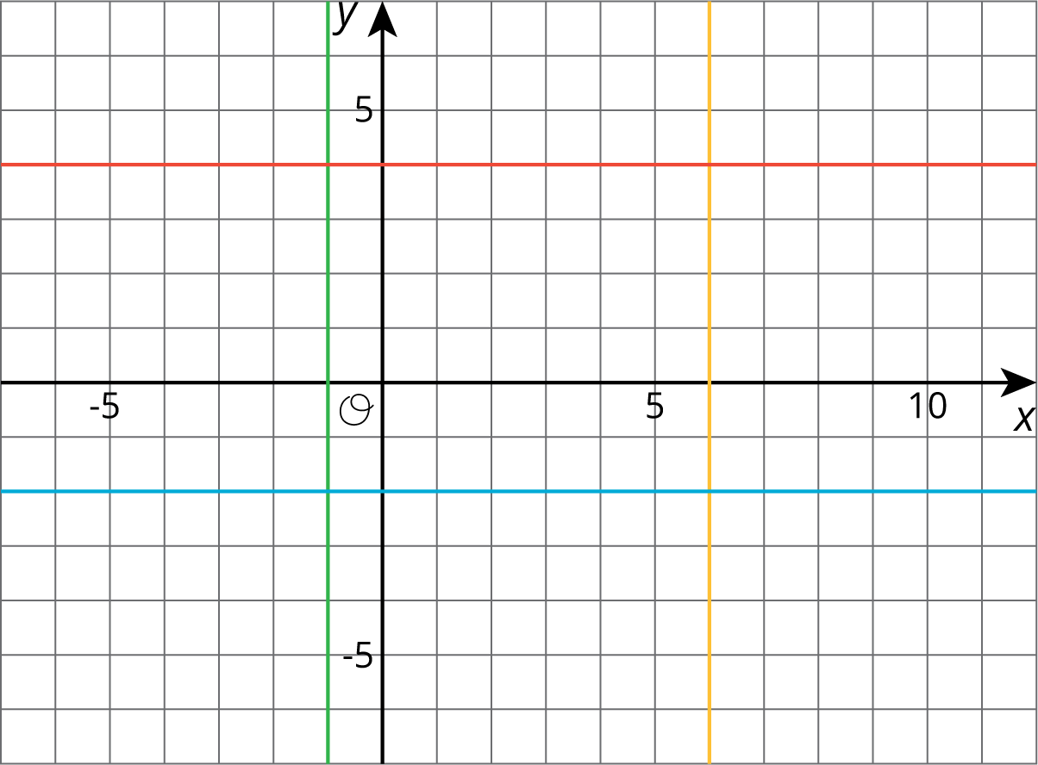

- A publisher wants to figure out how thick their new book will be. The book has a front cover and a back cover, each of which have a thickness of $\frac{1}{4}$ of an inch. They have a choice of which type of paper to print the book on.
  - Bond paper has a thickness of $\frac{1}{4}$ inch per one hundred pages. Write an equation for the width of the book, $y$, if it has $x$ hundred pages, printed on bond paper.
  - Ledger paper has a thickness of $\frac{2}{5}$ inch per one hundred pages. Write an equation for the width of the book, $y$, if it has $x$ hundred pages, printed on ledger paper.
  - If they instead chose front and back covers of thickness $\frac{1}{3}$ of an inch, how would this change the equations in the previous two parts?
- (From Unit 3, Lesson 7.)
© CC BY Open Up Resources. Adaptations CC BY IM.

