Lesson 1: What Is Volume?
- Let’s build and compare objects made of cubes.

Warm-up: Which One Doesn’t Belong: Objects Made of Cubes
Which one doesn’t belong?
A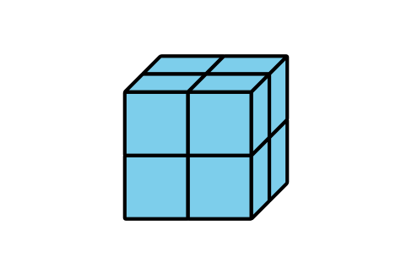
B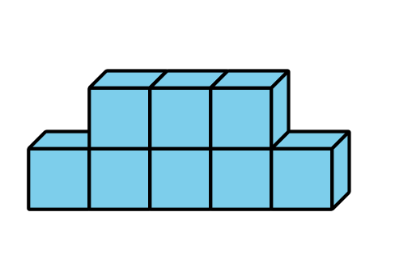
C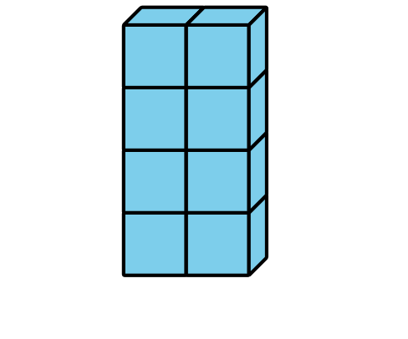
D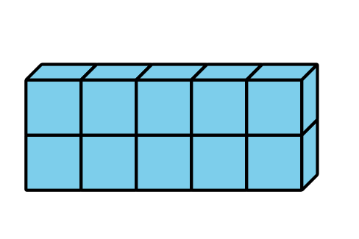

1.1: Build Objects with Cubes
- Which is bigger? Explain or show your reasoning.
- A
- B
- Which is bigger? Explain or show your reasoning.
- A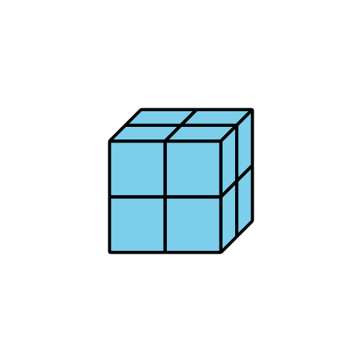
- B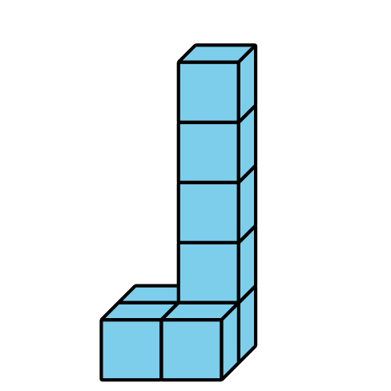
- What does it mean for an object to be “bigger”?

1.2: Build and Order
- Each group member:
  - Take a handful of connecting cubes.
  - Build an object.
- Order the objects by volume.
- Repeat.
- Each group member:
  - Take 9 connecting cubes.
  - Build an object.
- Order the objects by volume
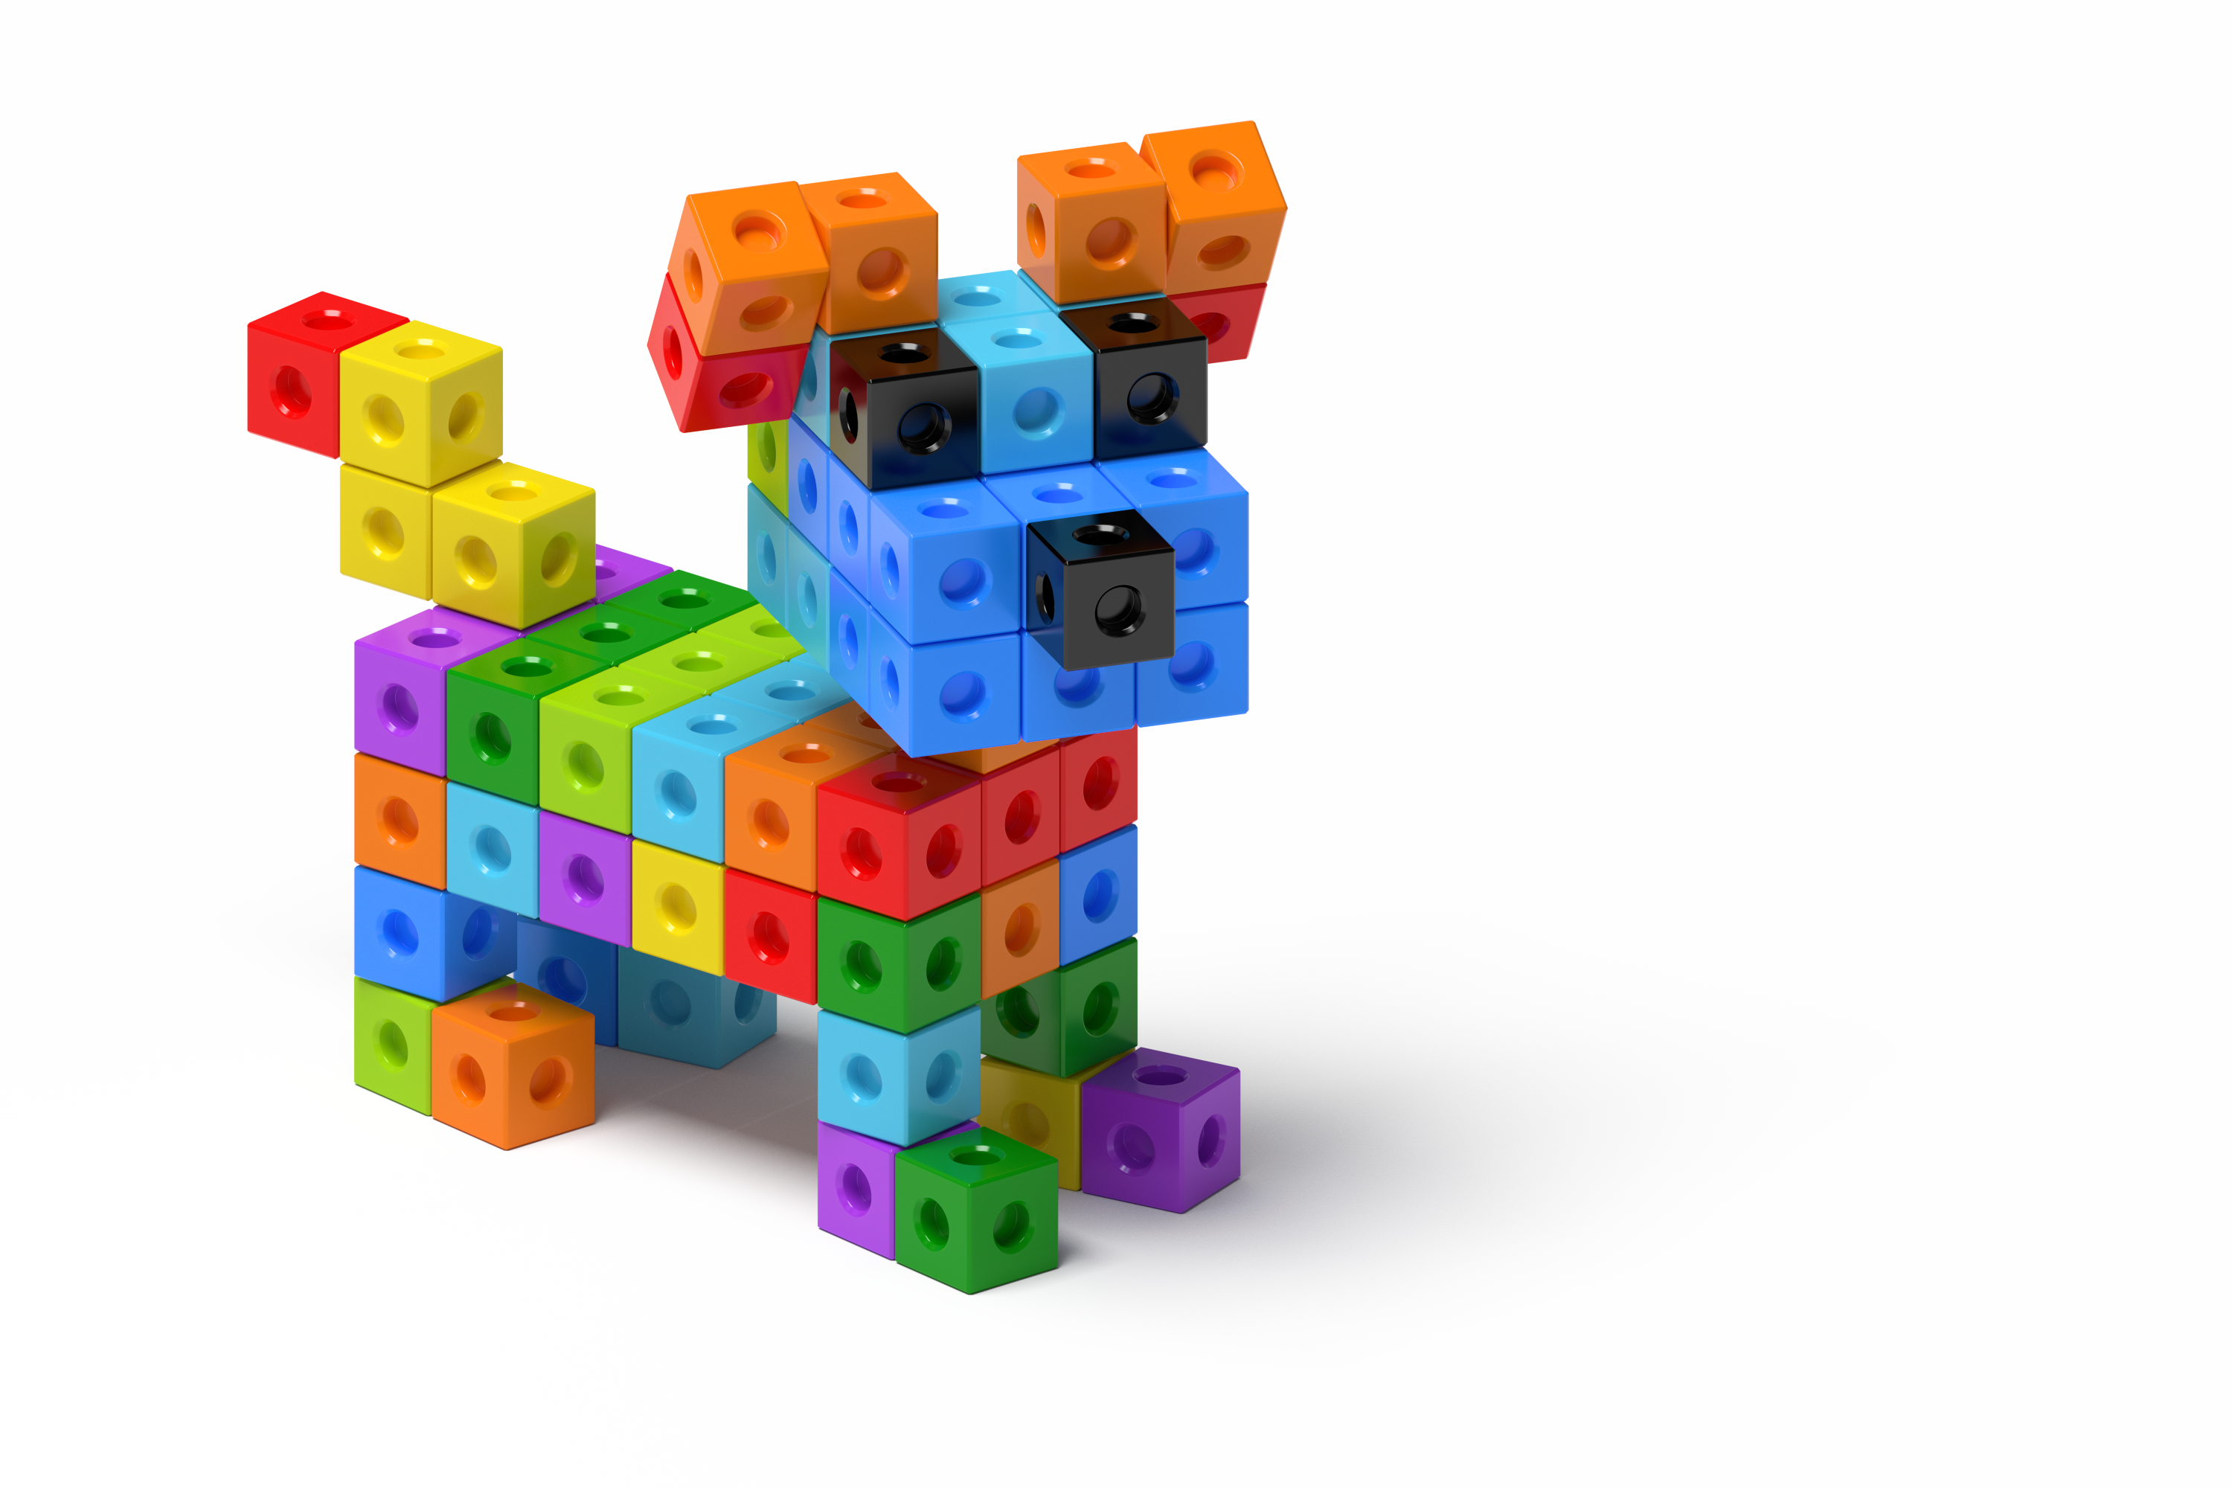
© CC BY 2021 Illustrative Mathematics®

