Lesson 1: How Do We Compose a Hundred?
- Let’s compose a hundred.
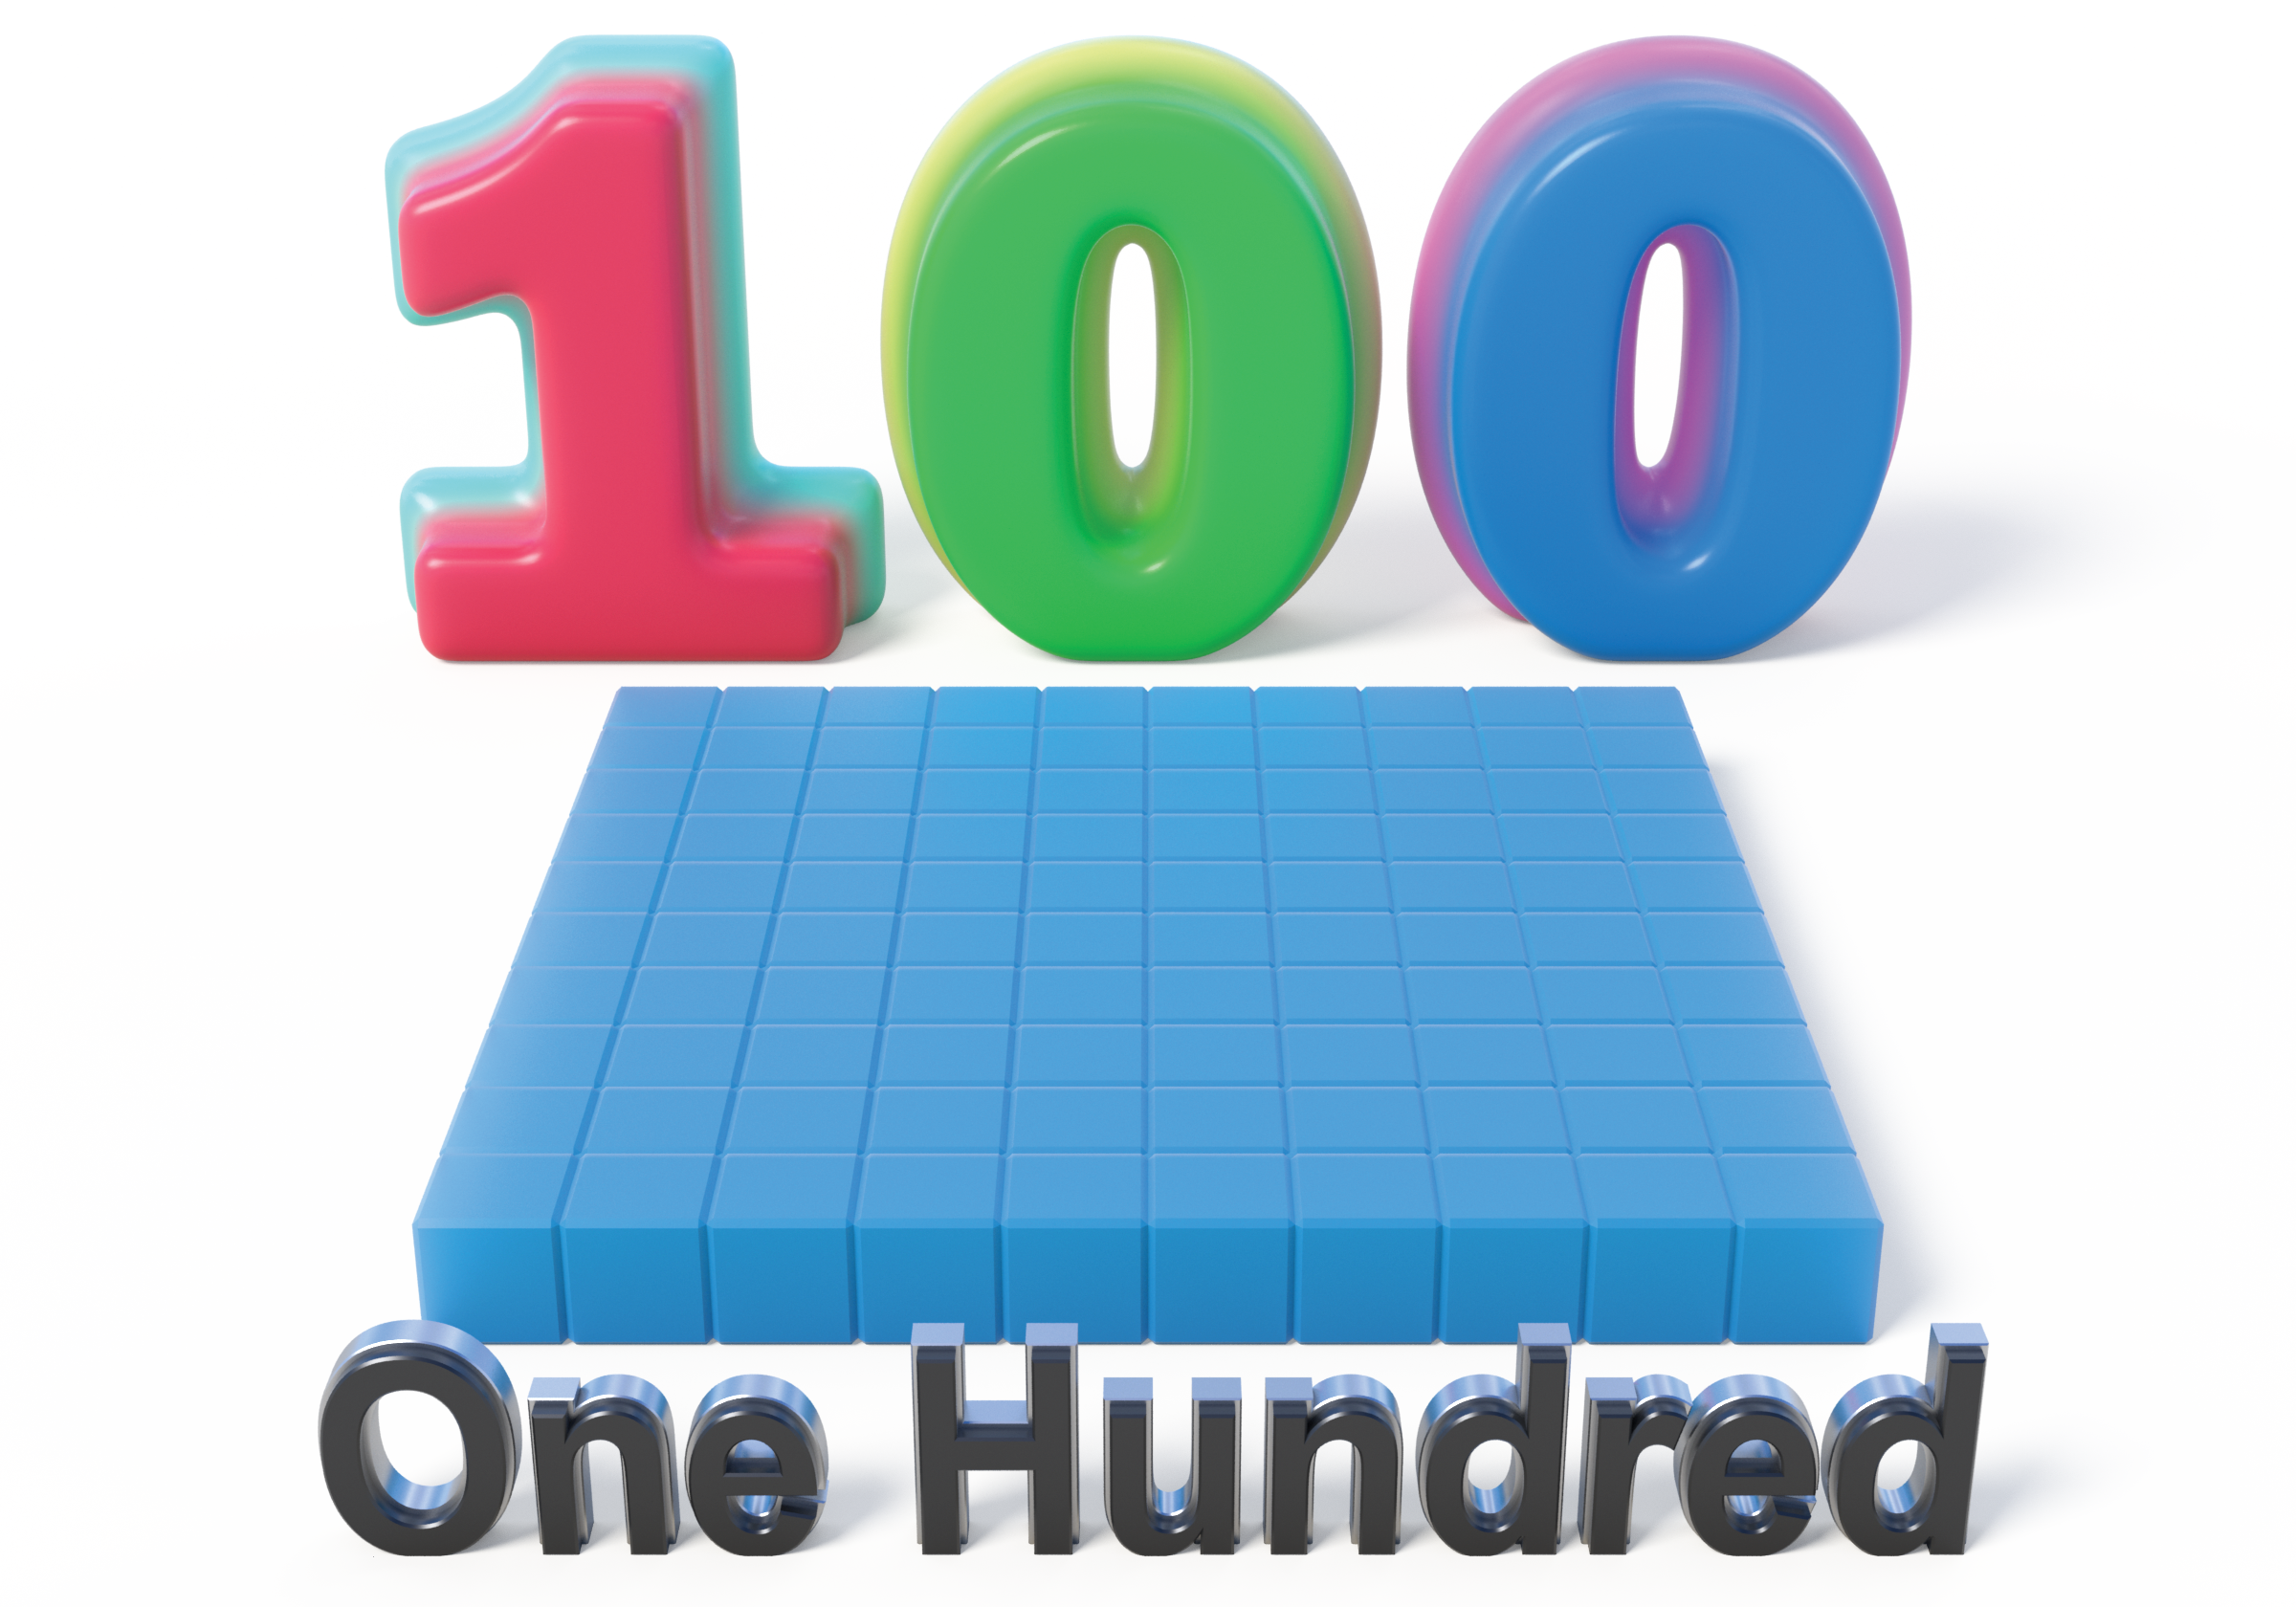

1.1: How Do We Make a Hundred?
- How many do you see? How do you see them?
- 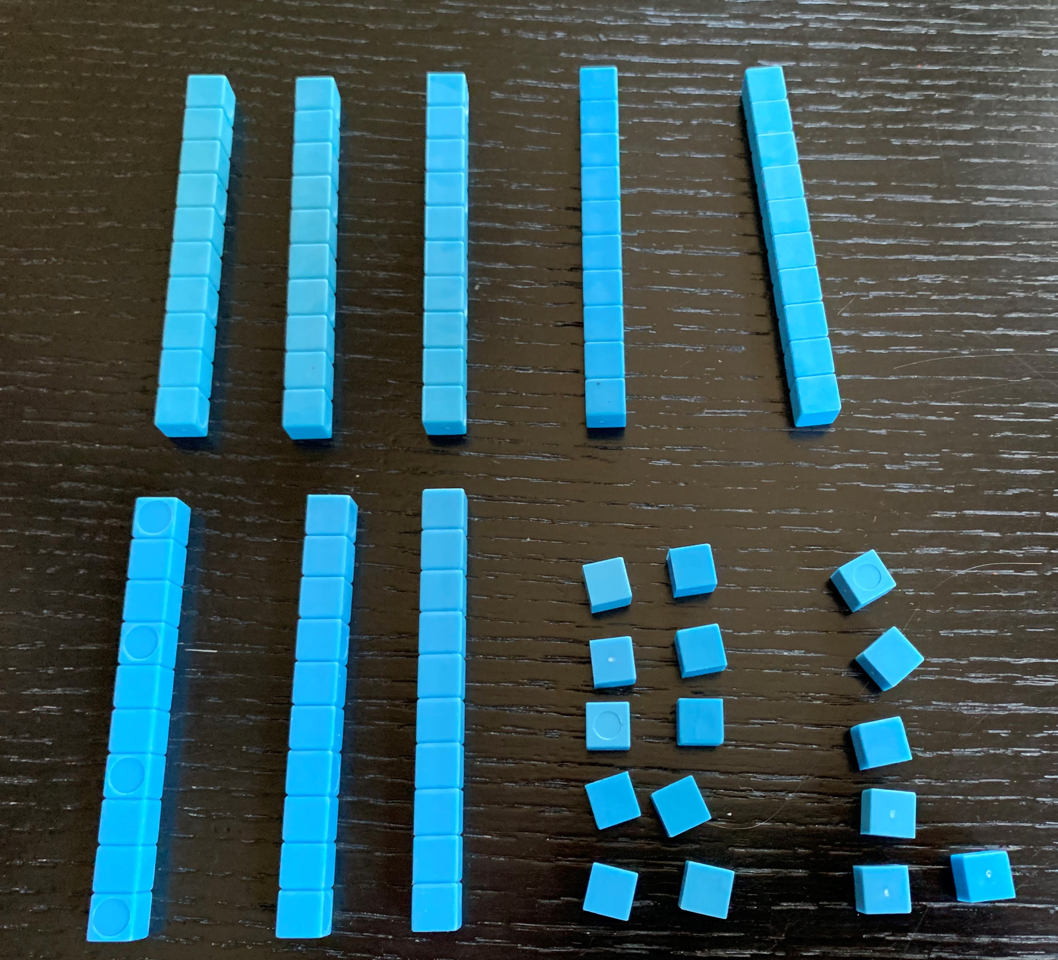
- Andre added more blocks.
- 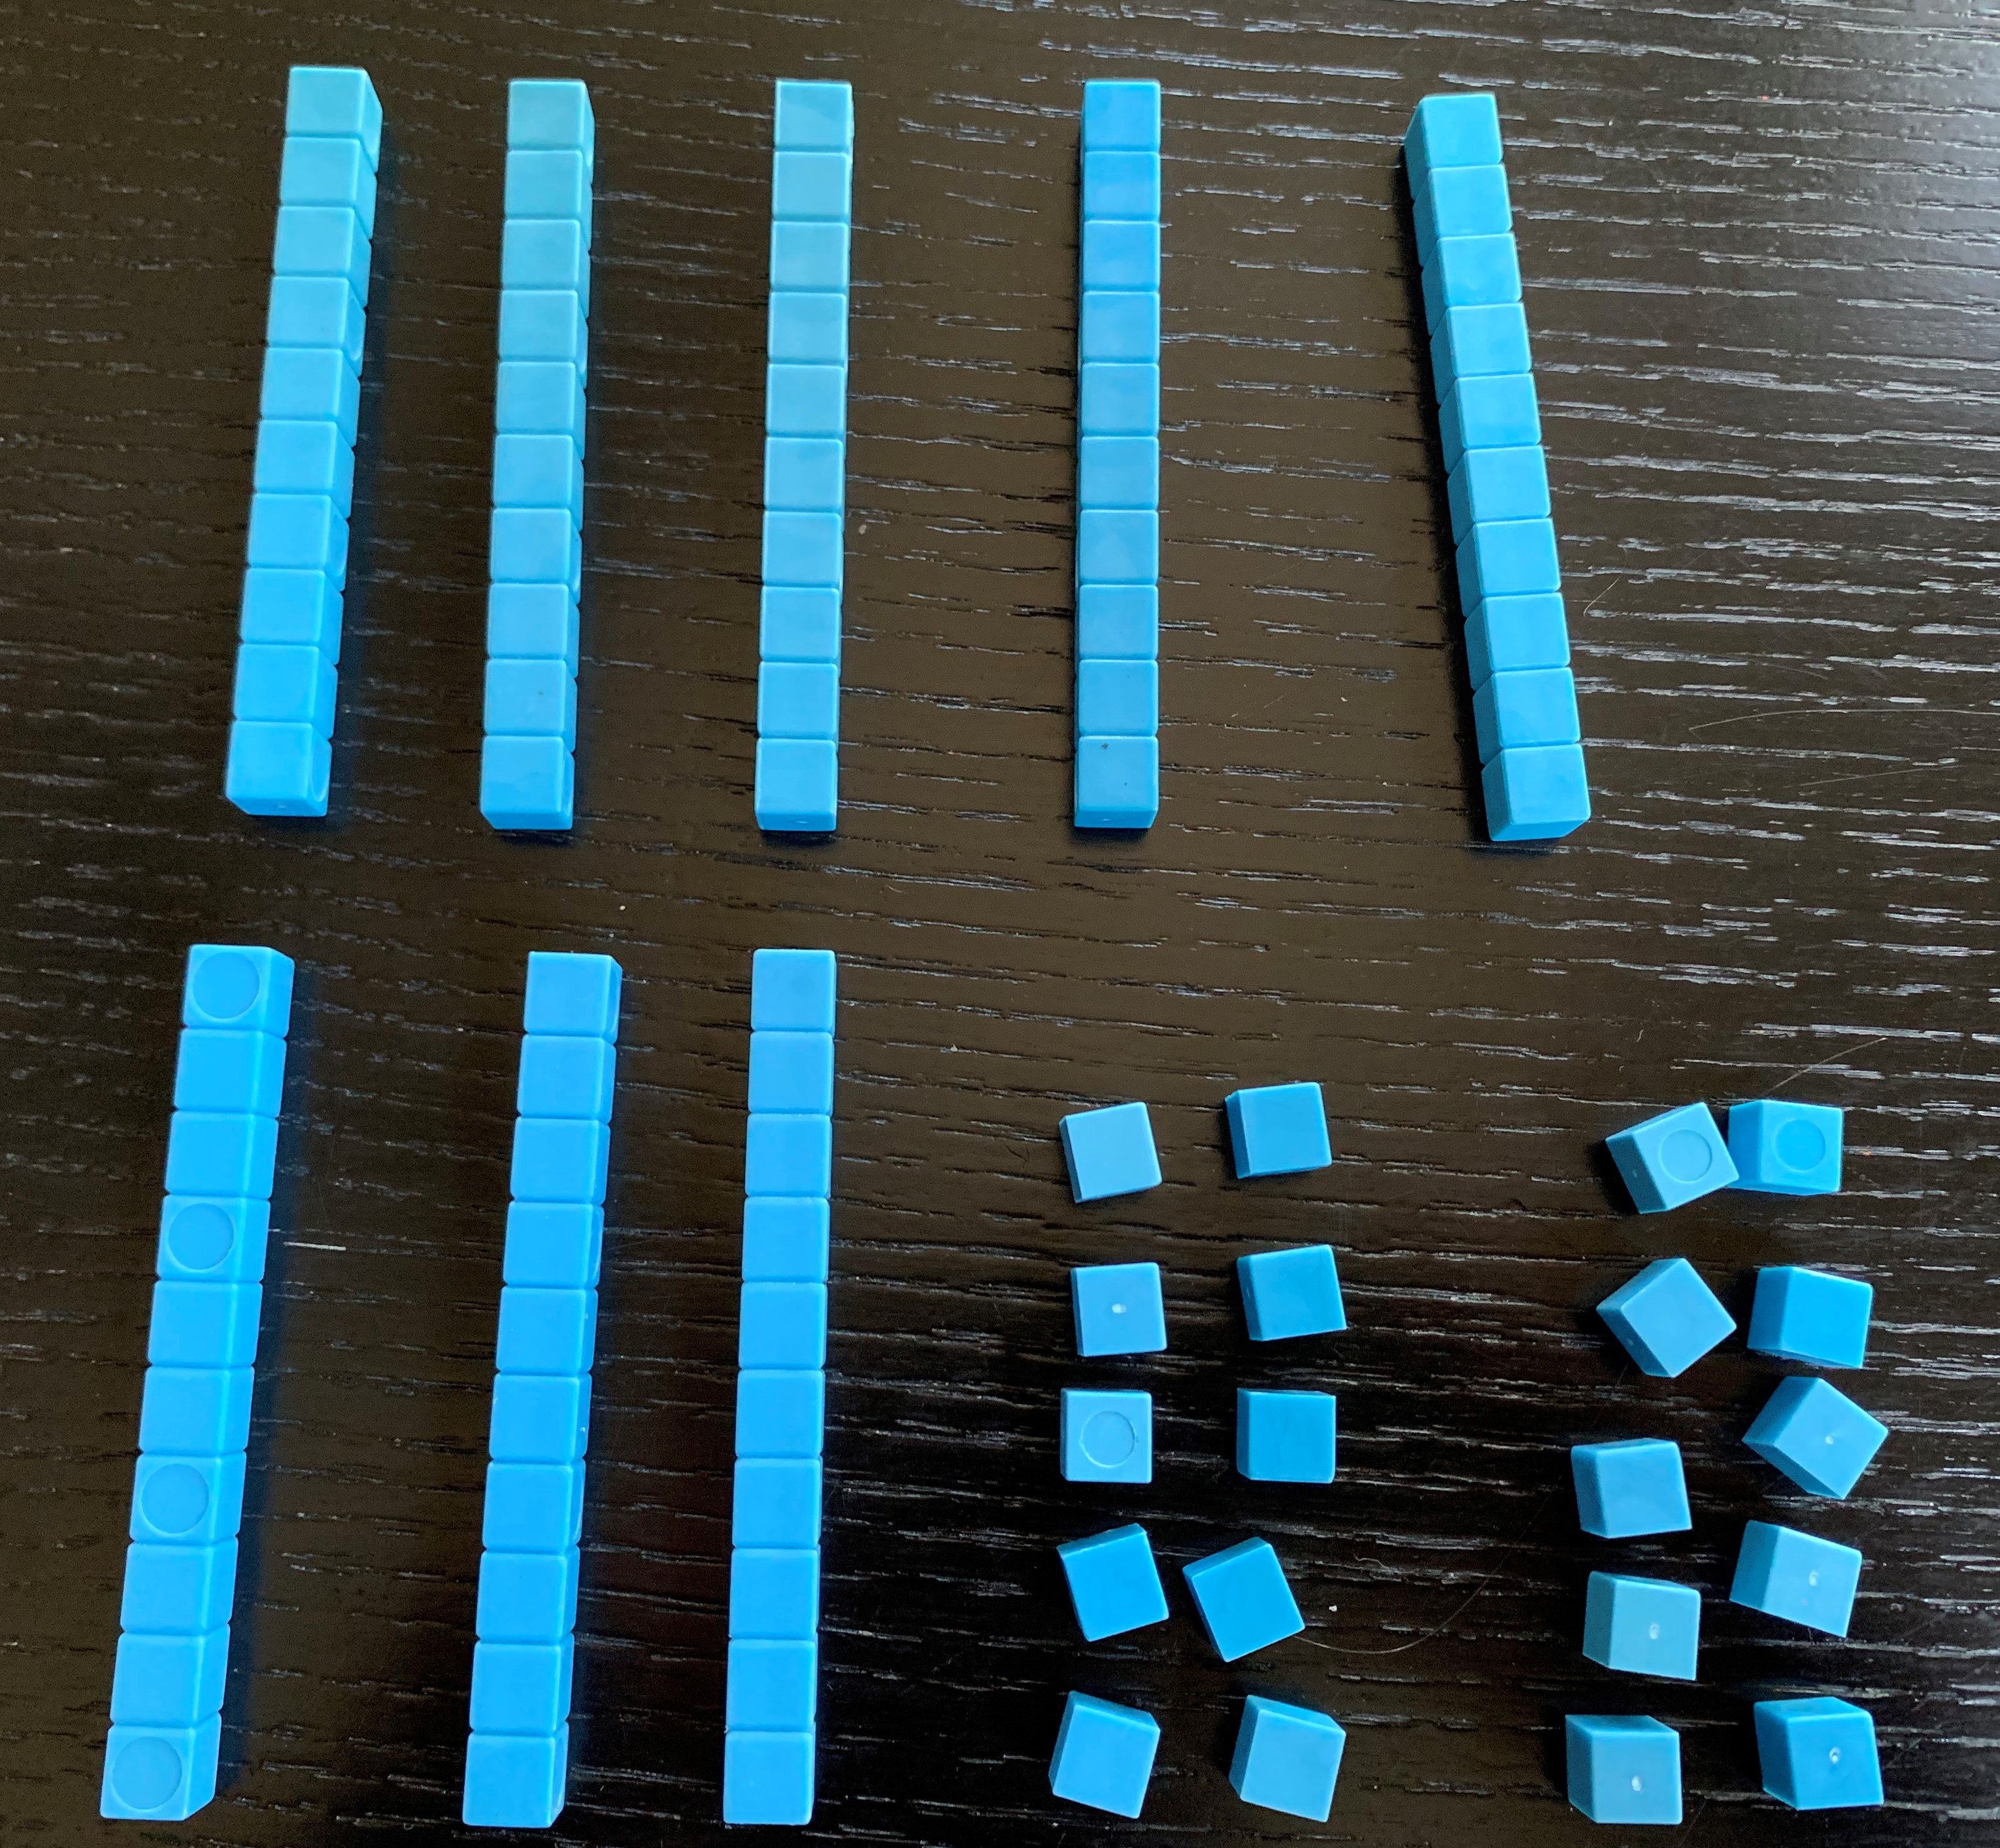
  - What is the value of Andre’s blocks now?
  - How many tens and ones are in this number?
- Andre made the same number with the fewest amount of blocks possible. Draw a base-ten diagram to show what Andre’s number looks like now. Use your base-ten blocks to help.

1.2: Different Ways to See 100
Three students were looking at 100 small squares arranged like this:
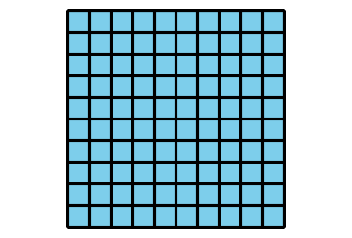
- Match the diagrams to the statements. Label each diagram with A, B, or C. Be prepared to explain your matches.
  - Priya said, “I see 100 ones.”
  - Kiran said, “I see 10 tens.”
  - Lin said, “I see 1 hundred.”
- 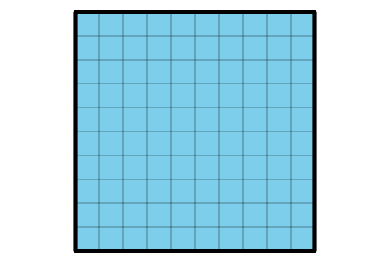
- 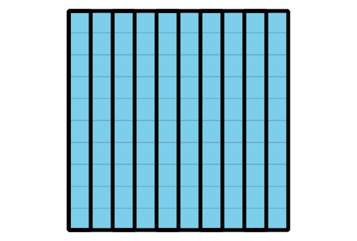
- 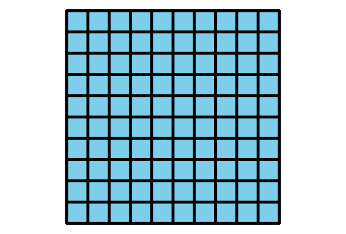
- ____________
- ____________
- ____________
- Represent $100+11$ with blocks or a diagram.
© CC BY 2021 Illustrative Mathematics®

