Unit 6 Lesson 4: Solid Shapes

WU Notice and Wonder: What is That Shape? (Warm up)

Student Task Statement
What do you notice? What do you wonder?
A
B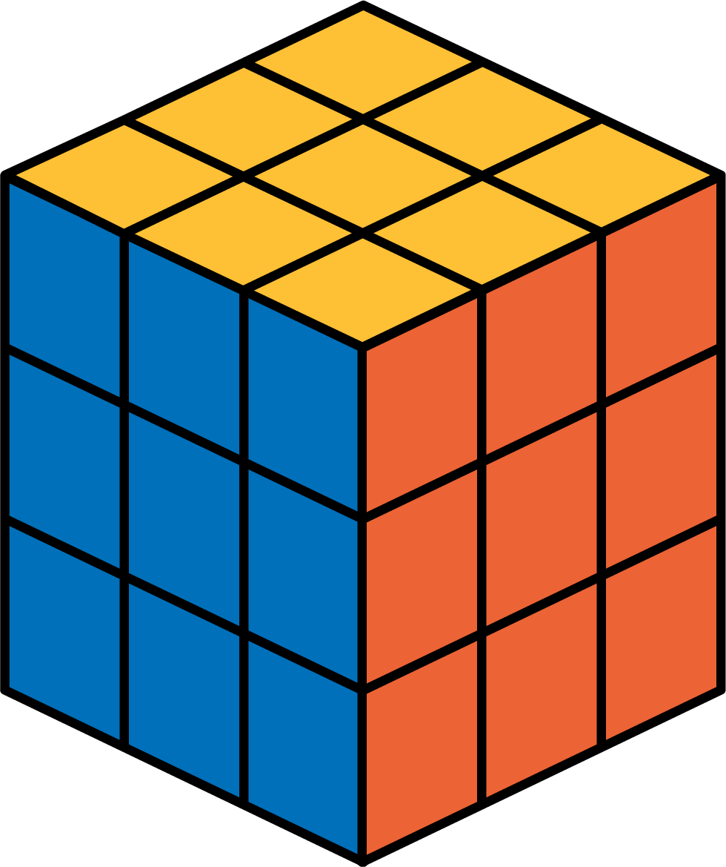
C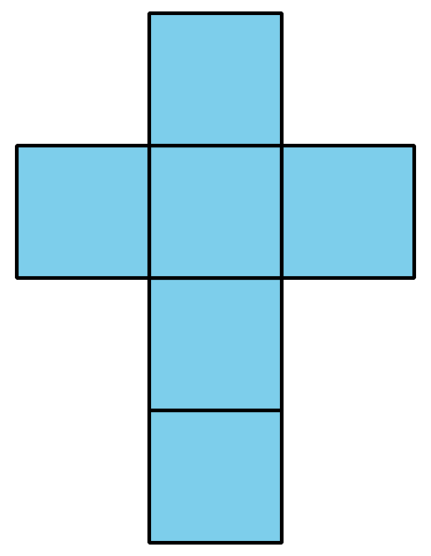
D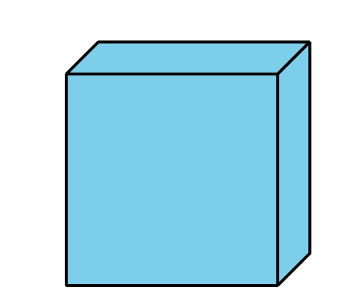

1 What is the Missing Shape?

Images for Launch
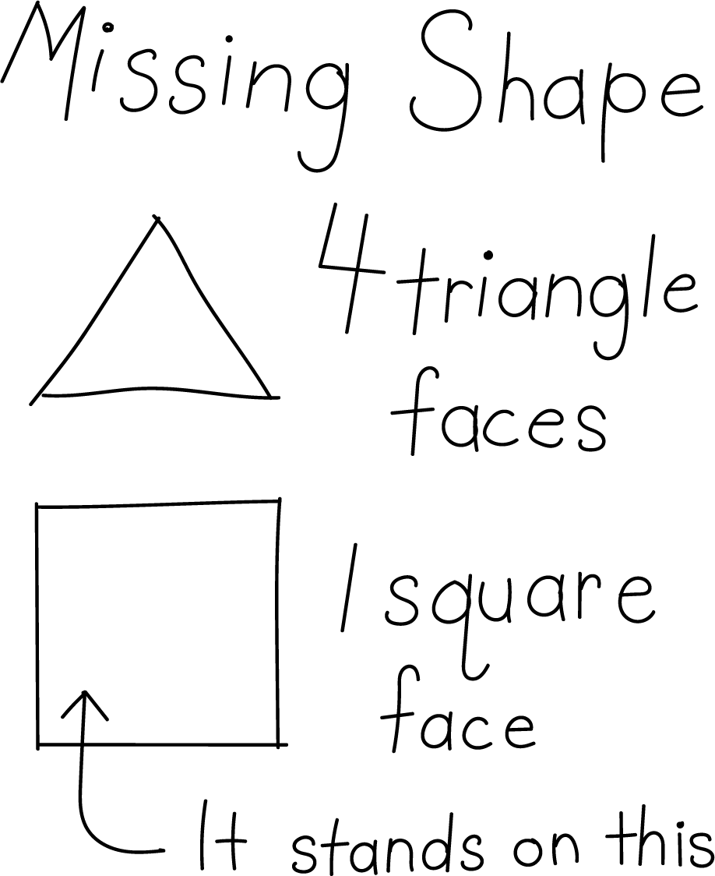

Student Task Statement
Make a poster to describe your solid shape. Use words, numbers, and drawings to help other groups name your shape.

2 Sort and Build Solid Shapes

Images for Launch
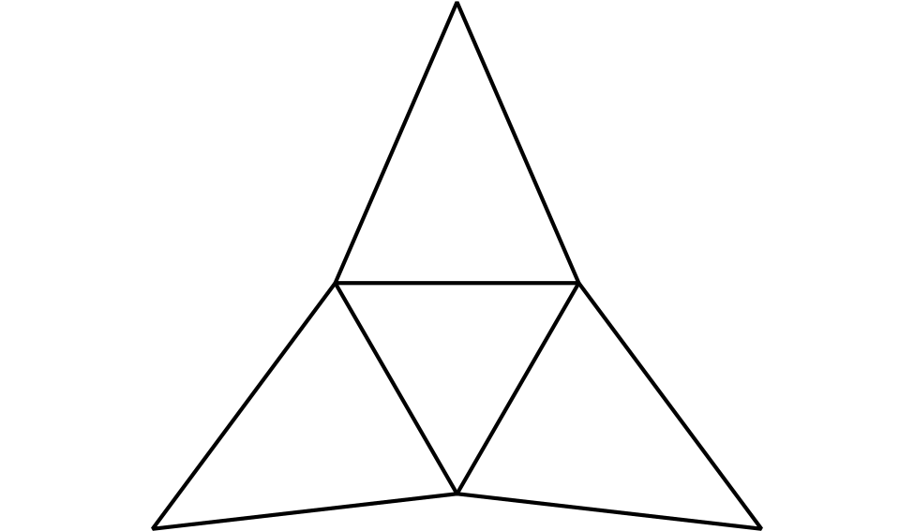

Student Task Statement
- Sort your shape design cards into groups. Be prepared to describe how you sort the cards.
- Match one of your cards to a solid shape. Explain your match.
- Which shape designs could be folded to make cubes? Explain.
- Your teacher will give you 2 shape designs. Fold the shape designs to make cubes. Compare your cube with your partner’s cube.

Activity Synthesis
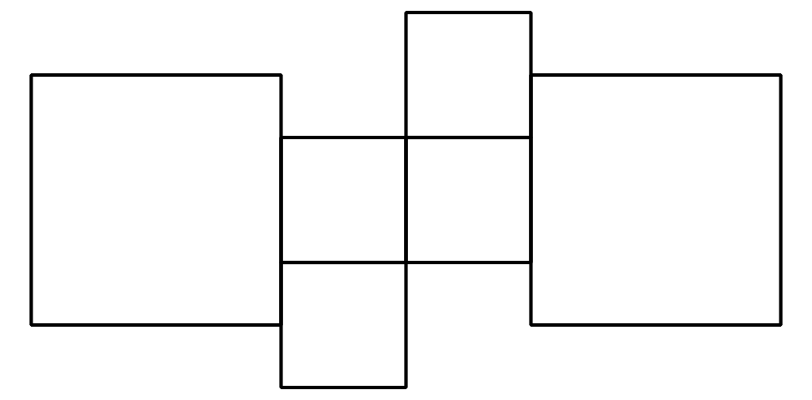
© CC BY 2021 Illustrative Mathematics®

