Unit 2 Lesson 15: Different Types of Story Problems

WU Which One Doesn’t Belong: Equations (Warm up)

Student Task Statement
Which one doesn’t belong?
- $7=\boxed{7}$
- $\boxed{7}=3+4$
- $4+3=\boxed{8}$
- $7−3=\boxed{4}$

1 What Questions Can We Ask?

Student Task Statement
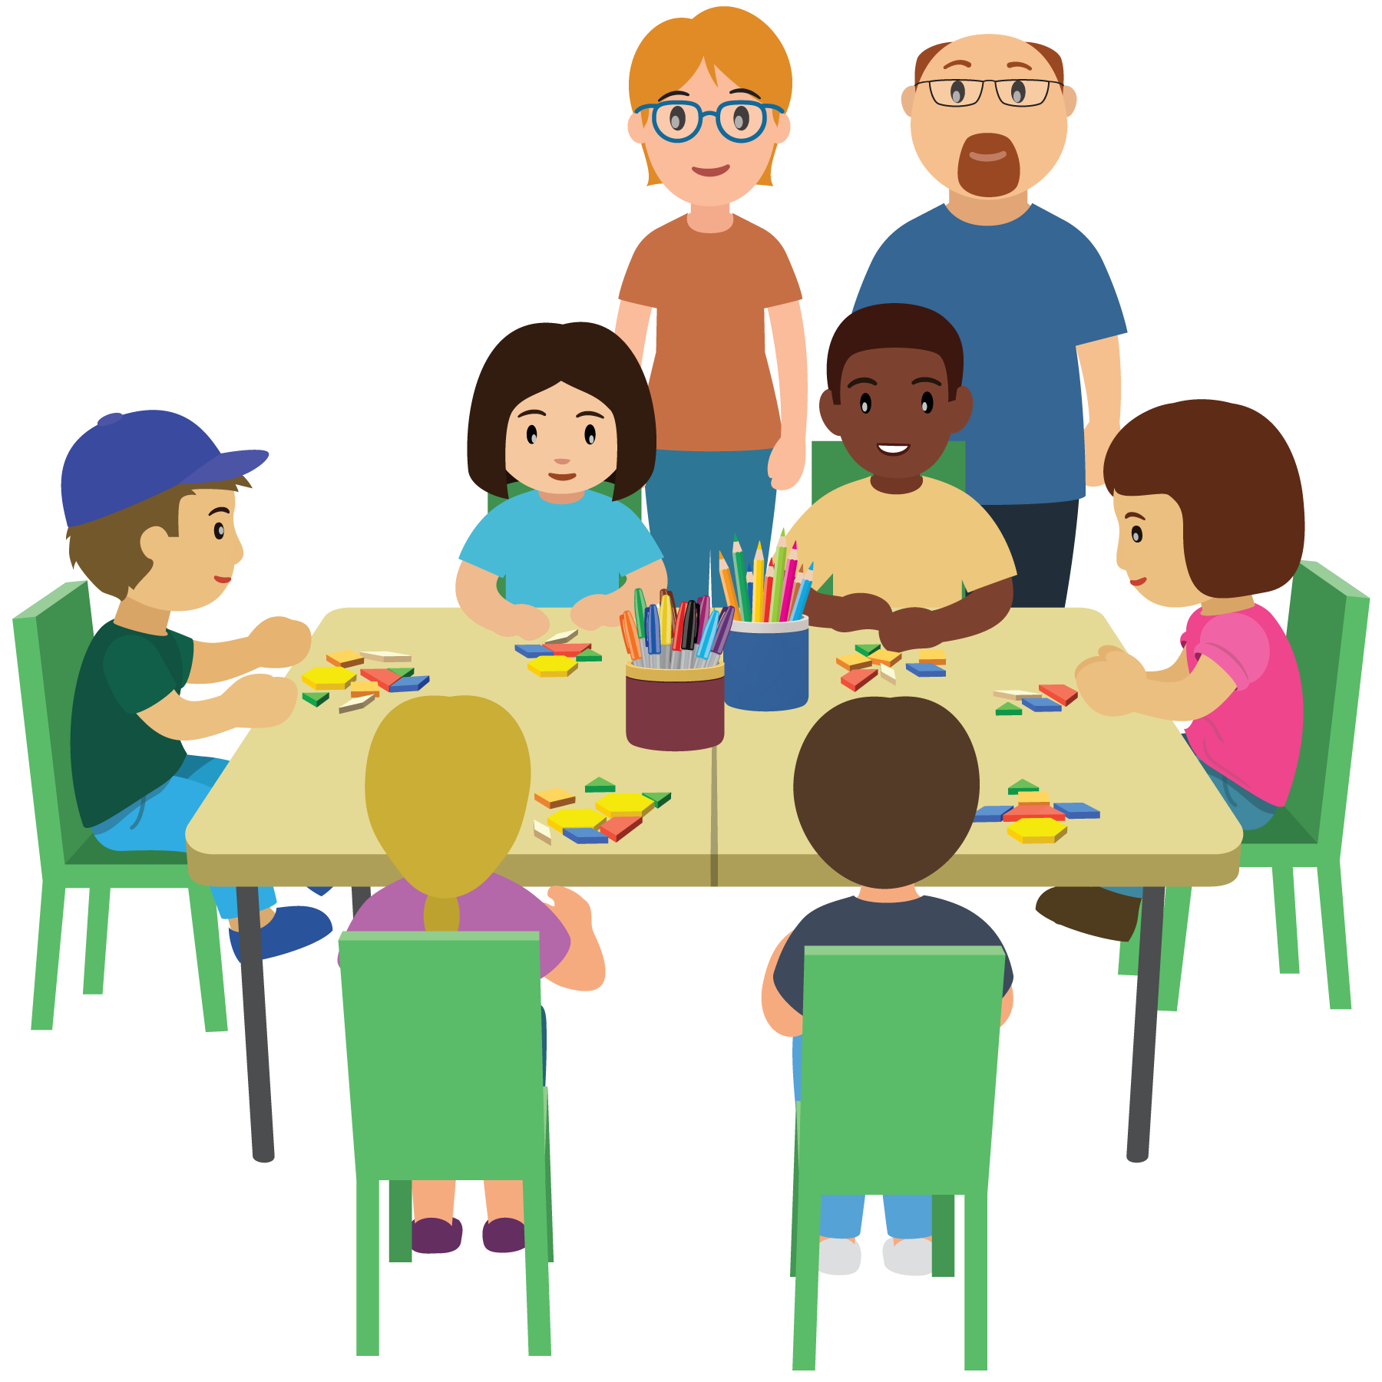
What mathematical questions can you ask about this image?

2 Different Types of Problems

Student Task Statement
- There are 8 people at the table.
6 of the people are students.
How many are teachers?
Show your thinking using drawings, numbers, or words.
- Equation: ________________________________
- Equation: ________________________________
- Elena has 4 pattern blocks.
Tyler has 6 pattern blocks.
How many fewer pattern blocks does Elena have than Tyler?
Show your thinking using drawings, numbers, or words.
- Equation: ________________________________
- Equation: ________________________________
- Tyler has 6 pattern blocks.
Elena has 4 patterns blocks.
How many pattern blocks do they have altogether?
Show your thinking using drawings, numbers, or words.
- Equation: ________________________________
- Equation: ________________________________
- Priya has 7 triangles and 3 squares.
How many more triangles than squares does Priya have?
Show your thinking using drawings, numbers, or words.
- Equation: ________________________________
- Equation: ________________________________

3 Centers: Choice Time

Student Task Statement
Choose a center.
Capture Squares
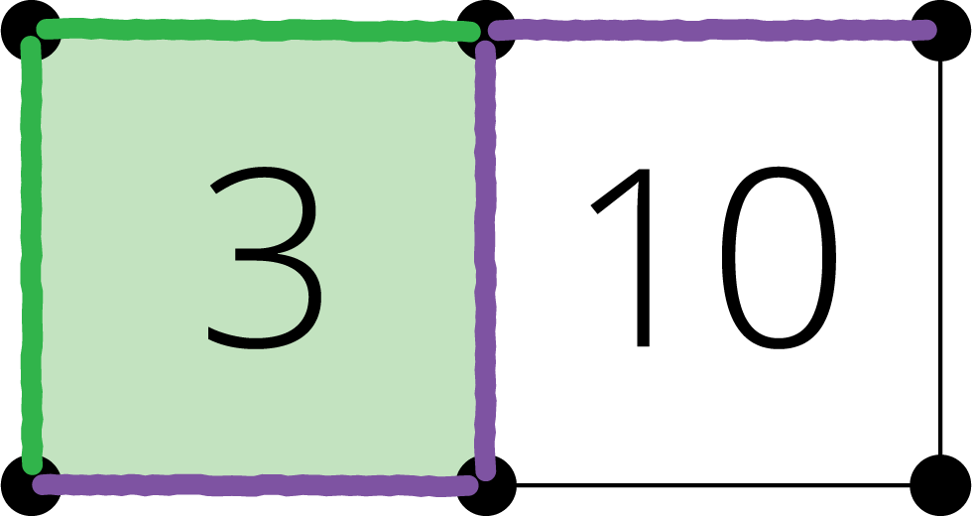
Shake and Spill
What's Behind My Back
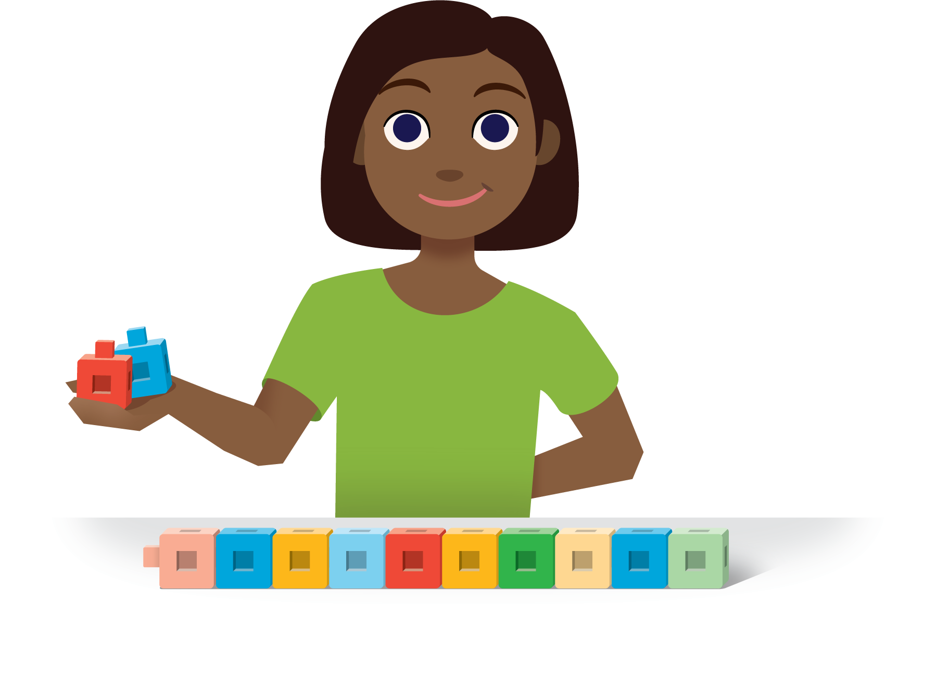
© CC BY 2021 Illustrative Mathematics®

