Lesson 14: Which Equation Matches?
- Let’s think about story problems and equations.

Warm-up: Which One Doesn’t Belong: Equations
Which one doesn’t belong?
- $10=6+4$
- $16−5=11$
- $11=6+4+1$
- 3+8=11
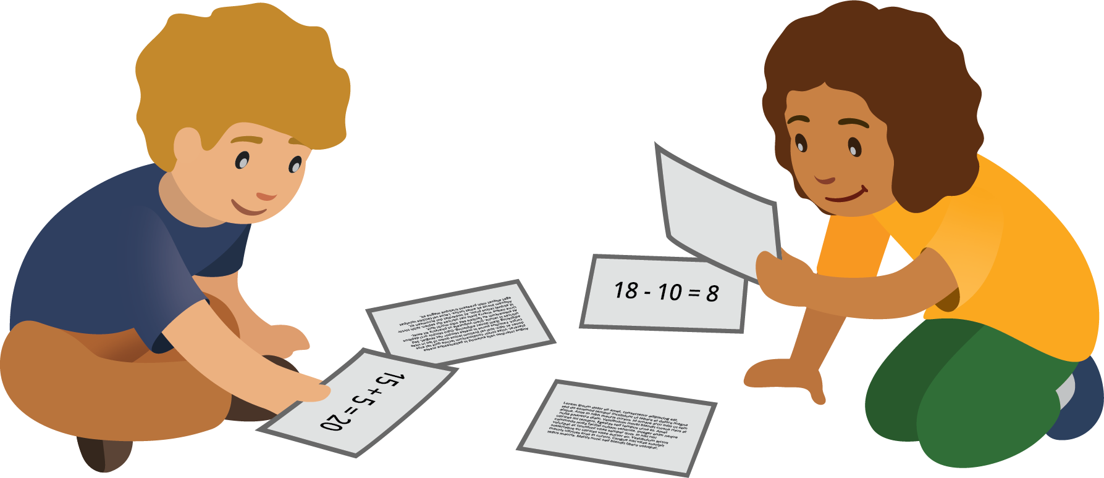

14.2: Stories and Equations
For each problem, circle the 2 equations that match the story.
You can use objects or drawings to represent the problem, if it helps you.
- Jada uses 8 pictures of people.
She also uses some pictures of animals.
Altogether she uses 11 pictures.
How many pictures of animals does she use?
  - $8+11=?$
  - $8+?=11$
  - $11−8=?$
- Kiran has 19 pictures.
He gives some to his sister.
Now, he has 11 pictures left.
How many pictures did Kiran give to his sister?
  - $11+19=?$
  - $19−?=11$
  - $19−11=?$
- Han’s collage has 16 stamps.
Lin’s collage has 10 fewer stamps.
How many stamps does Lin’s collage have?
  - $10+16=?$
  - $10+?=16$
  - $16−10=?$
- Elena uses 9 more stickers than Andre.
Andre uses 5 stickers.
How many stickers does Elena use?
  - $9+5=?$
  - $5+9=?$
  - $9−5=?$
- Noah has 6 stamps.
Tyler has 16 stamps.
How many fewer stamps does Noah have than Tyler?
  - $6+?=16$
  - $16−6=?$
  - $?−6=16$
- Clare has some stickers.
She gives 9 of them to her friends.
She has 5 stickers left.
How many stickers did Clare have to start with?
  - $5+9=?$
  - $9−5=?$
  - $?−9=5$
If you have time: Choose a story problem to solve.
Show your thinking using drawings, numbers, or words.
© CC BY 2021 Illustrative Mathematics®

