Lesson 5: Represent Measurement Data on Line Plots
- Let’s collect measurement data and show them on a line plot.

Warm-up: Number Talk: Multiply Teen Numbers
Find the value of each expression mentally.
- $3×10$
- $3×13$
- $6×13$
- $3×26$

5.1: Go for a Measurement Walk
- What objects will you measure?
- Record the lengths of the objects in the table (or on another sheet of paper).
- object | - length (inches)

- object | - length (inches)

5.2: Let’s Make a Line Plot
Create a line plot to represent the measurement data you collected. You will display and share your line plot with your class later.
You can use the blank number line here for your draft. Think about:
- how to label the tick marks so that all the measurements are included
- details to help others understand the data you collected

Section Summary
Section Summary
In this section, we learned how to measure lengths using rulers marked with halves and quarters of an inch.
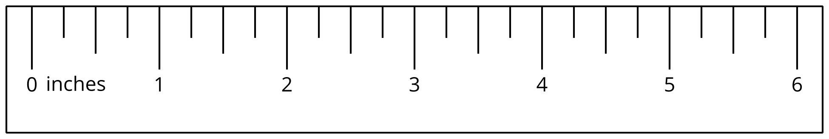
We also learned to make line plots to show measurements in half inches or quarter inches.
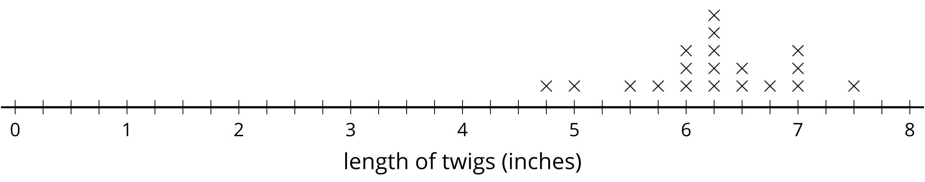
© CC BY 2021 Illustrative Mathematics®

