Lesson 10: Representing Large Numbers on the Number Line

10.1: Labeling Tick Marks on a Number Line
Label the tick marks on the number line. Be prepared to explain your reasoning.

10.2: Comparing Large Numbers with a Number Line
- Place the numbers on the number line. Be prepared to explain your reasoning.
  - 4,000,000
  - $5⋅{10}^{6}$
  - $5⋅{10}^{5}$
  - $75⋅{10}^{5}$
  - $(0.6)⋅{10}^{7}$
- Trade number lines with a partner, and check each other’s work. How did your partner decide how to place the numbers? If you disagree about a placement, work to reach an agreement.
- Which is larger, 4,000,000 or $75⋅{10}^{5}$? Estimate how many times larger.

10.3: The Speeds of Light
The table shows how fast light waves or electricity can travel through different materials.
material | speed (meters per second)
space | 300,000,000
water | $(2.25)⋅{10}^{8}$
copper wire (electricity) | 280,000,000
diamond | $124⋅{10}^{6}$
ice | $(2.3)⋅{10}^{8}$
olive oil | 200,000,000
- Which is faster, light through diamond or light through ice? How can you tell from the expressions for speed?
Let’s zoom in to highlight the values between $(2.0)⋅{10}^{8}$ and $(3.0)⋅{10}^{8}$.
- 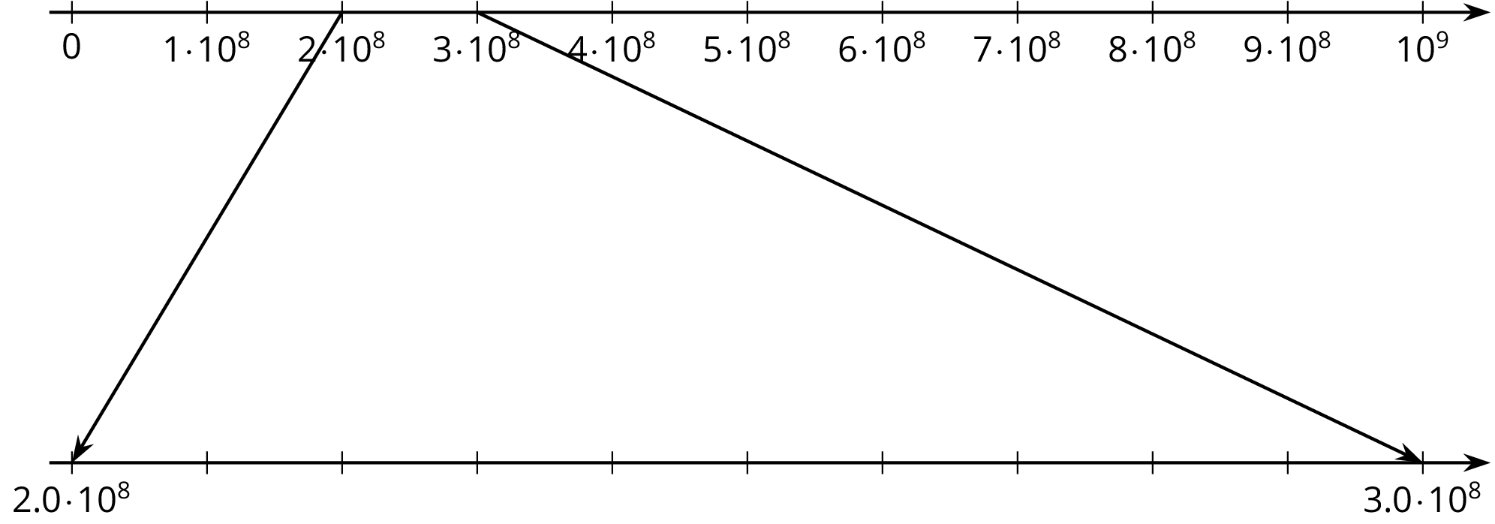
- Label the tick marks between $(2.0)⋅{10}^{8}$ and $(3.0)⋅{10}^{8}$.
- Plot a point for each speed on both number lines, and label it with the corresponding material.
- There is one speed that you cannot plot on the bottom number line. Which is it? Plot it on the top number line instead.
- Which is faster, light through ice or light through diamond? How can you tell from the number line?

Are you ready for more?
Find a four-digit number using only the digits 0, 1, 2, or 3 where:
- the first digit tells you how many zeros are in the number,
- the second digit tells you how many ones are in the number,
- the third digit tells you how many twos are in the number, and
- the fourth digit tells you how many threes are in the number.
The number 2,100 is close, but doesn’t quite work. The first digit is 2, and there are 2 zeros. The second digit is 1, and there is 1 one. The fourth digit is 0, and there are no threes. But the third digit, which is supposed to count the number of 2’s, is zero.
- Can you find more than one number like this?
- How many solutions are there to this problem? Explain or show your reasoning.

Lesson 10 Summary
There are many ways to compare two quantities. Suppose we want to compare the world population, about 7.4 billion
to the number of pennies the U.S. made in 2015, about
8,900,000,000
There are many ways to do this. We could write 7.4 billion as a decimal, 7,400,000,000, and then we can tell that there were more pennies made in 2015 than there are people in the world! Or we could use powers of 10 to write these numbers: $7.4⋅{10}^{9}$ for people in the world and $8.9⋅{10}^{9}$ for the number of pennies.
For a visual representation, we could plot these two numbers on a number line. We need to carefully choose our end points to make sure that the numbers can both be plotted. Since they both lie between ${10}^{9}$ and ${10}^{10}$, if we make a number line with tick marks that increase by one billion, or ${10}^{9}$, we start the number line with 0 and end it with $10⋅{10}^{9}$, or ${10}^{10}$. Here is a number line with the number of pennies and world population plotted:
© CC BY Open Up Resources. Adaptations CC BY IM.

