Unit 7 Lesson 13 Cumulative Practice Problems
- The elevation of a submarine is shown in the table. Draw and label coordinate axes with an appropriate scale and plot the points.
- time after noon (hours) | - elevation (meters)
- 0 | - -567
- 1 | - -892
- 2 | - -1,606
- 3 | - -1,289
- 4 | - -990
- 5 | - -702
- 6 | - -365

- The inequalities $h>42$ and $h<60$ represent the height requirements for an amusement park ride, where $h$ represents a person's height in inches.
- Write a sentence or draw a sign that describes these rules as clearly as possible.
- (From Unit 7, Lesson 8.)
- The $x$-axis represents the number of hours before or after noon, and the $y$-axis represents the temperature in degrees Celsius.
- 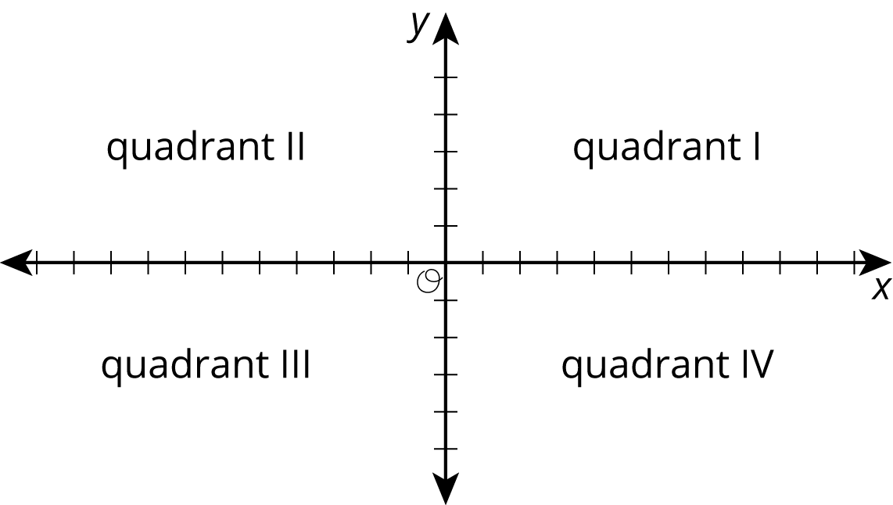
  - At 9 a.m., it was below freezing. In what quadrant would this point be plotted?
  - At 11 a.m., it was ${10}^{∘}\text{C}$. In what quadrant would this point be plotted?
  - Choose another time and temperature. Then tell the quadrant where the point should be plotted.
  - What does the point $(0,0)$ represent in this context?
- Solve each equation.
- $3a=12$
- $b+3.3=8.9$
- $1=\frac{1}{4}c$
- $5\frac{1}{2}=d+\frac{1}{4}$
- $2e=6.4$
- (From Unit 6, Lesson 4.)
© CC BY Open Up Resources. Adaptations CC BY IM.

