## Unit 5 Lesson 8: Using Graphs to Compare Relationships

### 1 Number Talk: Fraction Multiplication and Division (Warm up)

#### Student Task Statement

Find each product or quotient mentally.

### 2 Race to the Bumper Cars

#### Student Task Statement

Diego, Lin, and Mai went from the ticket booth to the bumper cars.

1. Use each description to complete the table representing that person’s journey.
   1. Diego left the ticket booth at the same time as Tyler. Diego jogged ahead at a steady pace and reached the bumper cars in 30 seconds.
   2. Lin left the ticket booth at the same time as Tyler. She ran at a steady pace and arrived at the bumper cars in 20 seconds.
   3. Mai left the booth 10 seconds later than Tyler. Her steady jog enabled her to catch up with Tyler just as he arrived at the bumper cars.

|  |  |
| --- | --- |
| * Diego’s time (seconds) | * Diego’s distance (meters) |
| * 0 |  |
| * 15 |  |
| * 30 | * 50 |
| * 1 |  |

|  |  |
| --- | --- |
| * Lin’s time (seconds) | * Lin’s distance (meters) |
|  | * 0 |
|  | * 25 |
| * 20 | * 50 |
| * 1 |  |

|  |  |
| --- | --- |
| * Mai’s time (seconds) | * Mai’s distance (meters) |
|  | * 0 |
|  | * 25 |
| * 40 | * 50 |
| * 1 |  |

1. Using a different color for each person, draw a graph of all four people’s journeys (including Tyler's from the other day).

* 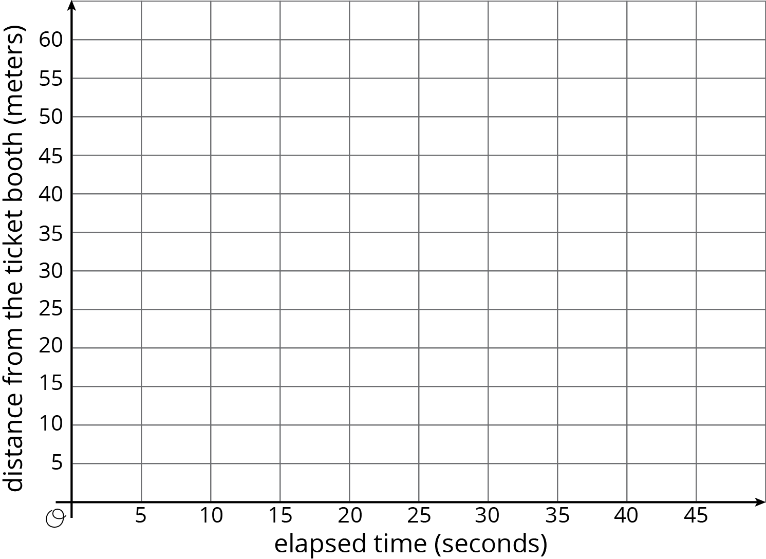

1. Which person is moving the most quickly? How is that reflected in the graph?

### 3 Space Rocks and the Price of Rope

#### Student Task Statement

1. Meteoroid Perseid 245 and Asteroid x travel through the solar system. The graph shows the distance each traveled after a given point in time.

* 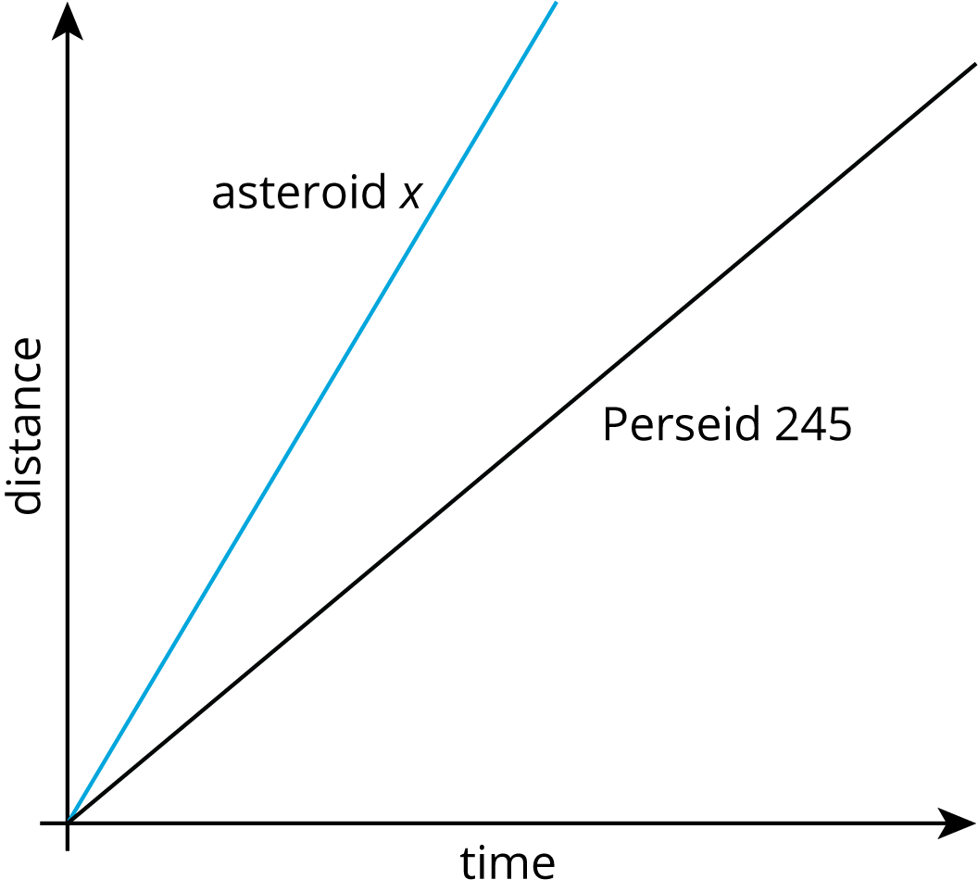
* Is Asteroid x traveling faster or slower than Perseid 245? Explain how you know.

1. The graph shows the price of different lengths of two types of rope.

* 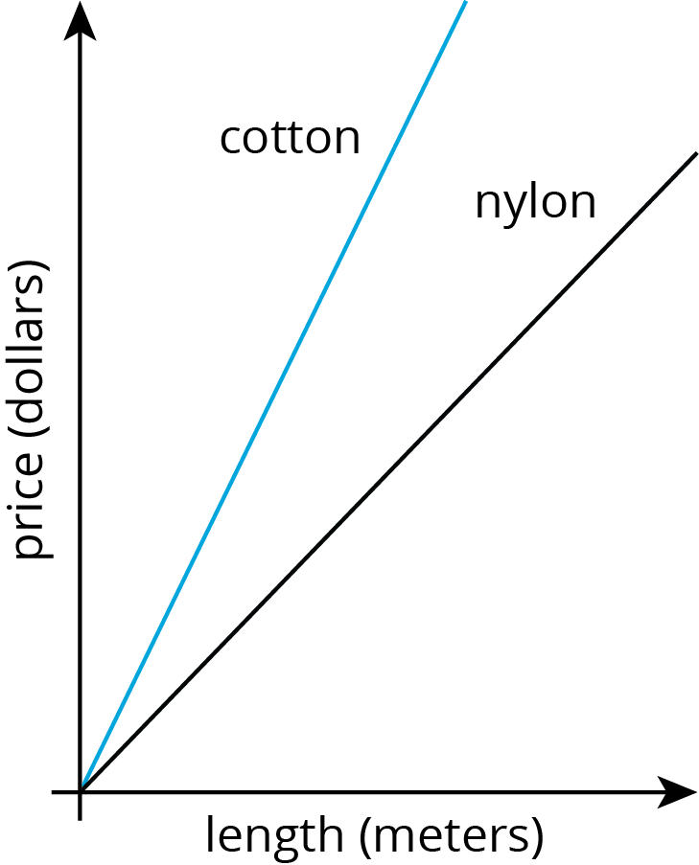
* If you buy $1.00 of each kind of rope, which one will be longer? Explain how you know.



© CC BY Open Up Resources. Adaptations CC BY IM.