Lesson 4 Practice Problems
- The scatter plot shows the number of times a player came to bat and the number of hits they had.
- 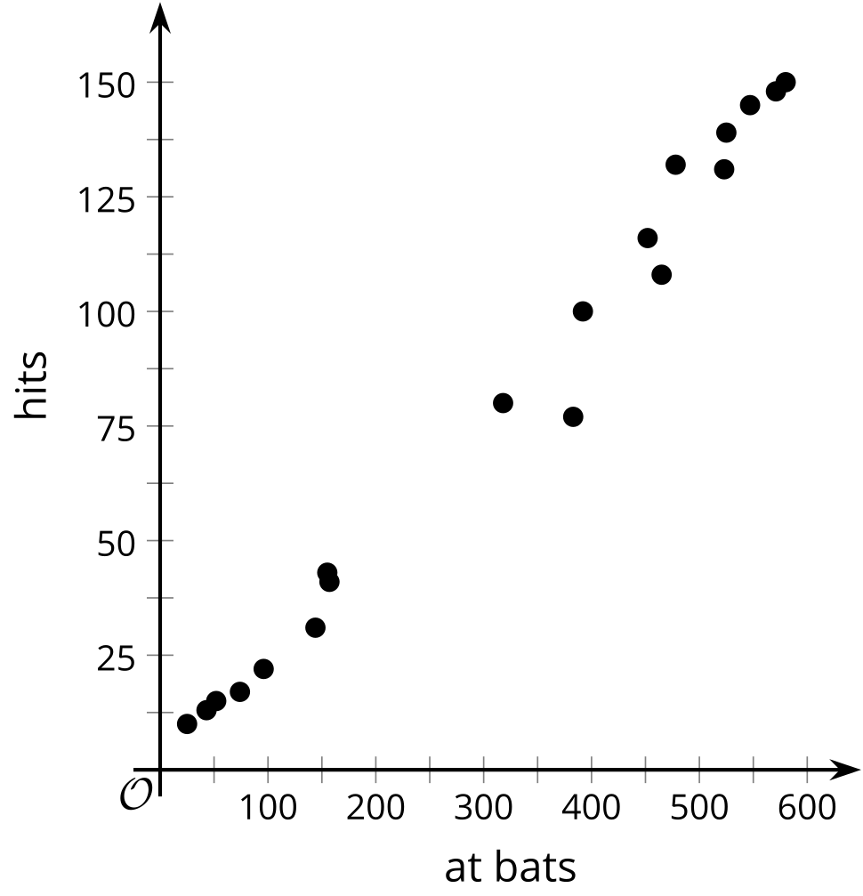
- The scatter plot includes a point at $\left(318,80\right)$. Describe the meaning of this point in this situation.
- The scatter plot shows the number of minutes people had to wait for service at a restaurant and the number of staff available at the time.
- 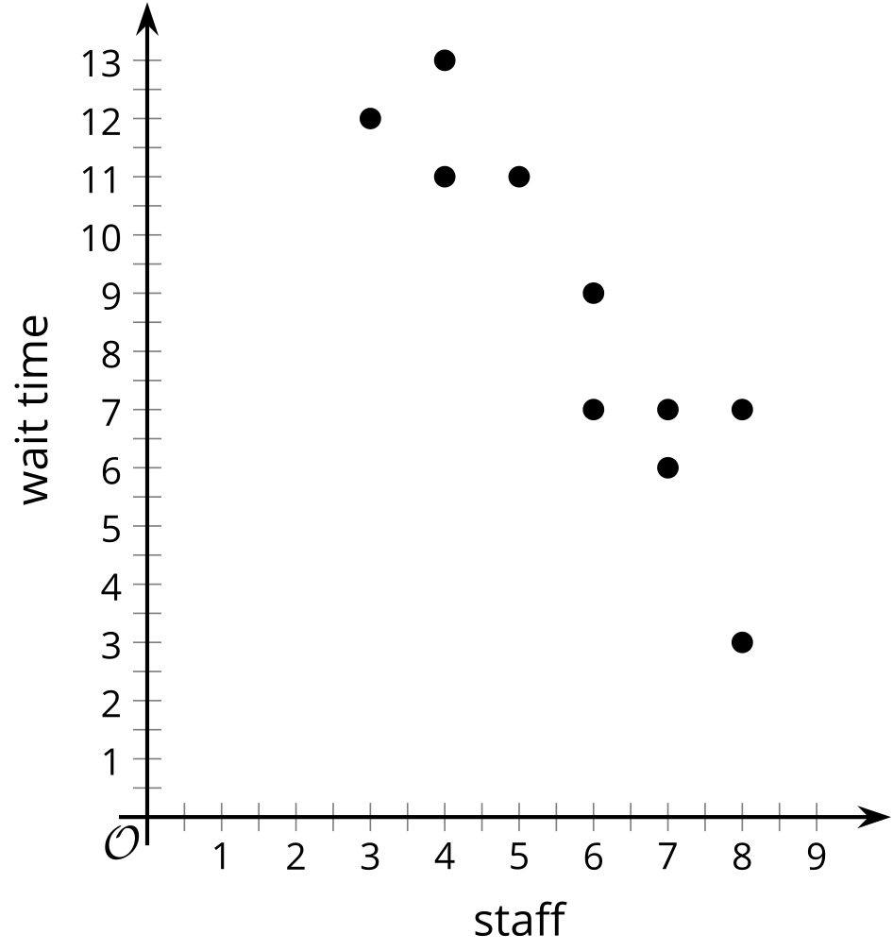
- A line that models the data is given by the equation $y=\text{-}1.62x+18$, where $y$ represents the wait time, and $x$ represents the number of staff available.
  - The slope of the line is -1.62. What does this mean in this situation? Is it realistic?
  - The $y$-intercept is $\left(0,18\right)$. What does this mean in this situation? Is it realistic?
- A taxi driver records the time required to complete various trips and the distance for each trip.
- 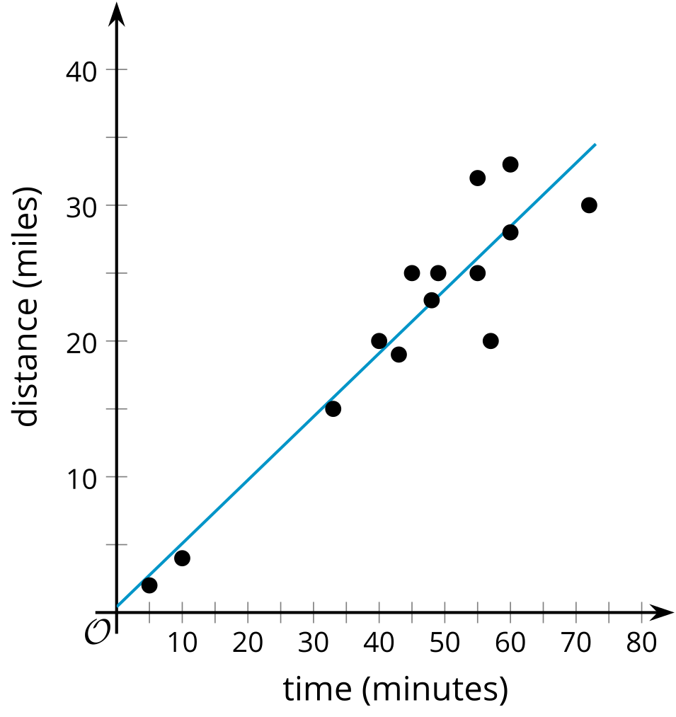
- The best fit line is given by the equation $y=0.467x+0.417$, where $y$ represents the distance in miles, and $x$ represents the time for the trip in minutes.
  - Use the best fit line to estimate the distance for a trip that takes 20 minutes. Show your reasoning.
  - Use the best fit line to estimate the time for a trip that is 6 miles long. Show your reasoning.
- Data is collected about the number of wins and losses by a random sample of teams with an animal mascot and those with another kind of mascot. The column relative frequencies are shown in the table. Based on the information in the table, is there an association between the variables? Explain your reasoning.
 | - animal mascot | - other type of mascot
- wins | - 74% | - 49%
- losses | - 26% | - 51%
- (From Unit 3, Lesson 3.)
- A random selection of indoor and outdoor pool managers are surveyed about the number of people in each age group that swim there. Results from the survey are displayed in the two-way table. Based on the data, does there appear to be an association between pool type and age group? Explain your reasoning.
 | - outdoor pool | - indoor pool
- younger than 18 | - 317 | - 41
- 18 or older | - 352 | - 163

- (From Unit 3, Lesson 3.)
- Data from a random sample of people are collected about how they watch movies in the genres of action or mystery. Which value would best fit in the missing cell to suggest there is no association between the genre and how the movies are watched?
 | - streaming movies | - disc rental
- action | - 526 | - 147
- mystery | - 317

  - 19
  - 89
  - 147
  - 320
- (From Unit 3, Lesson 3.)
© CC BY 2019 by Illustrative Mathematics®

