Lesson 2: Measure Volume
- Let’s count cubes.

Warm-up: Which One Doesn't Belong: Cubes
Which one doesn’t belong?
A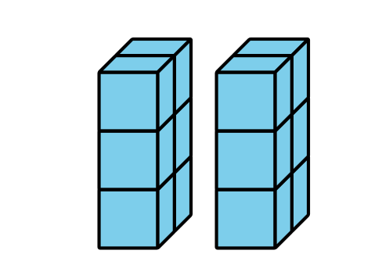
B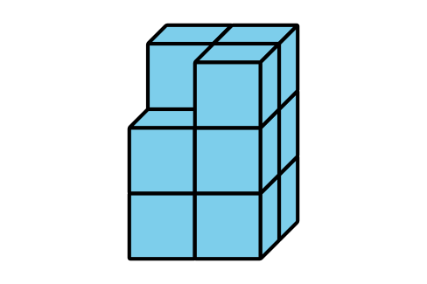
C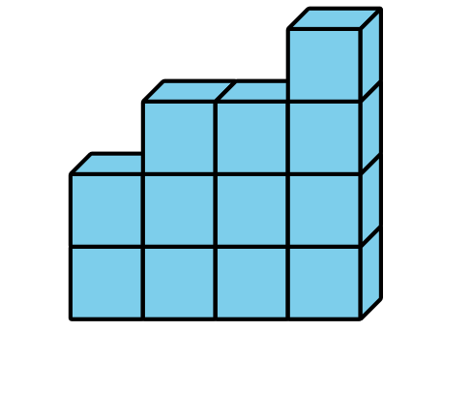
D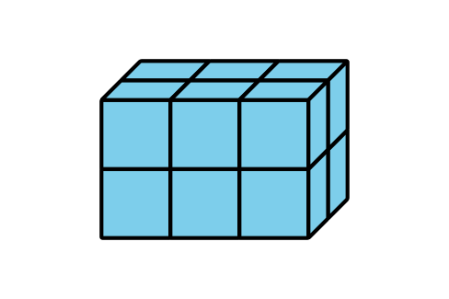

2.1: Finding Volume
- Partner A: Build an object using 8–12 cubes and give the object to Partner B.
- Partner B: Explain how you would count the number of cubes in the object.
- Partner A: Explain if you would count the cubes in the same way or in a different way.
- Switch roles and repeat.
- Which objects were easiest to count? Why?
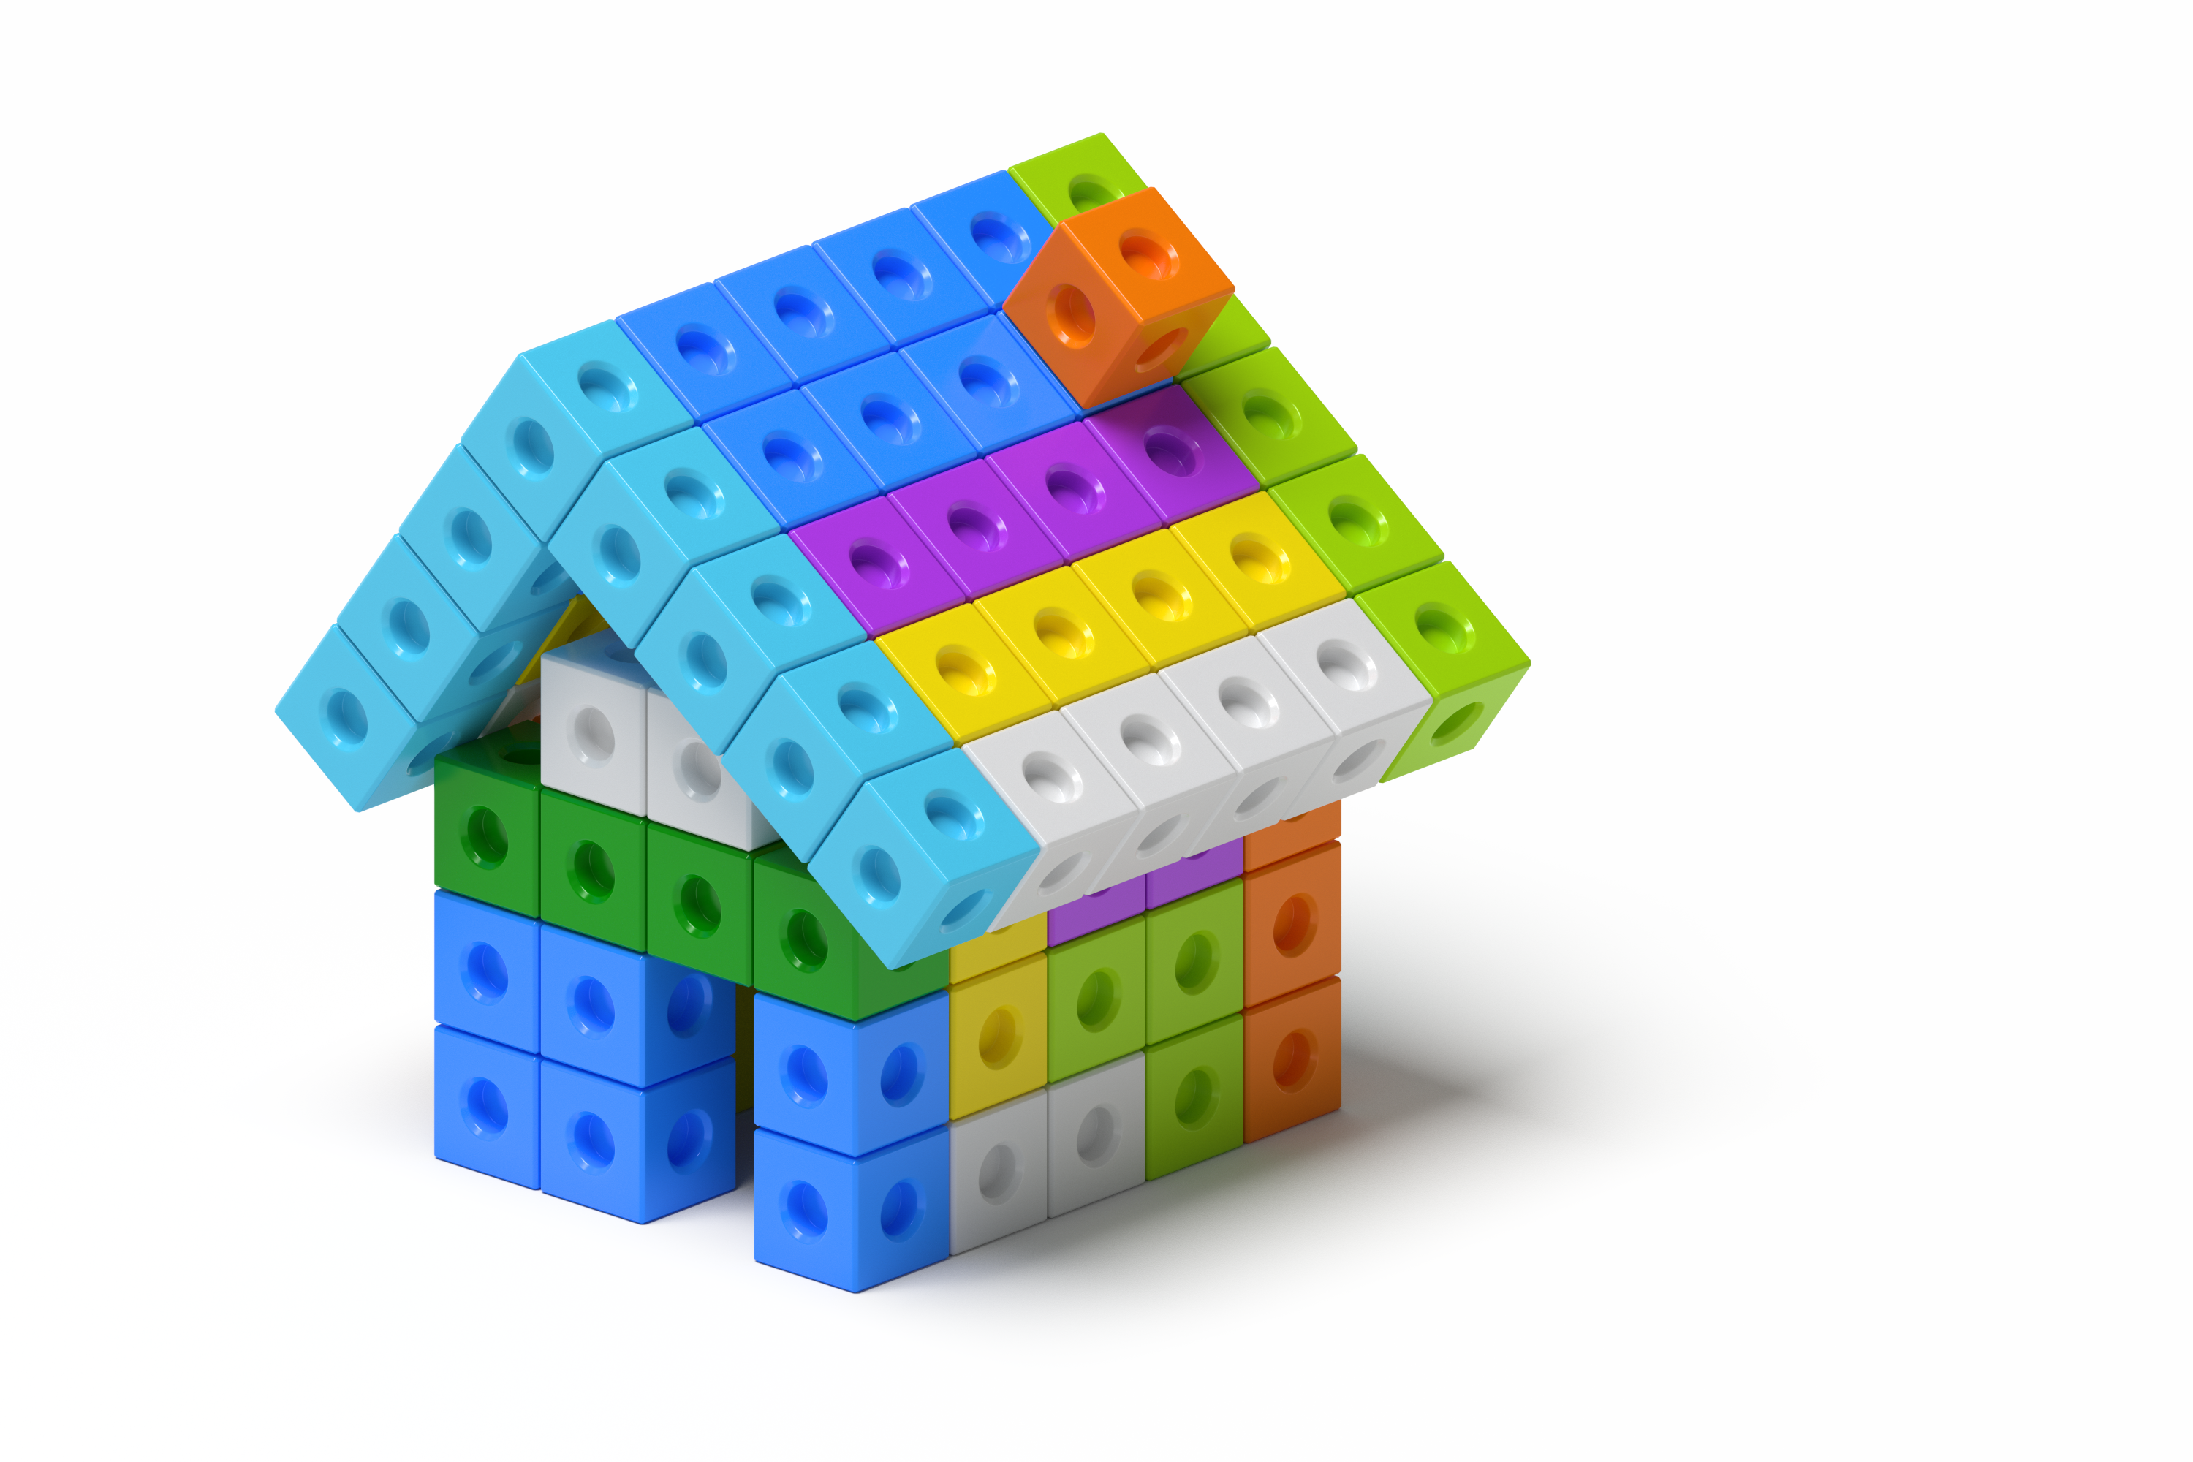

2.2: Guess My Prism
What is the same? What is different?
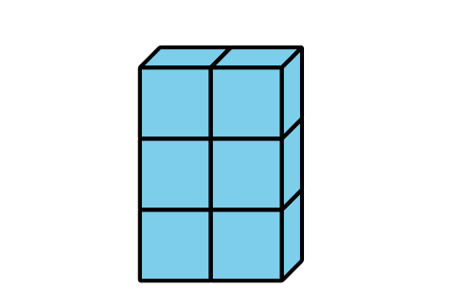
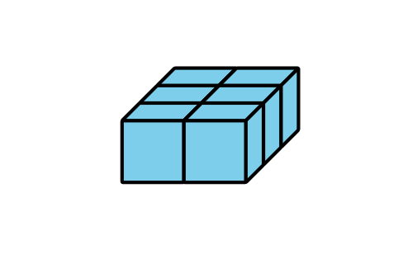
- The goal of the game is to get your partner to build the same prism.
  - Partner A: Use 16–24 cubes to build a prism. Describe it to your partner.
  - Partner B: Build the prism your partner describes to you.
- Place the two prisms next to each other and discuss what is the same and what is different about them.
- Switch roles and repeat.
© CC BY 2021 Illustrative Mathematics®

