Lesson 13 Practice Problems
- The polynomial function $B(x)=x^{3}−21x+20$ has a known factor of $(x−4)$. Rewrite $B(x)$ as a product of linear factors.
- Let the function $P$ be defined by $P(x)=x^{3}+7x^{2}−26x−72$ where $(x+9)$ is a factor. To rewrite the function as the product of two factors, long division was used but an error was made:
- x2+16x+118000x+9x3+7x2−26x−72000−x3+9x2_−26x−72000016x2−26x−720000−16x2+144x_−20000118x−7200−118x+1062_990
- How can we tell by looking at the remainder that an error was made somewhere?
- For the polynomial function $A(x)=x^{4}−2x^{3}−21x^{2}+22x+40$ we know $(x−5)$ is a factor. Select all the other linear factors of $A(x)$.
  - $(x+1)$
  - $(x−1)$
  - $(x+2)$
  - $(x−2)$
  - $(x+4)$
  - $(x−4)$
  - $(x+8)$
- Match the polynomial function with its constant term.
  - $P(x)=(x−2)(x−3)(x+7)$
  - $P(x)=(x+2)(x−3)(x+7)$
  - $P(x)=\frac{1}{2}(x−2)(x−3)(x+7)$
  - $P(x)=5(x−2)(x−3)(x+7)$
  - $P(x)=\text{-}5(x−2)(x−3)(x+7)$
  - -210
  - -42
  - 21
  - 42
  - 210
- (From Unit 2, Lesson 6.)
- What are the solutions to the equation $(x−2)(x−4)=8$?
- (From Unit 2, Lesson 11.)
- The graph of a polynomial function $f$ is shown. Which statement is true about the end behavior of the polynomial function?
- 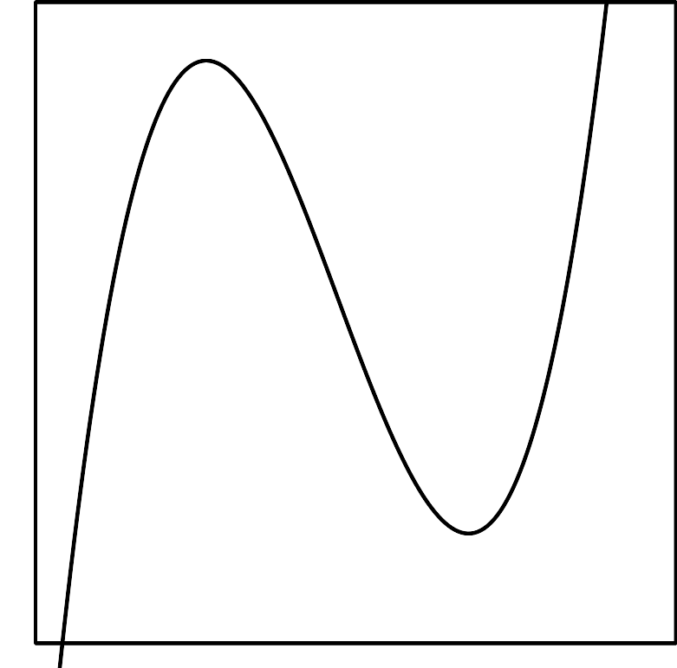
  - As $x$ gets larger and larger in the either the positive or the negative direction, $f(x)$ gets larger and larger in the positive direction.
  - As $x$ gets larger and larger in the positive direction, $f(x)$ gets larger and larger in the positive direction. As $x$ gets larger and larger in the negative direction, $f(x)$ gets larger and larger in the negative direction.
  - As $x$ gets larger and larger in the positive direction, $f(x)$ gets larger and larger in the negative direction. As $x$ gets larger and larger in the negative direction, $f(x)$ gets larger and larger in the positive direction.
  - As $x$ gets larger and larger in the either the positive or negative direction, $f(x)$ gets larger and larger in the negative direction.
- (From Unit 2, Lesson 8.)
- The polynomial function $p(x)=x^{3}+3x^{2}−6x−8$ has a known factor of $(x+4)$.
  - Rewrite $p(x)$ as the product of linear factors.
  - Draw a rough sketch of the graph of the function.
- (From Unit 2, Lesson 12.)
© CC BY 2019 by Illustrative Mathematics®

