Unit 2 Lesson 16: Center Day 3

WU Number Talk: Subtraction (Warm up)

Student Task Statement
Find the value of each expression mentally.
- $9−7$
- $9−2$
- $8−6$
- $8−2$

1 Introduce Capture Squares, Subtract Within 10

Student Task Statement

2 Centers: Choice Time

Student Task Statement
Choose a center.
Math Stories
Shake and Spill
What's Behind My Back
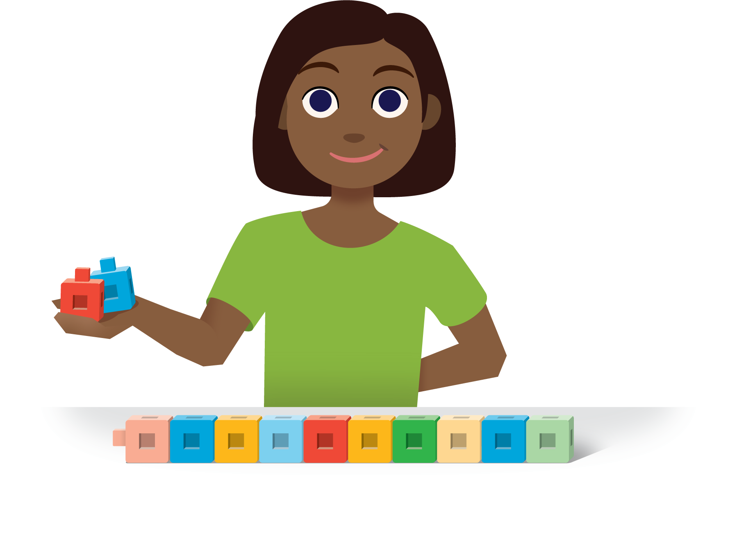
© CC BY 2021 Illustrative Mathematics®

