Lesson 15: Write Equations for Story Problems
- Let’s solve story problems and write equations.

Warm-up: Estimation Exploration: Paper Cranes
How many cranes are there in the image?
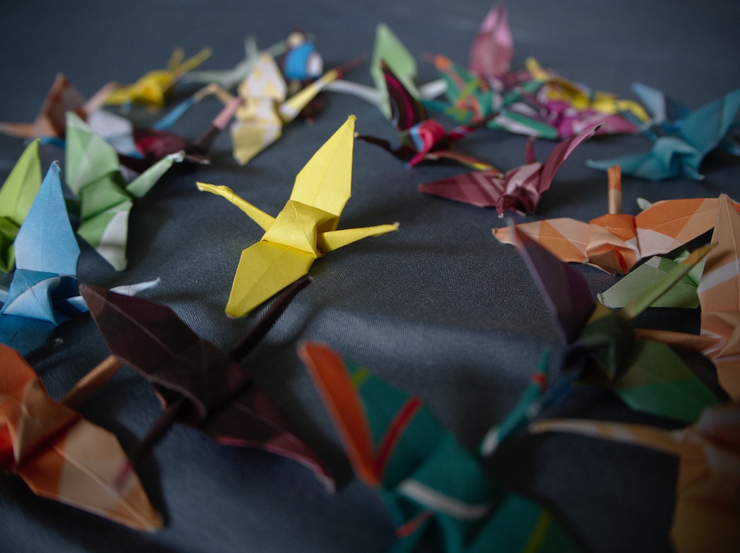
Record an estimate that is:
too low | about right | too high

15.1: Story Problems about Origami
Show your thinking using drawings, numbers, or words.
- Clare made some paper cranes.
She gives 12 of them to Han.
Now Clare has 7 cranes left.
How many cranes did she make?
- 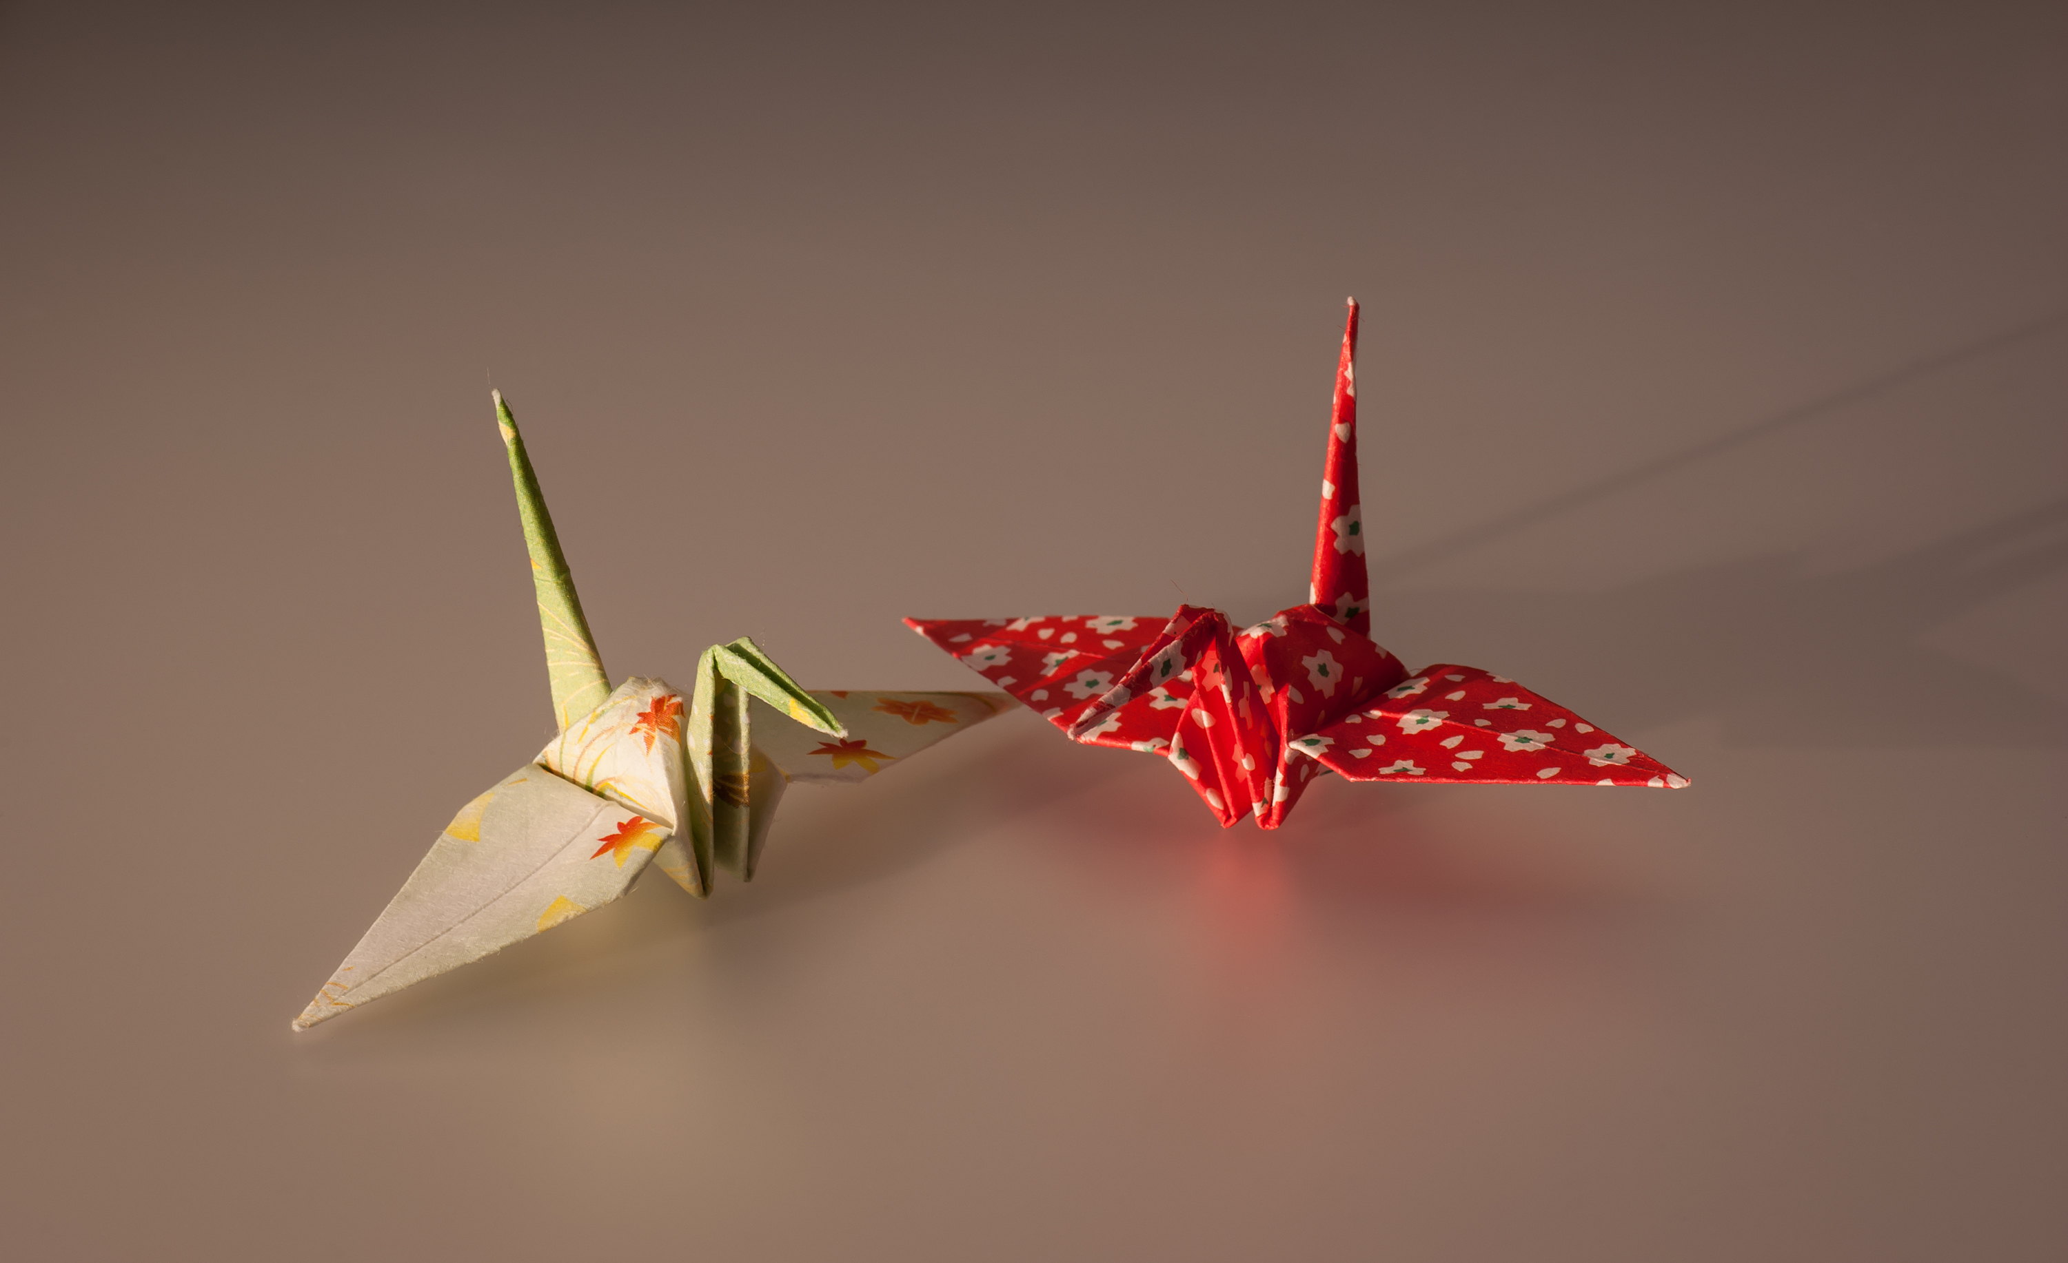
- Tyler made 15 origami butterflies.
Jada made 9 fewer origami butterflies than Tyler.
How many origami butterflies did Jada make?
- Elena made some red flowers.
Then she made 12 blue flowers.
Now she has 18 flowers altogether.
How many red flowers did she make?
- Mai made 8 paper frogs.
Diego made 17 paper frogs.
How many more frogs did Diego make than Mai?
- 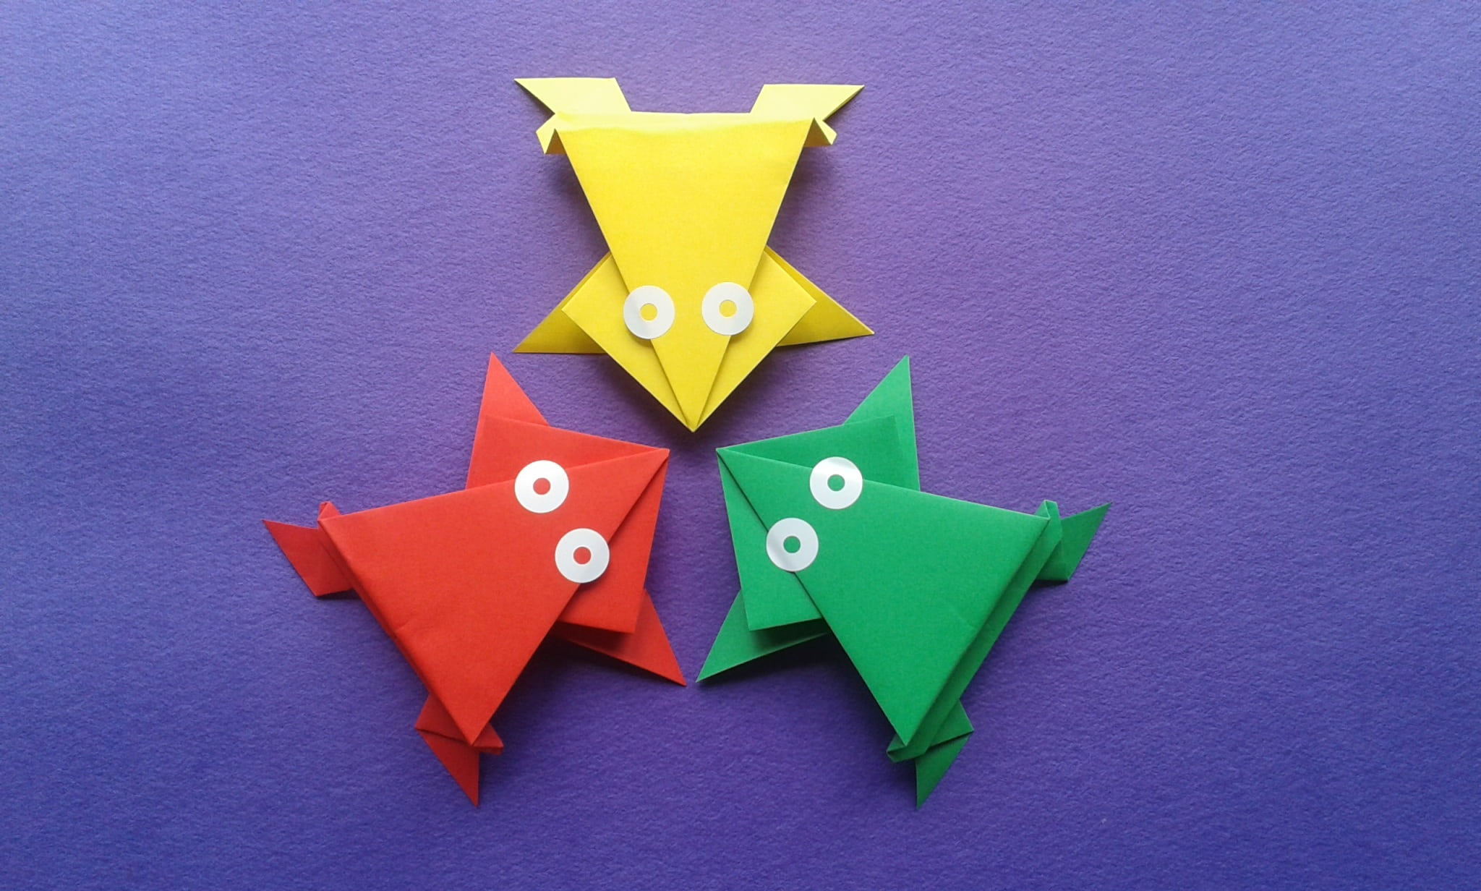

15.2: Gallery Walk: Write Equations
Write an equation that matches your classmates' work for each story problem.
- Equation: ________________________________
- Equation: ________________________________
- Equation: ________________________________
- Equation: ________________________________

Section Summary
Section Summary
We solved different types of problems and represented our thinking using drawings and equations.
Diego’s bracelet is 7 cubes longer than Mai’s bracelet.
Mai’s bracelet is 6 cubes long.
How long is Diego’s bracelet?
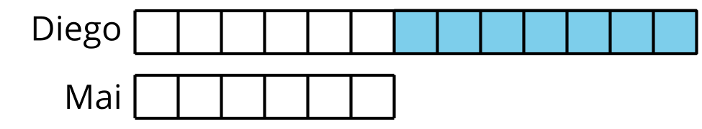
$6+7=\boxed{13}$
Kiran made some paper cranes.
He gave 5 of his cranes to his brother.
Now, he has 10 cranes left.
How many cranes did Kiran start with?
$5+10=\boxed{15}$
$\boxed{15}−5=10$
© CC BY 2021 Illustrative Mathematics®

