Lesson 6: Estimate and Measure Weight
- Let’s measure and estimate weight.

Warm-up: Notice and Wonder: Produce Stand
What do you notice? What do you wonder?
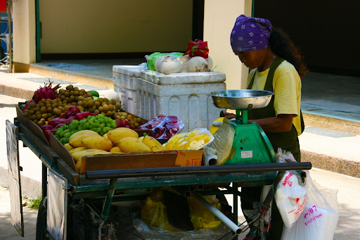

6.1: Estimate Weight
This paper clip weighs about 1 gram.
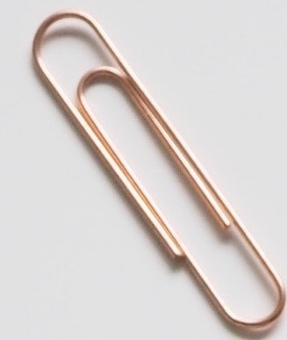
This basket of apples weighs about 1 kilogram.
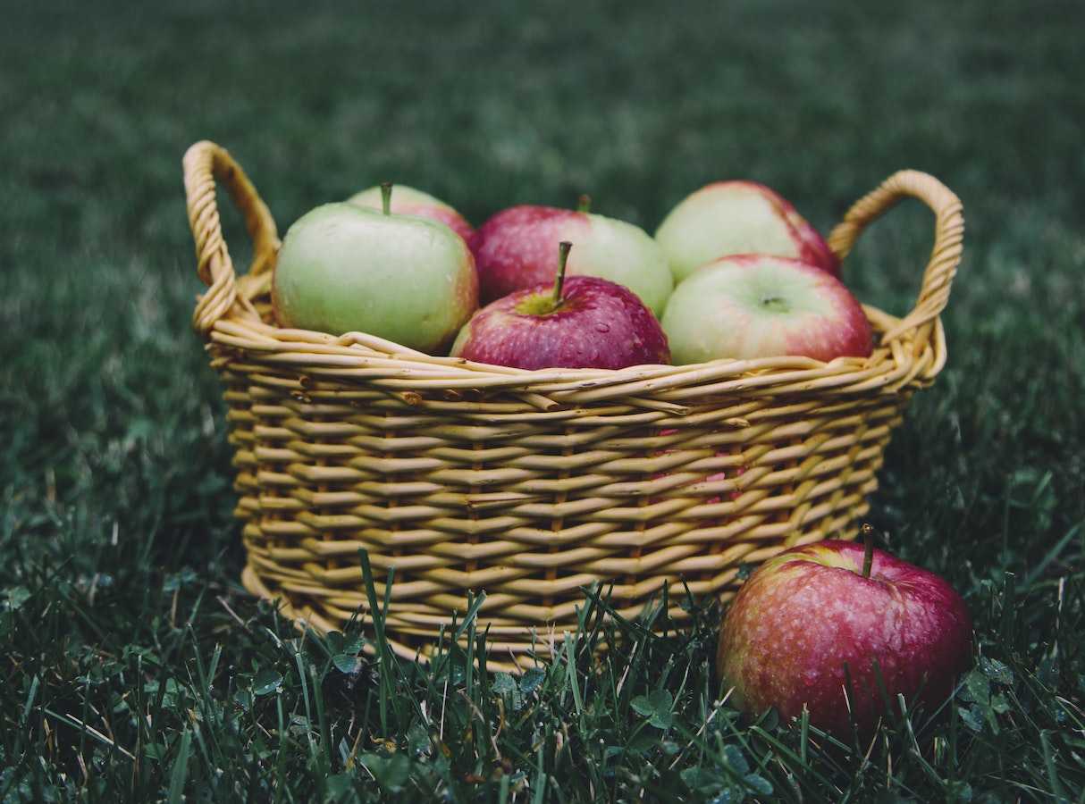
- For each weight measurement, find an example of something you think has about the same weight.
  - 1 gram
  - 10 grams
  - 100 grams
  - 1 kilogram
  - 2 kilograms
- Find some objects in the room that belong in each column based on their weight.
less than 1 gram | between 1 gram  and 100 grams | between 100 grams  and 1 kilogram | more than 1 kilogram

6.2: The Weight of Pets
Match each pet to the amount that could be its weight. Explain your reasoning.
pet
- guinea pig
- 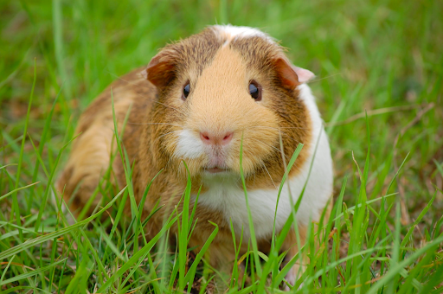
- dog
- 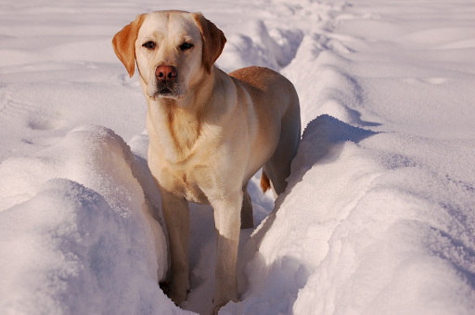
- small fish
- 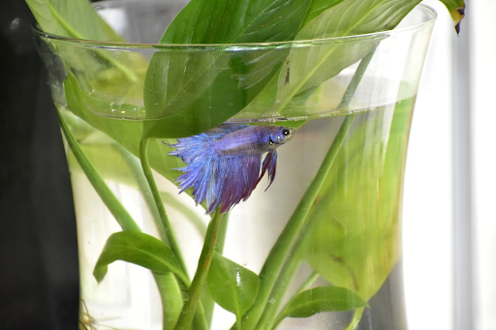
- cat
- 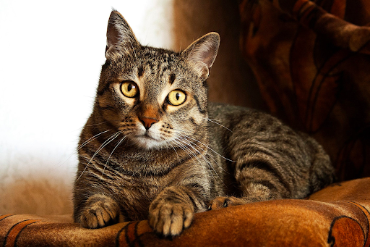
weight
- 20 kilograms
- 1 kilogram
- 3 kilograms
- 3 grams
© CC BY 2021 Illustrative Mathematics®

