Lesson 9: The Distributive Property, Part 1
Let's use the distributive property to make calculating easier.

9.1: Number Talk: Ways to Multiply
Find each product mentally.
$5⋅102$
$5⋅98$
$5⋅999$

9.2: Ways to Represent Area of a Rectangle
- Select all the expressions that represent the area of the large, outer rectangle in figure A. Explain your reasoning.
  - $6+3+2$
  - $6⋅3+6⋅2$
  - $6⋅3+2$
  - $6⋅5$
  - $6\left(3+2\right)$
  - $6⋅3⋅2$
- 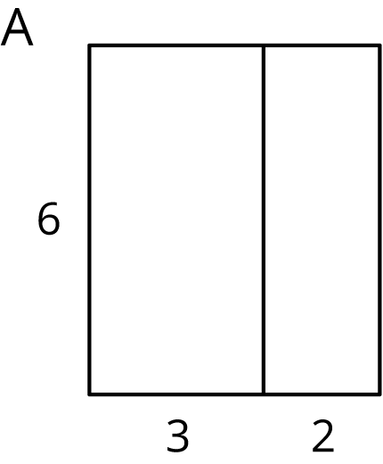
- Select all the expressions that represent the area of the shaded rectangle on the left side of figure B. Explain your reasoning.
  - $4⋅7+4⋅2$
  - $4⋅7⋅2$
  - $4⋅5$
  - $4⋅7−4⋅2$
  - $4\left(7−2\right)$
  - $4\left(7+2\right)$
  - $4⋅2−4⋅7$
- 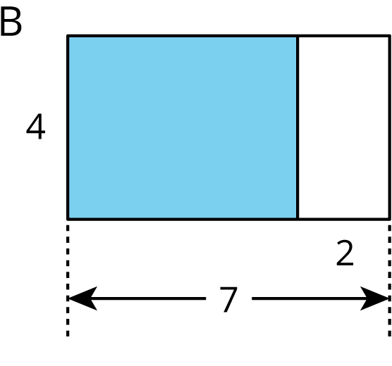

9.3: Distributive Practice
Complete the table. If you get stuck, skip an entry and come back to it, or consider drawing a diagram of two rectangles that share a side.
column 1 | column 2 | column 3 | column 4 | value
$5⋅98$ | $5\left(100−2\right)$ | $5⋅100−5⋅2$ | $500−10$ | 490
$33⋅12$ | $33\left(10+2\right)$
 |  | $3⋅10−3⋅4$ | $30−12$
 | $100\left(0.04+0.06\right)$
 |  | $8⋅\frac{1}{2}+8⋅\frac{1}{4}$
 |  |  | $9+12$
 |  |  | $24−16$

Are you ready for more?
- Use the distributive property to write two expressions that equal 360. (There are many correct ways to do this.)
- Is it possible to write an expression like $a\left(b+c\right)$ that equals 360 where $a$ is a fraction? Either write such an expression, or explain why it is impossible.
- Is it possible to write an expression like $a\left(b−c\right)$ that equals 360? Either write such an expression, or explain why it is impossible.
- How many ways do you think there are to make 360 using the distributive property?

Lesson 9 Summary
A term is a single number or variable, or variables and numbers multiplied together. Some examples of terms are 10, $8x$, $ab$, and $7yz$.
When we need to do mental calculations, we often come up with ways to make the calculation easier to do mentally.
Suppose we are grocery shopping and need to know how much it will cost to buy 5 cans of beans at 79 cents a can. We may calculate mentally in this way:
$5⋅79$
$5⋅70+5⋅9$
$350+45$
$395$
In general, when we multiply two terms (or factors), we can break up one of the factors into parts, multiply each part by the other factor, and then add the products. The result will be the same as the product of the two original factors. When we break up one of the factors and multiply the parts we are using the distributive property.
The distributive property also works with subtraction. Here is another way to find $5⋅79$:
$5⋅79$
$5⋅\left(80−1\right)$
$400−5$
$395$
© CC BY Open Up Resources. Adaptations CC BY IM.

