Lesson 11: Generemos fracciones equivalentes

Standards Alignments
Addressing | 3.NF.A.3.a, 3.NF.A.3.b, 3.OA.B.5
Building Towards | 3.OA.C.7

Teacher-facing Learning Goals
- Use diagrams to explain or show fraction equivalence.
- Use diagrams to generate equivalent fractions.

Student-facing Learning Goals
- Generemos fracciones equivalentes.

Lesson Purpose
The purpose of this lesson is for students to generate equivalent fractions.
In previous lessons, students learned what it means for two fractions to be equivalent. In this lesson, students continue to reason about and show equivalence visually, building on their work with fraction strips. They use shaded diagrams to help them generate equivalent fractions, including fractions greater than 1. The work here prepares students to use number lines to explain fraction equivalence later in the section.

Access for:

Students with Disabilities
- Action and Expression (Activity 1)

English Learners
- MLR8 (Activity 2)

Instructional Routines
Number Talk (Warm-up)

Lesson Timeline
Warm-up | 10 min
Activity 1 | 20 min
Activity 2 | 15 min
Lesson Synthesis | 10 min
Cool-down | 5 min

Teacher Reflection Question
Which students had opportunities to share their diagrams and thinking during whole-class discussion? How did you select these students?

Cool-down
(to be completed at the end of the lesson) 5min
Dos nombres de fracciones para cada diagrama

Standards Alignments
Addressing | 3.NF.A.3.b

Student-facing Task Statement
- Escribe dos fracciones que estén representadas por la parte sombreada de este diagrama.
- 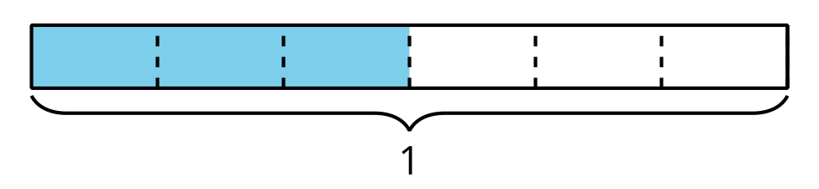
- Muestra que la parte sombreada de este diagrama representa tanto $\frac{5}{4}$ como $\frac{10}{8}$.
- 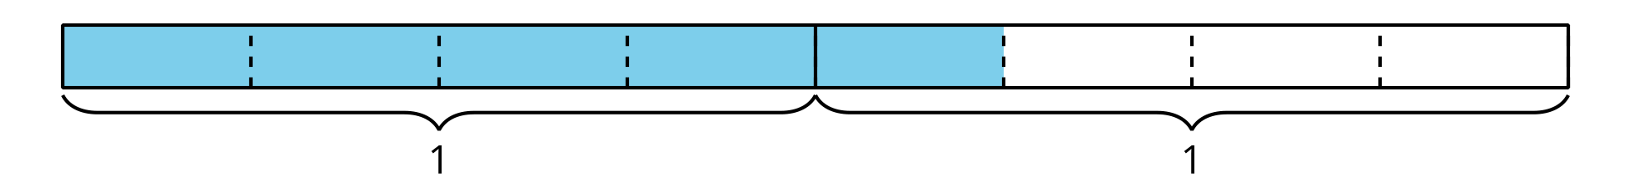

Student Responses
- $\frac{3}{6},\frac{1}{2}$
- Sample response: Each 1 whole is partitioned into fourths. Five fourths are shaded, which represents $\frac{5}{4}$. Each fourth can be split into two equal parts, which makes 8 eighths in 1 whole. Ten eighths are shaded, so that’s $\frac{10}{8}$.
- 