## Lesson 6: Rectangles and Squares

* Let’s learn the names of some more shapes.

### Warm-up: What Do You Know About Triangles?

What do you know about triangles?

### 6.1: Sort Rectangles

Let’s put the shapes into 2 groups.

Rectangle

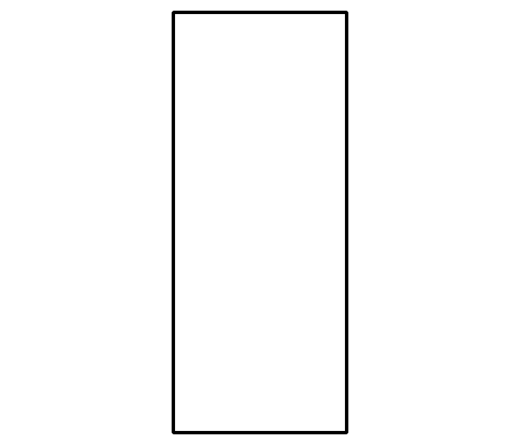

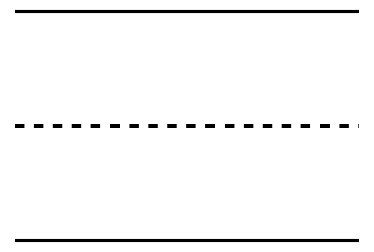

Line to separate the 2 groups.

Not a Rectangle

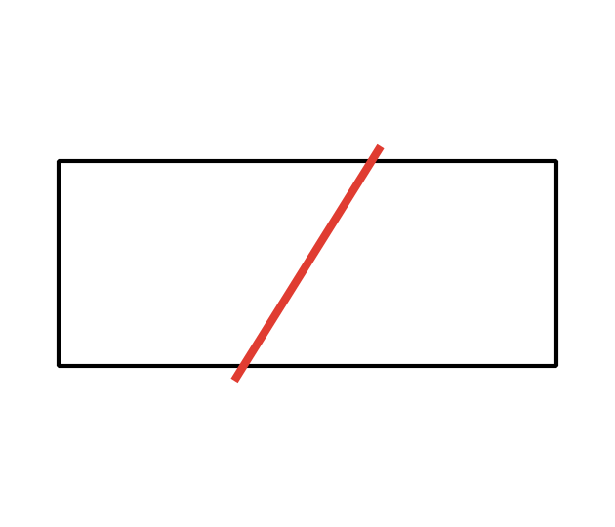



### 6.2: Compare Length of Rectangles

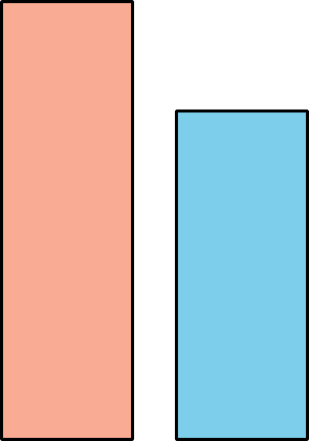



* 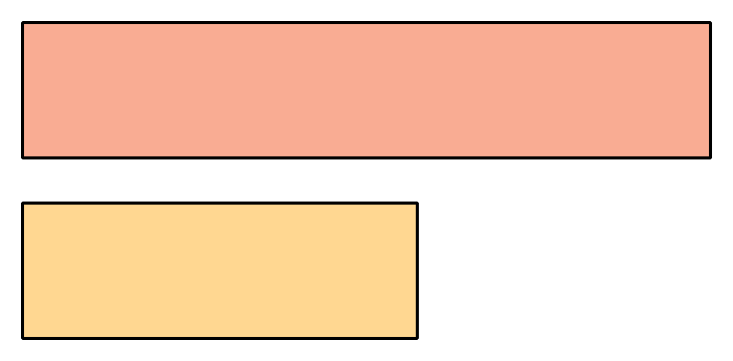



* 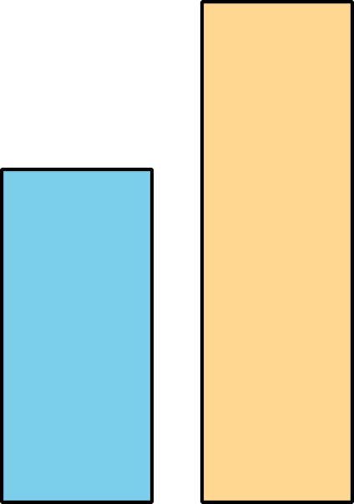



* 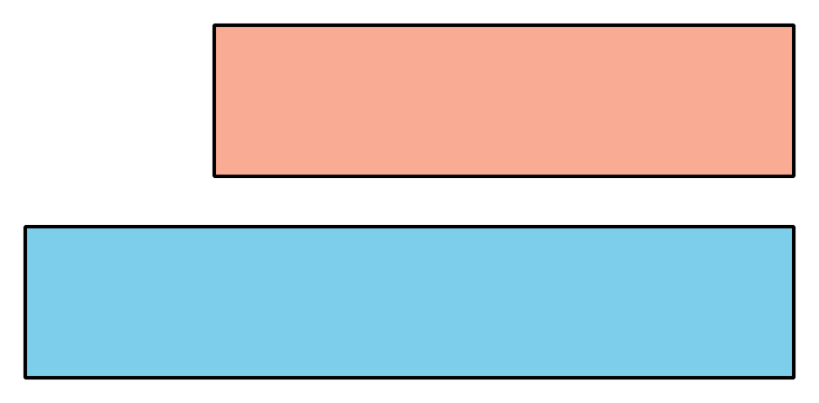



* 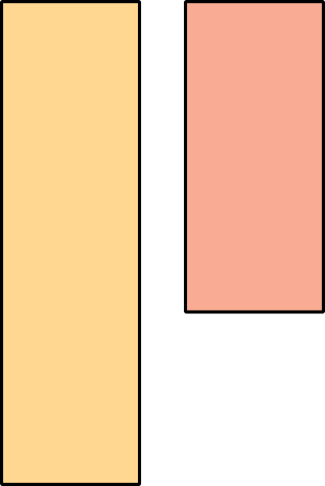

### 6.3: Centers: Choice Time

Choose a center.

Counting Collections

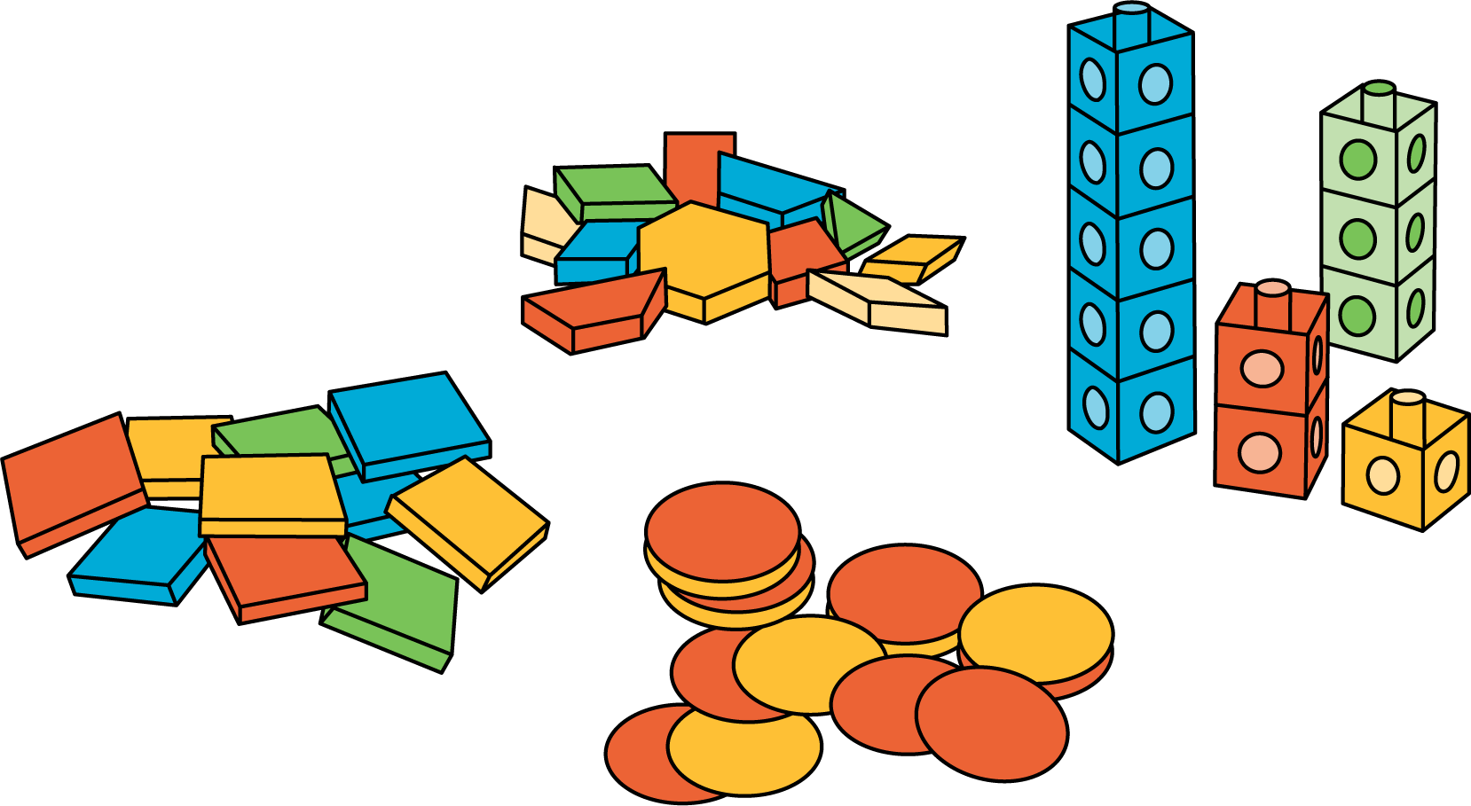

Which One

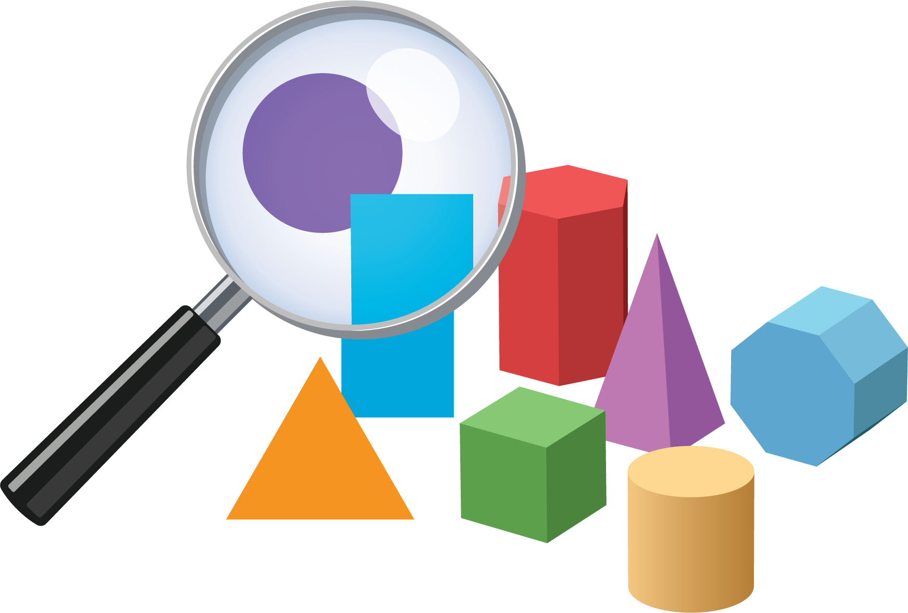

Picture Books

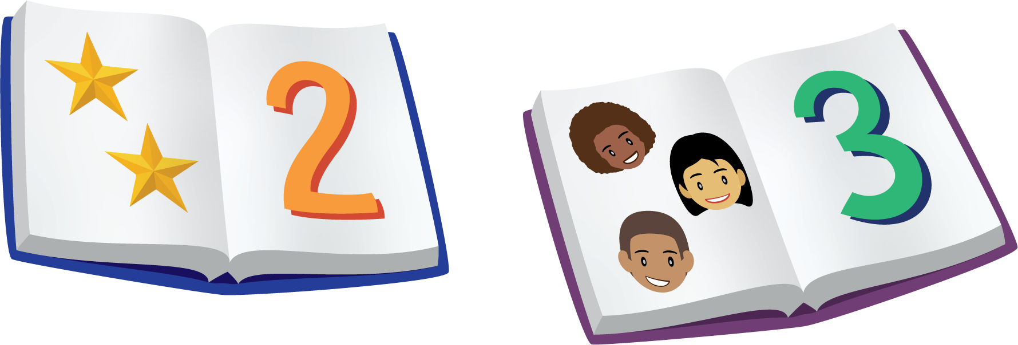

Bingo

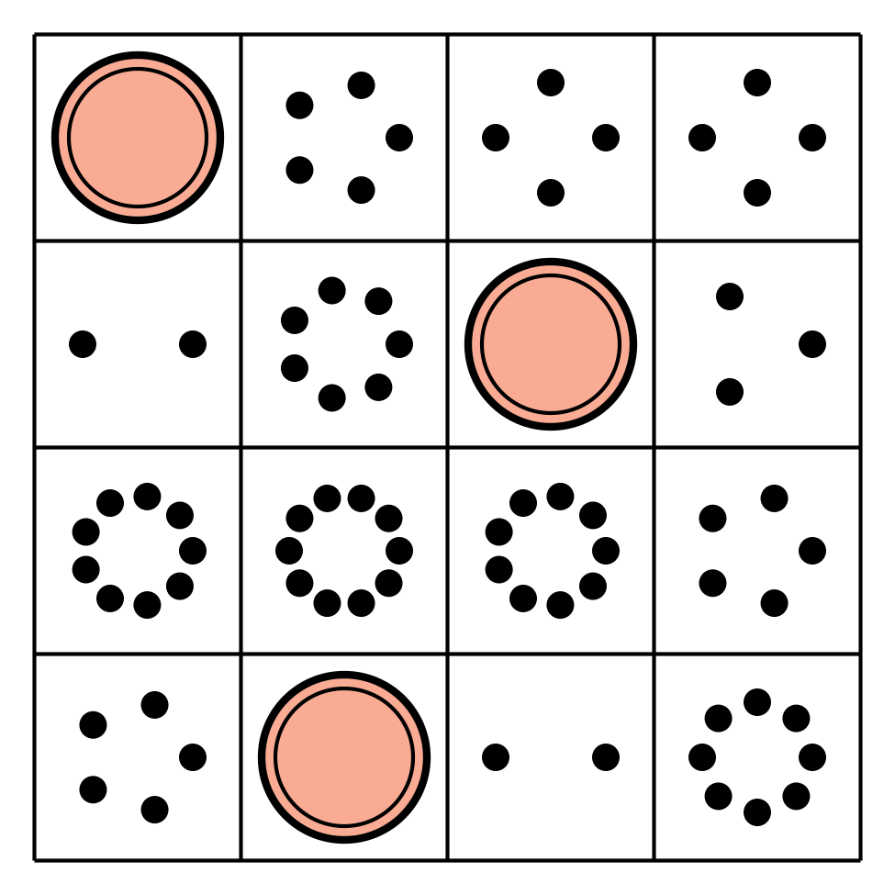

Shake and Spill

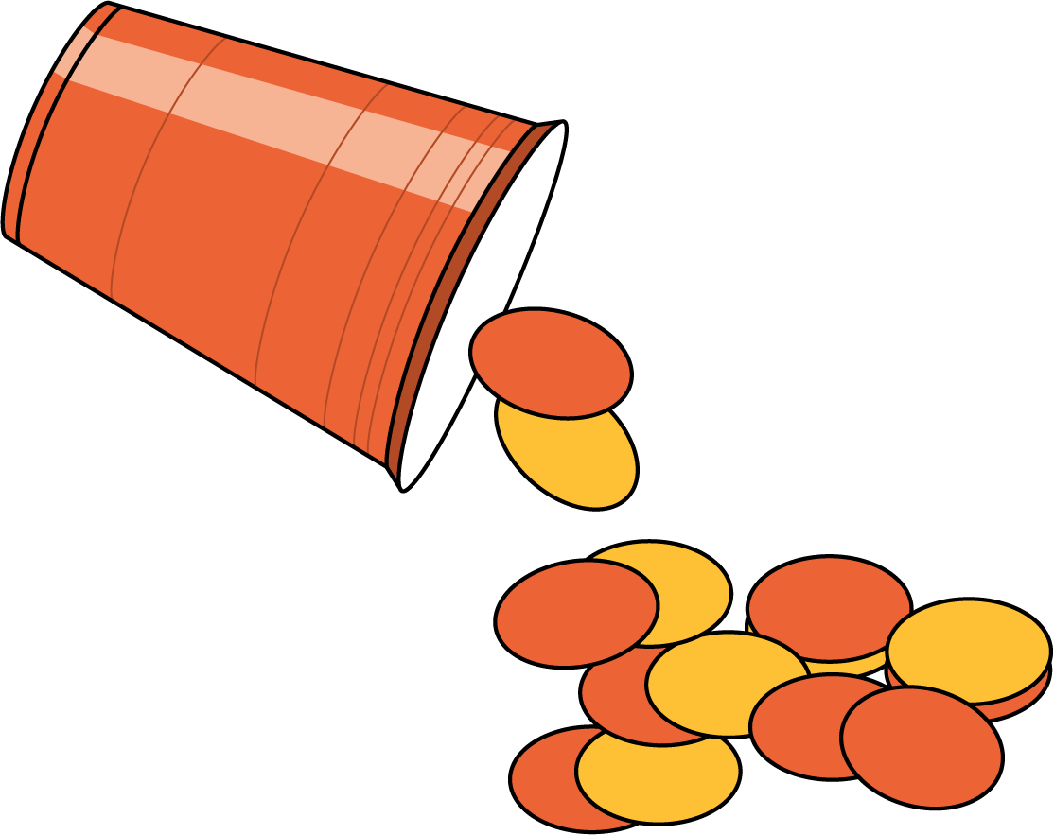



© CC BY 2021 Illustrative Mathematics®