Lesson 10: Interpreting and Writing Logarithmic Equations
- Let’s look at logarithms with different bases.

10.1: Reading Logs
The expression $\log_{10}1,​000=3$ can be read as: “The log, base 10, of 1,000 is 3.”
It can be interpreted as: “The exponent to which we raise a base 10 to get 1,000 is 3.”
Take turns with a partner reading each equation out loud. Then, interpret what they mean.
- $\log_{10}100,​000,​000=8$
- $\log_{10}1=0$
- $\log_{2}16=4$
- $\log_{5}25=2$

10.2: Base 2 Logarithms
$x$ | $\log_{2}\left(x\right)$
1 | 0
2 | 1
3 | 1.5850
4 | 2
5 | 2.3219
6 | 2.5850
7 | 2.8074
8 | 3
9 | 3.1699
10 | 3.3219

$x$ | $\log_{2}\left(x\right)$
11 | 3.4594
12 | 3.5845
13 | 3.7004
14 | 3.8074
15 | 3.9069
16 | 4
17 | 4.0875
18 | 4.1699
19 | 4.2479
20 | 4.3219

$x$ | $\log_{2}\left(x\right)$
21 | 4.3923
22 | 4.4594
23 | 4.5236
24 | 4.5850
25 | 4.6439
26 | 4.7004
27 | 4.7549
28 | 4.8074
29 | 4.8580
30 | 4.9069

$x$ | $\log_{2}\left(x\right)$
31 | 4.9542
32 | 5
33 | 5.0444
34 | 5.0875
35 | 5.1293
36 | 5.1699
37 | 5.2095
38 | 5.2479
39 | 5.2854
40 | 5.3219
- Use the table to find the exact or approximate value of each expression. Then, explain to a partner what each expression and its approximated value means.
  - $\log_{2}2$
  - $\log_{2}32$
  - $\log_{2}15$
  - $\log_{2}40$
- Solve each equation. Write the solution as a logarithmic expression.
  - $2^{y}=5$
  - $2^{y}=70$
  - $2^{y}=999$

10.3: Exponential and Logarithmic Forms
These equations express the same relationship between 2, 16, and 4:
$\log_{2}16=4$
$2^{4}=16$
- Each row shows two equations that express the same relationship. Complete the table.
 | - exponential form | - logarithmic form
- a. | - $2^{1}=2$
- b. | - ${10}^{0}=1$
- c. |  | - $\log_{3}81=4$
- d. |  | - $\log_{5}1=0$
- e. | - ${10}^{\text{-1}}=\frac{1}{10}$
- f. | - $9^{\frac{1}{2}}=3$
- g. |  | - $\log_{2}\frac{1}{8}=\text{-}3$
- h. | - $2^{y}=15$
- i. |  | - $\log_{5}40=y$
- j. | - $b^{y}=x$
- Write two equations—one in exponential form and one in logarithmic form—to represent each question. Use “?” for the unknown value.
  - “To what exponent do we raise the number 4 to get 64?”
  - “What is the log, base 2, of 128?”

Are you ready for more?
- Is $\log_{2}\left(10\right)$ greater than 3 or less than 3? Is $\log_{10}\left(2\right)$ greater than or less than 1? Explain your reasoning.
- How are these two quantities related?

Lesson 10 Summary
Many relationships that can be expressed with an exponent can also be expressed with a logarithm. Let’s look at this equation: $2^{7}=128$ The base is 2 and the exponent is 7, so it can be expressed as a logarithm with base 2:
$\log_{2}128=7$
In general, an exponential equation and a logarithmic equation are related as shown here:
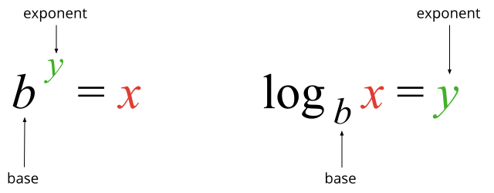
Exponents can be negative, so a logarithm can have negative values. For example $3^{\text{-}4}=\frac{1}{81}$, which means that $\log_{3}\frac{1}{81}=\text{-}4$.
An exponential equation cannot always be solved by observation. For example, $2^{x}=19$ does not have an obvious solution. The logarithm gives us a way to represent the solution to this equation: $x=\log_{2}19$. The expression $\log_{2}19$ is approximately 4.25, but $\log_{2}19$ is an exact solution.
© CC BY 2019 by Illustrative Mathematics®

